Rhodes uniVERSITY
An Evaluation of Windows® Vista™
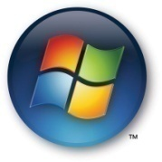

Richard Awusi
November 2007

Supervisor: John Ebden
Consultants: Jill Japp and Billy Morgan

Thesis submitted in partial fulfilment of the requirements for the
Bachelor of Science Honours Degree in Computer Science

Rhodes University

RHODES UNIVERISTY
Abstract

The purpose of this project is to evaluate the latest operating system that has graced the computing world from Microsoft. Windows Vista comes with exciting new features, security upgrades and a friendlier user environment. Windows Vista was officially released to the world on the 30th of January 2007, to some anticipation by the computing world. There was a lot of talk of the innovative features that were present in the new operating system, improved file systems, user interface, etc. My project aims to investigate what Windows Vista has to offer, whether it features all the elements proposed by Microsoft.

Acknowledgements

I would like to acknowledge my supervisor, Mr John Ebden, for his contribution to me during the year, my project consultants, Billy Morgan and especially Jill Japp for her continuous patience with me. I acknowledge the financial and technical support of this project of Telkom SA, Business Connexion, Comverse SA, Verso Technologies, Stortech, Tellabs, Amatole, Mars Technologies, Bright Ideas Projects 39 and THRIP through the Telkom Centre of Excellence at Rhodes University.

Contents

Acknowledgements 3
Contents 4
List of Figures 7
List of Tables 8
Chapter 1 - Introduction 9
1.1 Project Motivation 9
1.2 Document Structure 9
1.3 Introduction – A History of Windows Vista 11
Chapter 2 – Editions 12
2.1 Vista Starter 12
2.2 Home Basic 12
2.3 Home Premium 13
2.4 Business Edition 13
2.5 Vista Ultimate 14
2.6 Vista Enterprise 14
2.7 A comparison of editions 15
Chapter Summary 16
Chapter 3 – Installation 17
3.1 System Requirements 18
3.1.1 Graphics 18
3.1.2 Processor 19
3.2.3 Memory 19
3.2 Single Installation Image 19
3.3 User Interaction 21
3.4 System Configuration (Windows System Assessment Tool) 21
Chapter summary 26
Chapter 4 – Vista Features 27
4.1 ReadyBoost 27
4.2 SuperFetch 28
4.3 User Interface 30
4.3.1 AERO 31
4.3.2 Explorer 34
4.4 User Account Control 36
4.5 Instant Search 37
4.6 Shadow Copy 37
Chapter summary 38
Chapter 5 – System Tests and Performance 39
5.1 System strain test 39
5.1.1 Performances 40
5.2 Hard drive Tests 43
5.2.1 Searching 44
5.2.2 File Copying 45
5.3 Memory Tests 48
5.4 Defragmentation 50
Chapter Summary 50
Chapter 6 –Compatibility Tests 51
6.1 Office 2003 and 2007 51
6.2 Drivers 51
6.3 Games 52
Chapter summary 54
Chapter 7 – Vista Deployment 55
7.1 GHOST 55
7.1.1 Creating the Vista image 55
7.1.2 Machine setup for Ghosting 56
7.1.3 Deployment 57
7.2 ImageX 58
7.2.1 Creating the install image 58
7.2.2 Deployment 58
Chapter summary 59
Chapter 8 – Conclusions 60
Chapter 9 – Possible Extensions 62
References 63
Appendices 67
Appendix 1 – WinSAT log file 67
Appendix 2 – Portion WinSAT XML file 69
Appendix 3 – Copy Program Code 72

List of Figures

Figure 1 - WinSAT Application Programming Interface. 22
Figure 2 - Windows Experience Index generated by running WinSAT on my high grade system 24
Figure 3 - ReadyBoost dialog boxes. Left: AutoPlay popup if device is ReadyBoost capable. Right: Allocating portion of device memory 28
Figure 4 - Microsoft Office 2007 startup times on Vista and XP 29
Figure 5 - Firefox startup times on Vista and XP 30
Figure 6 - Aero in action on the left, Aero disabled on the right 31
Figure 7 - Windows Flip 3D (WINKEY+TAB) 32
Figure 8 - Windows Flip (ALT+TAB) 33
Figure 9 - Windows Live Thumbnails 33
Figure 10 - Explorers different folder sizes 34
Figure 11 - Windows explorer's new look 35
Figure 12 - User Account Control Dialog prompt for elevation 36
Figure 13 - Shadow Copy 38
Figure 14 - HeavyLoad system strain program. Not working (left), working (right) 40
Figure 15 - HeavyLoad screenshot of Vista. 41
Figure 16 - HeavyLoad on Windows XP 42
Figure 17 - Vista hard drive performance test 43
Figure 18 - XP hard drive performance test 44
Figure 19 - Numerous file copy results 46
Figure 20 - Single large file copy results 47
Figure 21 - Vista memory test results 49
Figure 22 - XP memory tests results 50

List of Tables

Table 1 - Windows Vista edition comparison 16

Chapter 1 - Introduction

1.1 Project Motivation

Microsoft regards Windows Vista as their best operating system to date, featuring an improved user interface, new file handling system, networking, and improved security. The project aims to assess the various features of Vista, and where possible, benchmarking results against its predecessor Windows XP. One of the focus areas of the project is deploying Vista on a large scale, e.g. in a computer laboratory situation, with tools such as GHOST and ImageX. Considering such large scale deployments, the aim is to create a single Vista image and have it multi-casted to other machines on the domain.

1.2 Document Structure

Chapter one gives a basic introduction of the project work and what is required. A general overview of Windows Vista as well as its history is explored.
Chapter two takes a look at the various versions of Windows Vista that are available. Features present and absent in each edition are looked at, and where possible, I give reasons as to why I feel certain features should have been included or removed.
Chapter three starts to look at working with Vista itself. Here, I take a look at installing Vista on a personal computer, taking into account system specifications, and monitoring what automated activities Vista undertakes, such as automatic updates.
Chapter four introduces some of the features present in Windows Vista. Here, I take a look at a few of the new features, not necessarily what is present in the edition of Vista that I am using. I will however indicate which version of Vista the feature might be absent from.
Chapter five takes a look at tests conducted on Vista and its performance, and where possible, Windows XP. Results will be presented from each test, and where tests have been conducted on more than one operating system, they will be benchmarked against each other.
Chapter six looks at compatibility between the Microsoft Office suites, device drivers and some games with Vista.
Chapter seven will see Vista being deployed in a computer laboratory. Two methods of deployment are evaluated, GHOST and Windows Automation Installation Kit (featuring ImageX). GHOST allows for a single machine to be prepped and an image created of its operating system. This image can then be placed on a server, and have all other machines booting off the network to pick it up and copy it to their hard drive. ImageX works the same way, except ImageX is a file based application whilst GHOST is sector based. These are explained in more detail later.
Chapter eight is where I draw up my conclusions about Vista based on my findings.
Chapter nine gives some possible extensions to my project.

1.3 Introduction – A History of Windows Vista

Microsoft began their plans for developing Windows Vista in 2001, before the release of Windows XP. At the time, Vista had the codename Longhorn and was set for release sometime in late 2003. It was initially meant to be an “in between” operating system, which was to be a release between Windows XP and the then planned, Windows 7, codenamed Blackcomb.
However, as work continued on Longhorn, many of the features initially planned for Blackcomb gradually began to filter into Longhorn. This led to the release date of Longhorn being pushed further from its initial 2003 release date. With ongoing delays becoming more common, and the fear of feature creep, Microsoft decided to change things around. The original Longhorn idea which was based on the source code of Windows XP was scrapped. Development started afresh, but now basing the new operating system on the Windows Server 2003 source code. Previously mentioned features for Longhorn were dropped, and a completely new methodology of development was started. This methodology was referred to by Microsoft as the “Security Development Life-Cycle”, a new way of development that would address the security issues that were present in the Windows codebase.
After changing names from Longhorn to Vista, Microsoft began a massive beta testing program that involved thousands of companies and volunteers. According to Microsoft [Microsoft 8], Vista beta 1 was released to over 10 000 volunteers through the MSDN developer program, Microsoft TechNet and the Windows Vista Technical Beta Program, a program setup solely for Vista beta testing. Each subsequent build of the operating system that followed incorporated most of the planned features of Vista. By February 2006, Vista was declared “feature complete” and most of the work that followed thereafter was concentrated on stabilizing the operating system, performance, application and driver compatibilities, and product documentation. Beta 2 of Vista was released in late May and was made available to the general public. This beta version was downloaded by over five million people worldwide.
Microsoft had hoped to have the operating system available by Christmas 2006, but this was pushed further back to January 2007 allowing hardware and software vendors time to prepare drivers for the new operating system. In November 2006, Microsoft announced the completion of Windows Vista, thus bringing an end to Microsoft’s lengthiest project. Finally, on the 30th of January 2007, Windows Vista was released to the world.

Chapter 2 – Editions

There are six main editions to Windows Vista. These are Vista Starter, Home Basic, Home Premium, Business Edition, Vista Ultimate and Vista Enterprise.

2.1 Vista Starter

Vista Starter is designed to help people in developing technological markets learn new computer skills and gain valuable computing abilities. This edition contains the least number of features of all the editions, providing only the essentials for beginner users. Vista Starter is not as popular as the other editions due to it being available only outside of the United States. With Vista Starter, one can only ever have three applications opened at any given time, something that is a major headache to people used to having ten to twenty programs opened at a time.

2.2 Home Basic

This version contains more features than starter but less than all other editions and is aimed at users who have basic computing needs, such as emailing, browsing the internet and photo viewing. Home Basic has merely the base enhancements, such as improved security, stability and performance. However, this edition lacks, what My Digital Life [2007] describes as; “Tools that make using a computer fun and entertaining…”; tools such as Windows Media Centre and Windows Aero.
Practically tagged as the black sheep of all the Vista editions, Home Basic comes as the cheapest ($199, roughly R1400) of all the editions. But Home Basic, according to Marc Wagner [2007] of ZDNet is capable of running smoothly on a low grade system, unlike the other editions. Wagner claims this to be as a result of Aero being absent from the operating system, something that requires high grade graphics and a lot of system memory.
Home Basic is Vista’s version of Microsoft Windows XP Home, and is not meant for advanced users or IT professionals. As Microsoft makes clear, this edition is directed at the home user.

2.3 Home Premium

Home Premium is a step up from Home Basic. This version of Vista features some more advanced features, such as the new Aero interface and Parental Access Control (PAC), making it ideal for the home user as well as for the mobile computer. Being a step up from Home Basic, and being cheaper than the other “higher order” versions, Home Premium has apparently proven to be the most popular according to Gregg Keizer [2007].
Marc Wagner [2007] refers to Home Premium as “…Media Center and Tablet PC rolled into one”. This edition offers users slightly more advanced features than Home Basic, but does not include some security improvements such as BitLocker encryption and Windows complete PC backup and restore.
Home Premium however provides the home user with features such as DVD maker and Movie Maker in High Definition, allowing users to create personal high quality home videos.
What is lacking in Home Basic and Home Premium however, is Remote Desktop. One would expect Remote Desktop to be made available in the home editions incase one requires some kind of external help. If the home editions are meant to be for home users, it’s very likely that assistance might be required by users who are just getting started.

2.4 Business Edition

The Business Edition of Vista is aimed primarily at small businesses that want to make their computing needs easier. Business comes with built in features that make it easier to connect to the business’ network and share files. Business does not include the entertainment features, such as Windows Media Center, as contained in some of the other editions.
The Business edition introduces new features over the home editions. Features present in Business that are not in the home editions include Windows Meeting Space - which allows for what Microsoft describes as, “…face-to-face collaboration of small groups of Windows Vista users…” [Microsoft 9] - Windows Fax and Scan, offline access to files and folders, roaming user profiles, and group policies amongst others. With these features, Vista Business appears to be the Windows XP Professional version of the Vista range.
This is the edition I will be using for my thesis work because it is relatively well priced and I believe it will be the version that will prove to be popular amongst the consumer market with time. With Home Basic being the cheapest ($199, roughly R1400 depending on the exchange rate) and Vista Ultimate being the most expensive ($399, roughly R3000), Business seems the best prices edition at $299 (roughly R2200), when features are considered.

2.5 Vista Ultimate

As the name states, this is the ultimate version of Vista that has the combined features of all other versions. Together with these features, Ultimate comes with Windows Ultimate Extras, which are a set of add-ons, language packs, etc, that the user can add to the operating system to make it more ravishing.
The Ultimate edition contains all the features that were proposed by Microsoft for Windows Vista. This edition introduces the security feature known as BitLocker Drive Encryption, a feature which encrypts data on the hard drive in order to increase security of data. All in all, Vista Ultimate is the ideal edition for a user who wants all the offerings of Vista.

2.6 Vista Enterprise

This version of Vista builds on the Business edition, with improved networking capabilities, advanced hardware-based encryption technology (BitLocker) and allowing for the deployment from a single disk image. This version is only available to volume license customers.

2.7 A comparison of editions

The table below lists some of the most important features in Windows Vista. The table was obtained directly from the Microsoft website [Microsoft 10]:

Features | Home Basic | Home Premium | Business | Ultimate
Most secure Windows ever: Windows Defender and Windows Firewall
Quickly find what you need: Instant Search and IE7
Elegant Windows Aero desktop experience
Best choice for laptops: Windows Mobility and Tablet PC
Collaborate and share documents: Windows Meeting Space
Experience photos and entertainment: Windows Media Center
Enjoy Windows Media Center
Protect against hardware failure: Windows Complete PC backup and restore
Windows Fax and Scan
Use Scheduled Backup
Easier remote access for your business: Remote Desktop
Easier networking connectivity: Network and Sharing Center
Better protect your data: Windows BitLocker Drive Encryption
Easily make DVDs: Windows DVD Maker
Have more fun on your PC: Games
Create high definition movies: Windows Movie Maker in High Definition

Table 1 - Windows Vista edition comparison

Chapter Summary

The various editions of Vista make it ideal for an IT professional to choose an edition that best suits their development needs. However, this can also serve as a disadvantage as the average user (layman) might not know which edition best suites them. The different price ranges that each edition has do help the user when purchasing plans are being made. Overall, I believe the different editions are a welcome.

Chapter 3 – Installation

To begin, let me mention what I have to work with, with regard to my machine system specifications. I did work on two different machines, one with relatively high grade specifications, and another with what I would consider “average” specifications, though still relatively high. The high grade system had the following specs:
- Intel Core 2 Duo @ 1.86 GHz
- 2 GB system memory
- 150 GB hard drive
- 128 MB Graphics card that is DirectX 9 compatible
Other than graphics card, which just meets the bare minimum requirements for running Vista, all other system hardware surpasses the recommended requirements. From here on in, I shall refer to the above mentioned system as my “high grade” system, and the next system as the “average” system.
The “average” system had the following system specs:
- 3.0 GHz Intel Pentium 4 processor
- 1 GB system memory
- 80 GB hard drive
- 64 MB graphics card with DirectX 9 support

3.1 System Requirements

The hardware requirements of Windows Vista are probably one of the most talked about points when it comes to the new operating system. Users have been complaining about the requirements that Microsoft has put forward as the recommended system specifications required to run Vista. These include:
- 1 GHz 32-bit or 64-bit processor
- 1 GB system memory
- 40 GB hard drive with at least 15 GB available space
- DirectX 9 capable Graphics card with a minimum of 128 MB onboard memory
These are the recommended system specs for running Home Premium, Business and Ultimate editions. These specs are slightly relaxed for Home Basic, which only requires 512 MB system memory, a 20 GB hard drive, but still with 15 GB available space, and a graphics card with only 32 MB of memory [Microsoft 4].

3.1.1 Graphics

In order to run Home Premium, Business and Ultimate at their full potential, Microsoft has recommended a graphics card that has at least 128 MB of dedicated graphics memory and is DirectX 9 compatible. Home Basic and Starter however do not require such, and will work just fine on any graphics card that is DirectX 9 compatible and has a minimum of 32 MB of memory. Notably, they are the only editions that lack the Aero interface, leading me to conclude Aero is the cause of the high graphics requirements.
The graphics requirements do not end there. Microsoft has included a few other requirements for the Aero enabled editions. Not only do the graphics cards require a lot of their own dedicated memory, but they also require:
- Windows Driver Display Model (WDDM) driver
- Pixel Shader 2.0 in hardware
- 32 bits per pixel
According to a presentation given by Richard G. Russell [2006], out of 512 MB of onboard system RAM, only 64 can be used for graphics memory when running Vista, and out of 1 GB, up to 256 can be used. When running Aero, a whole 512 MB must be available to system. Thus, if you have 512 MB system RAM shared with your graphics card, enabling Aero is out of the question.

3.1.2 Processor

The processor is probably the only requirement that has not received much criticism. With a minimum processor speed of 1GHz for both the 32-bit and 64-bit editions, most consumers were not too distraught about it.

3.2.3 Memory

Vista memory requirements are the one requirement that have caused quite a stir in the consumer market. Home Basic requires 512 MB of memory, while the other editions all require 1 GB of memory. Memory can be shared between memory and graphics, but as pointed out above, this is dependent on how much memory is actually present in the system.

3.2 Single Installation Image

Installation of Vista has changed from that of its predecessor Windows XP due to the introduction of a new file based image known as the Windows Imaging (WIM) file, Danielle and Nelson Reust [2007]. The operating system is written as one single image file onto the install DVD. During installation, the image is copied to the destination hard drive, expanded, and system configuration takes place. According to PC Magazine [2007], the image is the operating system zipped up with all its files and folders. The image is simply decompressed once it has been copied.
The WIM file format, being a file based format, provides Microsoft with several benefits over other file formats which are sector based. Jerry Honeycutt [2007] of Microsoft TechNet provides the following benefits the WIM file offers:
- The WIM image is hardware-agnostic, meaning you only need one image to address different hardware configurations.
- It allows you to store multiple images within one file, something that Microsoft has taken advantage of by shipping all the Vista editions on one single DVD.
- WIM enables compression and single instancing where single instancing is a way of storing one file for all images that reference that file. This means images 1, 2, and 3 no longer need to have their own copy, but mere references to one.
- WIM allows you to service an image offline. Components such as patches and drivers can be added to an image without a new image having to be created.
- The WIM image allows you to install a disk image on any partition size disk, unlike sector based images that can only install on disks of the same size or bigger.
- The WIM image allows for non-destructive deployment, which means data can be left on the volume on which you apply an image without losing your data. This is because data is not erased from the volume to which an image is applied.
The WIM file does not seem to introduce any real speed to the installation of Vista when compared to XP. In fact, it takes longer. During my installation of Vista, it took me between 30 to 40 minutes to install Vista Business depending on which machine I was installing it on. What is nice about the WIM file though is that being a file based image, the various editions can be stored on a single DVD and have all editions share files that are common. This decreases the size of the image considerably when written to disk.

3.3 User Interaction

When installing Windows XP, the user is asked for numerous amounts of information. The user is requested to input the current date, current time, network information, etc, which is pretty much the same with Windows Vista.
At installation startup, there’s the usual loading of files in preparation for the installation. The user is then prompted to enter information such as the current time, selecting their language of choice, entering the product key, selecting an edition (if a product key is not provided) and selecting the partition on which they would like to install the operating system to.
Vista does not make it compulsory to provide a product key before installation. Instead, you can simply by pass the product key window and select any edition you desire. By doing this, one can run any edition until activation is required, 30 days after installation. After this period, Vista simply refuses to boot any user to their desktop until activation takes place.

3.4 System Configuration (Windows System Assessment Tool)

New to Windows Vista is the Windows System Assessment Tool or just WinSAT as it is commonly called. When Vista is installed on a machine for the first time, a host of system assessments are done of the processor, system memory, graphics, video playback and system disks before the first user login.
The following diagram obtained from Richard G. Russell [2006] shows the application programming interface (API) of WinSAT:
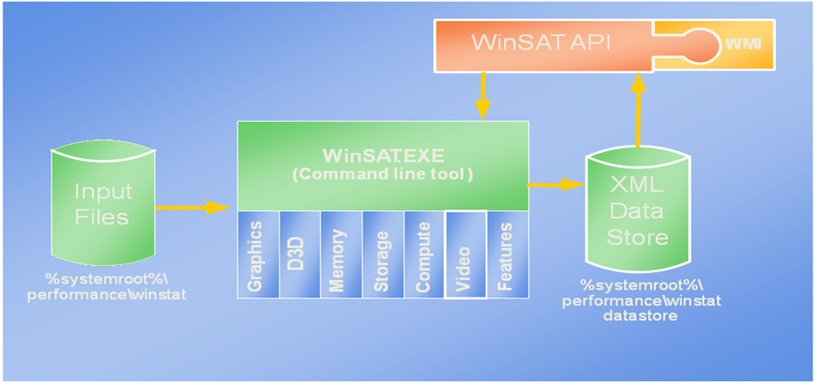
Figure 1 - WinSAT Application Programming Interface.

The WinSAT API is meant to provide a simple automated COM interface for such languages such as Visual Basic, Javascript, HTML, XML and Powershell. It provides easy programmatic access to WinSAT and the data store as well as access to WinSAT via the Windows Management Instrumentation (WMI) according to Russell.
A little about the components of the WinSAT API as presented by Windows Client Performance development manager Richard Russell:
- Data store – stores formal assessments done by WinSAT. Maintains results of the last 100 assessments and deletes the oldest as new assessments are performed. The initial assessment generated during “Out-of-Box Experience (OOBE)” is kept.
- Graphics – assesses a systems ability to run Aero. The assessment drives the hardware the same way the Desktop Window Manager (DWM) would. The results are then used by the DWM in making decisions about enabling Aero.
- D3D – designed to assess a systems ability to render 3D gaming graphics. The assessment concentrates on the shader arithmetic logic unit performance, shader texture load performance and post-pixel blend performance. This assessment is targeted at Pixel Shader 2.0 or better hardware.
- Memory – this assessment is focused on memory throughput and not latency, and is designed to assess how well large blocks of memory can be moved.
- Storage – this is a “sweep” test of the hard disk in which the physical disk is divided into regions, and evaluated for random read and write performance, and sequential read and write performance. Metrics in mega bytes per second are reported for each region, and an aggregated mean of all the regions is used as that hard disks rating.
- Compute (Processor assessment) – is designed to assess a system’s computational ability through the use of data compression and decompression algorithms, data encryption and decryption, as well as windows media encoding.
- Video – an assessment designed to assess a systems ability to play high definition Windows Media Video as well as for any other video format for which a codec is available on the system.
WinSAT rates each of the above mentioned hardware on a scale from 1 to 5.9, with 1 being the lowest and 5.9 being the highest. A final overall system score known as the windows experience index (WEI) is then determined. This score is not an average of all the scores, but is the lowest score that is scored by any hardware component. This means, if every piece of hardware scores an individual rating of 5.0 except one, e.g. graphics scores 1.5, then the final overall system rating will be a score of 1.5 [Microsoft 10].
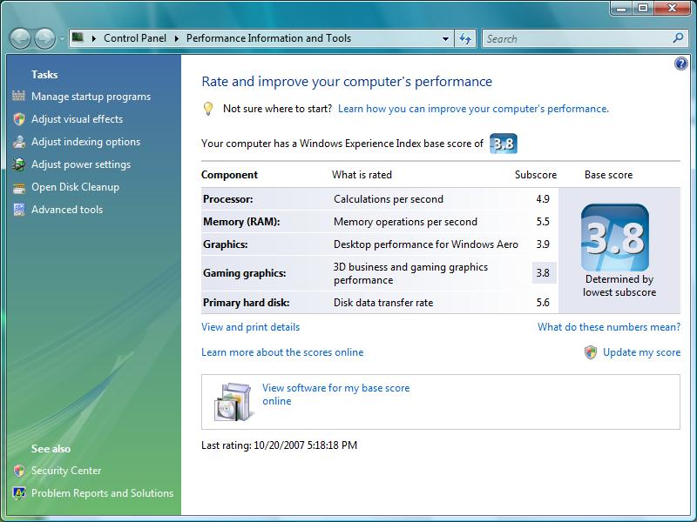
Figure 2 - Windows Experience Index generated by running WinSAT on my high grade system

The above screenshot is the rating I received for my “high grade” machine. Since the gaming graphics scored the lowest rating, it serves as my overall system rating.
The “average” system was not so lucky. Having a 64 MB graphics card, it received a graphics rating of only one. I could not get Aero enabled on the system. I tried on numerous occasions updating my graphics driver and manually running WinSAT, but had absolutely no luck.
The results of each WinSAT assessment are saved for later access in the registry, as an XML file on the local machine, and in a log file. The XML file is saved at “%systemroot%\performance\winsat\datastore” where %systemroot% could be “C:\Windows\”. The XML file is more detailed than the log file and contains information about each assessment and the values that were attained from it. The log file contains details about which assessment was run and the end result of that assessment, either a success or a failure. The log file is logged at “%systemroot%\performance\winsat\winsat.log”. A sample of the log file and a portion of the XML file are given in Appendix 1 and Appendix 2 respectively.
In an article by Faud Abazovic [2007] of The Inquirer he makes it clear that he does not think WinSAT is a good tool for assessing the capability of a machine. According to Abazovic, his computers base score dropped after upgrading his system memory, an upgrade which had led to an improvement in the performance of Vista. As far as Abazovic is concerned, WinSAT is not a good tool for assessing computers’ capabilities and urges users to ignore it.
Another author, Adrian Kingsley Hughes [2007, also complains about WinSAT. In an article, he goes on to say, “To be honest, I can’t see the score that the Windows Experience Index generates being good for anything…”
According to a presentation by Richard G. Russell [2006], WinSAT does not run automatically when a hardware or driver is upgraded or changed. In order for this automation to be possible, Russell mentions that the tool would require user account control (UAC) elevation, meaning more prompts for user consent. Russell mentions that since most users refuse the prompt for elevation, running of the tool is left at the users’ discretion. What has also been done is that independent hardware vendors have been asked to run the tool automatically during software installation. Since installation runs under elevation, WinSAT can be started and system assessment can take place after the software has been installed.

Chapter summary

The system requirements of Vista are not as bad as most might think. On average, most computers will meet the system processor requirements. And although there’s a 1 GIG RAM recommendation, Vista does run fine on 512 MB, only the Aero effect is lost. The installation time I find is not really that much longer than XP. The graphical installation interface is a definite improvement, and gives a much friendlier look to it. With all editions on one DVD, it allows users to try out any edition they wish and then determine which one best suits their needs. Should they wish to upgrade to a different edition, they don’t need to go out a purchase a brand new copy of the operating, making upgrades considerably cheaper on the consumer. The WinSAT rating I found was quite harsh, but the log files generated are a great way for a user to monitor differences in hardware upgrades.

Chapter 4 – Vista Features

Windows Vista comes with a plethora of features intending to make using the new operating system simpler, faster and more secure. This chapter takes a look at some of these features, and where work was done I present my findings and compare them with what others I may have found.

4.1 ReadyBoost

ReadyBoost, or “memory on a stick” as it is being called, is a feature new to Vista that allows a user to extend their system memory through the use of a USB device. According an article by Loyd Case [2006], ReadyBoost will come in handy for small blocks of random I/O operations such as paging files or other small files such as DLLs or OCXs. According to Case, ReadyBoost can serve these faster than a hard disk can, especially if the disk head has to move substantial amounts to locate small amounts of data.
In order for a USB device to be ReadyBoost compatible, it needs to have the capability of operating at certain speeds. Loyd Case and Ed Bott, [2007] both mention the following speeds for the USB devices:
- 2.5 MB/sec throughput for 4KB random reads
- 1.5 MB/sec throughput for 512KB random writes
These results have to be consistent across the entire device, and in addition, the device must have between 256MB to 4GB of space.
When a USB device is plugged into a Vista machine and it’s ReadyBoost capable, the following screen is presented with an option to “Speed up my system”:
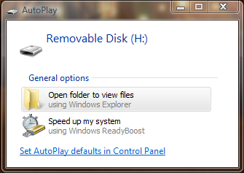 | 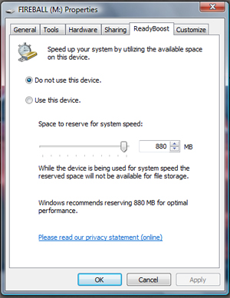

Figure 3 - ReadyBoost dialog boxes. Left: AutoPlay popup if device is ReadyBoost capable. Right: Allocating portion of device memory

The user can then choose the amount of space they wish to allocate for use. If the device is not ReadyBoost capable, Vista does not allow the user to use it as an extension to the system memory.

4.2 SuperFetch

SuperFetch is a new memory management technique introduced to Vista in which the most frequently used programs are preloaded into system memory, making them readily available when it comes to their startup. SuperFetch introduces extremely fast startup times for commonly used programs, but slows down a bit when a non-frequently used program is opened. This, however, is a satisfactory trade-off in my opinion.
I installed Microsoft Office 2007 on both my Vista machine as well as my Windows XP machine (running exactly the same system specifications as that of the Vista machine) to try and monitor this. My most frequently used program in the Office suite is Outlook, so I based most of my monitoring on it. Below, I present a graph of the times in seconds it took Outlook to open on the two operating systems over a period of one month:
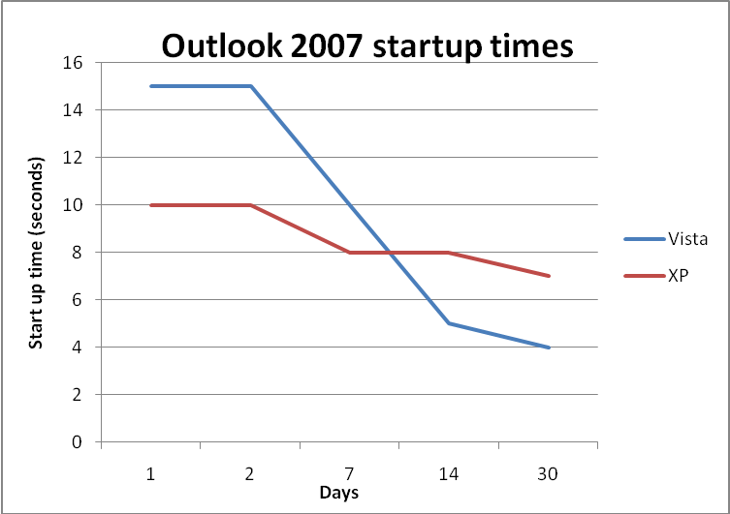
Figure 4 - Microsoft Office 2007 startup times on Vista and XP

On each of the 30 days, I would open and close Outlook once a day on both machines. As the graph shows, the startup time of Outlook decreased considerably over time on Vista, and though I noticed a decrease in the startup time of Outlook on XP as well, it is not as substantial as that of Vista.
I also performed monitoring tests on Mozilla Firefox 2.0, also over a period of a month. With Firefox however, I went ahead and added additional search engines as well as a plugin, forecast-fox. Over the next month, the startup times of Firefox was monitored on the two machines, and like that of Outlooks results, there was a decrease in the startup time of Firefox on the Vista machine, whilst on the XP machine, there was a substantial slow down after the installation of the forecast-fox plugin and search engines, which were installed exactly one week after the test began. Exactly one day after the plugin and search engine additions, there was a great increase in XP Firefox startup time, but Vista did not show that great an increase. Over the next week, both operating systems showed a decrease in the startup times, but Vista showed a greater decrease. The graph below shows the results of this:
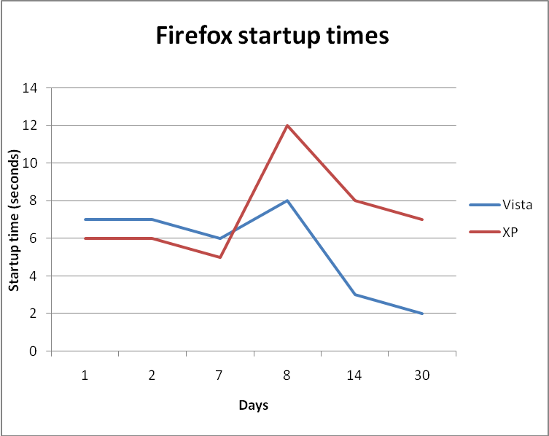
Figure 5 - Firefox startup times on Vista and XP

From the above results, there’s no doubt in my mind that SuperFetch uses system memory as a cache. This is further supported when I open the task manager and take a look at the resources page. At any given time, after about two months of running of running Vista, I found my memory usage sitting at over 45% after Windows startup. This equates to 900 MB of my system memory constantly being used.

4.3 User Interface

One of the biggest talking points of Windows Vista, and in my opinion also one of its big selling points, is the new user interface. Vista features the new Aero interface which comes with additional visual benefits such as Windows Flip 3D and Live Thumbnails.

4.3.1 AERO

Aero comes fitted with a stylish new look for Vista, providing transparency effects on all windows that are not maximized. These features however do not come without a price. One of Vista’s requirements for those editions that are Aero capable as mentioned above is a 128 MB DirectX 9 compatible graphics card. Aero provides a new look to Vista that I think is elegant and neat. The transparency effects are completely unobtrusive, and an absolute joy to work with. According to Jen Matzan, [2007], “The new Windows Aero theme is strikingly attractive and adds significantly to Vista's overall user experience.”
The following figure shows the difference between Aero being enabled (left) and when Aero is disabled (right):
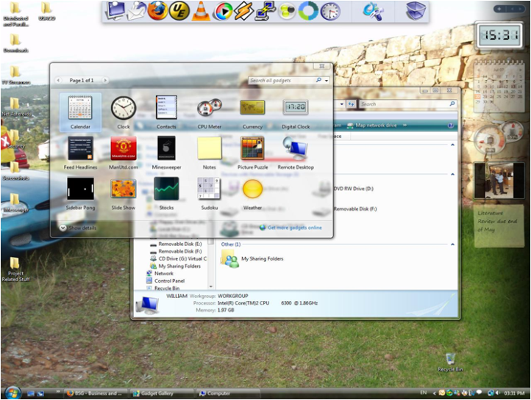 | 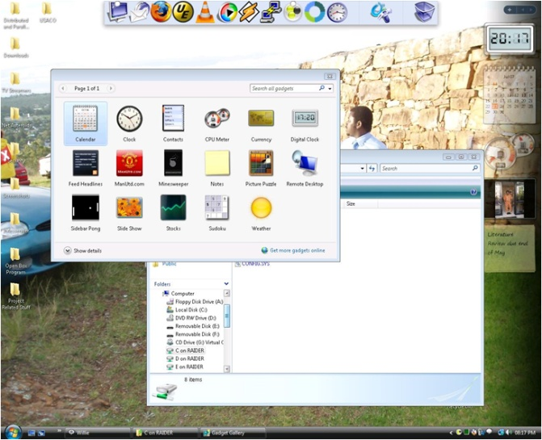
Figure 6 - Aero in action on the left, Aero disabled on the right

Aero is not always active when it is enabled. When the system is under strain, or a tasking program is running, Vista automatically disables aero so as to improve system performance. I noticed this when running programs that had video output of some sort such as VLC media player, or when I made remote connections to the Vista machine. Also, the level of transparency, colour and its saturation can be dictated by the user through the “Personalize” option available when the user right-clicks on the desktop.

4.3.1.1 Windows Flip 3D

Windows Flip 3D is a new way of performing the classic ALT-TAB for switching between opened applications. Instead of the ALT-TAB key combination, Flip 3D is achieved by making use of the Windows Key (WINKEY) + TAB combination. Windows Flip 3D is, as described by Microsoft [Microsoft 3], “a three-dimensional stack [of opened applications] on your desktop”. The windows are arranged, stacked behind one another, and are scrolled forward or backward as they are tabbed through. The beauty about this new display feature is that it is displayed in real-time [Microsoft 3]. That is, as the contents of the window changes, so do the previews on the thumbnails, Windows Flip or Windows Flip 3D.
Below is a screenshot of Windows Flip 3D in action:
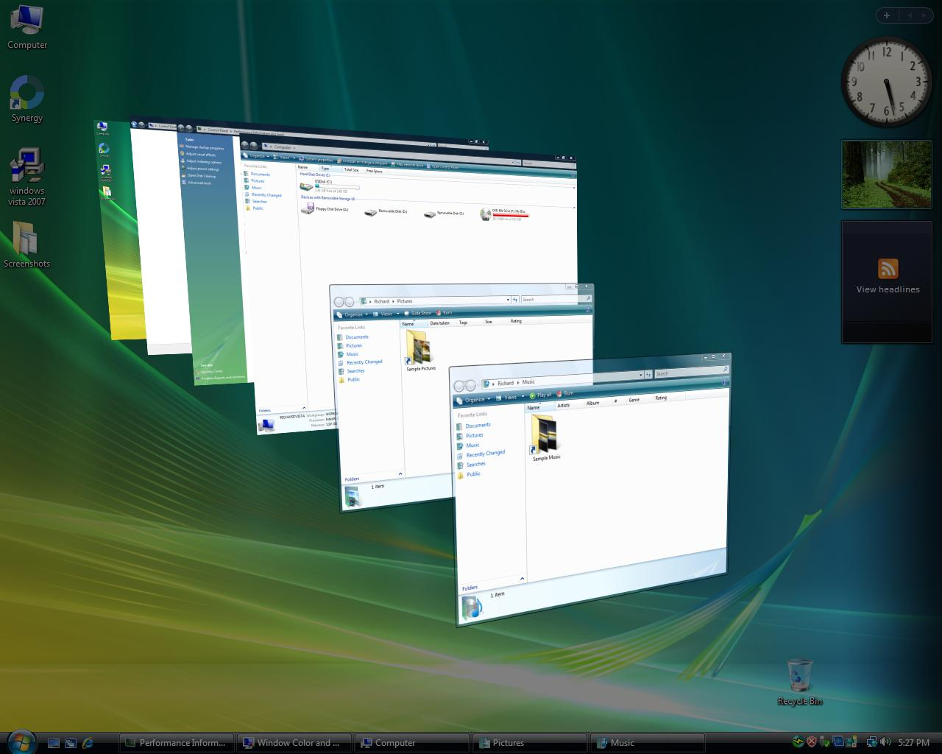
Figure 7 - Windows Flip 3D (WINKEY+TAB)

4.3.1.2 Windows Flip and Live Thumbnails

Windows Flip is the new look ALT-TAB, providing live previews of running applications. Windows Flip however does not work on a system that does not have Aero enabled. On an “Aero-less” system, the user only sees the normal ALT-TAB as it is in Windows XP.
Live Thumbnails is another step up in dynamic information display. One no longer has to restore a window from the task bar in order to see its contents. When a user rests the mouse over an application on the task bar, dynamic content of that window is displayed. Like Windows Flip and Windows Flip 3D, Aero needs to be enabled on the system before one can gain access to this feature.
Below is a screenshot of Windows Flip and Live Thumbnails respectively:
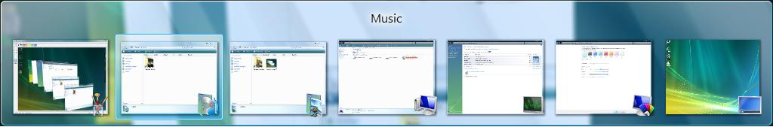
Figure 8 - Windows Flip (ALT+TAB)

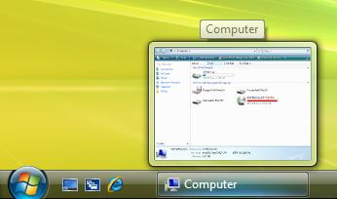
Figure 9 - Windows Live Thumbnails

Windows Flip and Windows Live Thumbnails add to the user experience in the sense that, one no longer has to open a window in order to see its contents. Simply move your mouse over it on the taskbar to display the current contents of the Window or ALT+TAB to see all windows’ content.

4.3.2 Explorer

The explorer interface has undergone a bit of a change as well, though in my opinion it’s nothing major. The first thing I noticed about explorer is the scalable folders. The folders can be scaled from the list view size (which is the default view for Vista) to massively enlarged folder icons.
Below are screenshots of the folder enlargements:
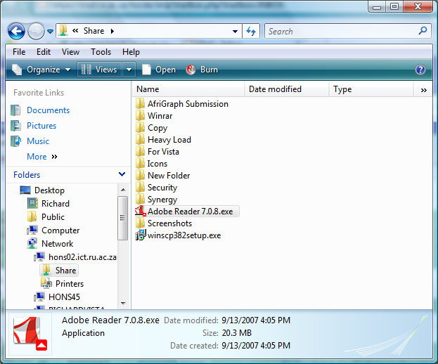 | 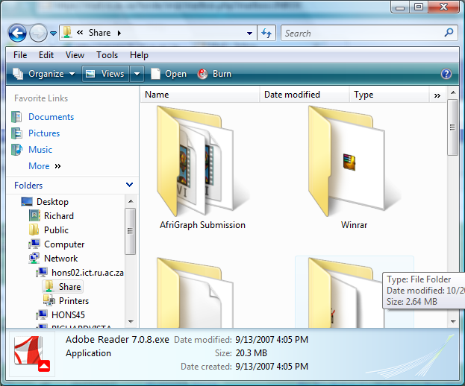
Figure 10 - Explorers different folder sizes

Another thing that caught my eye, and frustrated me a bit, was the missing menu bar on explorer. By default, the menu bar is hidden; something I believe is an absolute design disaster. The menu bar was one of the first things I looked for when I opened explorer, but to my shock, it was missing. After a minute or two of fiddling around, I was finally able to show it by right-clicking on the window toolbar and selecting “Menu bar”.
Another nice feature of the explorer interface is the new drive information that is immediately visible when “My Computer” is opened. Each drive is displayed along with a graphical indication of the drive capacity, space used, and space available. A blue bar is shown next the drive to show its capacity, except when the available space left on the drive falls below 15% of the drives capacity. When this is the case, the bar becomes red.
The diagram below shows the explorer interface:
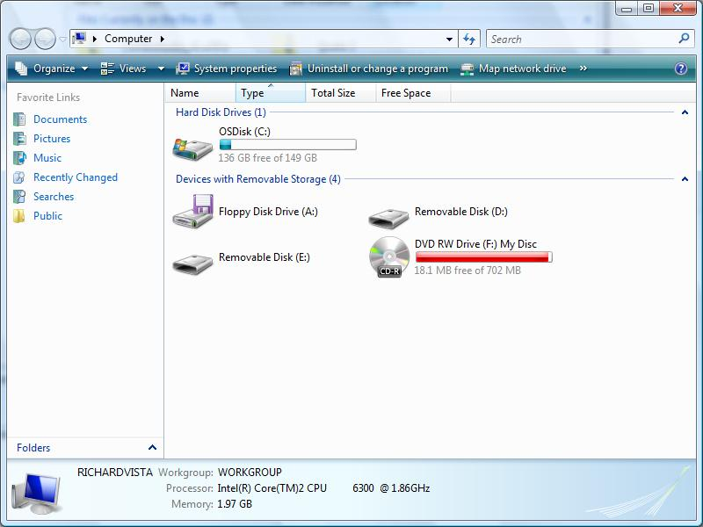
Figure 11 - Windows explorer's new look

Thom Helweda [2007] however does not agree with the new explorer interface. As far as he is concerned, there are a plethora of buttons everywhere on explorer which take time to figure out. His given example is the new sidebar on each folder window, which changes constantly between being a tree-view and a favourites menu. His argument, “…give a drop-down menu or tabs…so that you (the user) can select which of the two you want…” I find this a good argument because I also got slightly thrown off by the side bar being divided into two parts, each doing its own thing.
I think the new look explorer overall is quite elegant, stylish, and definitely does a good job of giving the user the option of scaling window icons. This certainly gives the user a much greater sense of control over their machine. The graphical display of the space available on any disk drive is a pro, but the menu bar that is hidden by default is a definite con in my book.

4.4 User Account Control

User Account (Access) Control (UAC) according to Microsoft TechNet [2007], is supposed to “…reduce the exposure and attack surface of the operating system by requiring that all users run in standard user mode.” UAC is a way of ensuring that users aren’t always running in administrator mode, which should help in limiting attacks on the operating system.
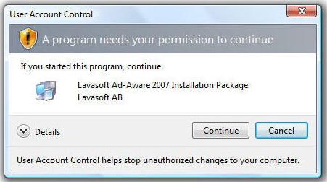
Figure 12 - User Account Control Dialog prompt for elevation

I was quite irritated with UAC right from the start. A clean install of Vista on any system usually means a user will be installing numerous applications within the first couple of days. In this period, I believe UAC will prove to be more of a nuisance than a security feature. I could not stand the constant prompts for elevation whenever I tried to install a new program. Fortunately, those like me that wish to disable UAC can do so through the security policy of Vista. I find the easiest way is to go to Start->Run and run “secpol.msc”. Select Local Policies and then Security Options in the right pane, and on the left pane, UAC options are at the bottom of the window.
Thomas Greene [2007] of The Register speaks well of the idea behind UAC but also finds it an irritation when a user, who is already running in administrator mode, is being constantly prompted for credentials.
As great a change as UAC introduces to the Windows operating systems, it is still not perfect according Neil McAlister [2007] of PC Advisor. According to McAlister, UAC still allows installers to run with full privilege, which is potentially dangerous. He also mentions that certain executables that ship with Vista can be used to exploit UAC but does not give any examples.
Paul Thurott [2007] urges users to tolerate the UACs constant prompts for credentials. Although it might be an irritation to most people at first, he says once the system has been configured and all programs installed, it becomes less of a nuisance. He believes UAC is an essential part of Vista’s “secure by design”.
The idea behind UAC is good, and both Greene and McAlister agree that it is a step in the right direction, but they also believe it could have been handled better by Microsoft. Thurott on the other hand seems to think UAC is a good idea and that users should not even think about disabling it. I believe if you are a user who does a lot of administrator work, or does simple things such as adding environmental variables often, UAC will turn out to be an interruption to the flow of activities on the computer.

4.5 Instant Search

Instant search allows a user to search for any document they want on their computer. By default, the instant search only indexes the “My Documents” folder of the current user. This can be extended by indexing all drives on the computer. This will then allow the user to search for any document anywhere on the computer. In order to change the indexing options, go to Start -> Control Panel -> Indexing Options. From there, the user can select which drives to add or remove as they see fit.

4.6 Shadow Copy

ShadowCopy is a feature that basically backs up files as a user works on them [Microsoft 7]. When a file is modified, ShadowCopy backs up the file and makes the backup available for the purposes of rolling-back to a previous version. However, in order for shadow copying to work, System Protection needs to be turned on. Once this is done, shadow copies of files are created each time the system creates a restore point. By default, this is done once a day. A simple right-click on a file or folder gives the option to “Restore previous version”, which brings up a window with all shadow copies made of the file.
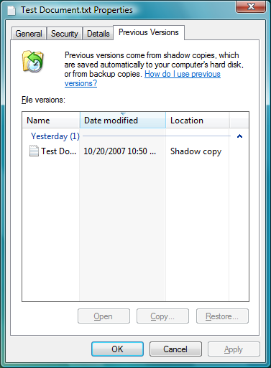 | Figure 13 - Shadow Copy  The diagram to the left shows the window that appears when one chooses to restore a file to a previous version. A list of all available versions is made available to the user showing when in time the shadow copy was made. The user can then select which version they wish to restore to. The user can choose to either over-write the existing file, or copy the shadow copy’s version to a new location.

Chapter summary

Vista comes with a host of new features, most of which improve the general usability of the operating system. Features such as SuperFetch and ShadowCopy definitely help improve the speed of accessing programs and backing up documents. Although you trade system RAM for the super fast startup of programs, it is a trade-off that I find is worth making. Some features such as file indexing and UAC I feel could have been done better by indexing the entire system drives as default, and having UAC recognizing when a user is in administrator mode and not constantly prompt for elevation. With all features considered, they definitely help improve usability and overall system performance

Chapter 5 – System Tests and Performance

One of the new features in Vista that makes it easier to use is the introduction of instant search in the Windows menu bar. With this search, any file, given that it’s not a protected operating system’s file, can be found through the search. This is achieved in Vista by indexing the drives available to the operating system. However, I expected the new indexing procedure to rather slow down Vista, at least in certain activities such as file copying, but lead to an increase in speed of other activities such as searching.
To perform the system tests, I made use of two programs, a program called HeavyLoad, which puts strain on the system, and another called Performance Test, which had methods of performing hard drive and memory tests. The workings of these tests are explained below.
The hard drive and memory tests were performed on both Windows XP and Vista so as to have some sort of benchmark for Vista.

5.1 System strain test

The strain tests were conducted with HeavyLoad which puts strain on all system resources, hard disks, system memory (RAM), central processing unit (CPU), operating system, etc. In order to stress the resources mentioned above, HeavyLoad writes a very large file to the temp folder (and keeps writing until it is stopped), it allocates physical and virtual memory, and it repeatedly draws Bezier patterns to the screen.
A screenshot of Heavy Load is given below, when not working on the left, and when working on the right:
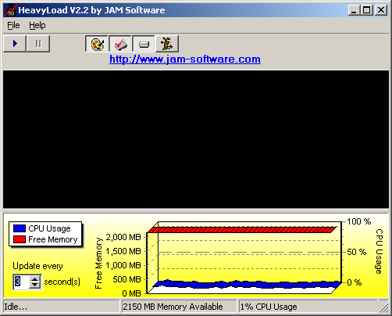 | 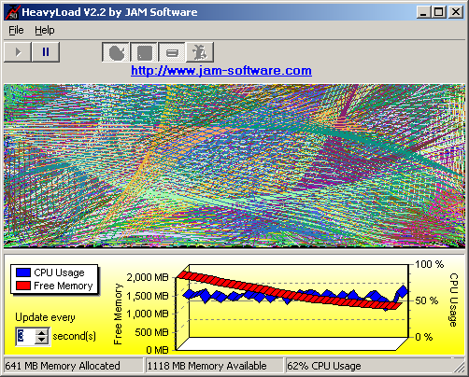
Figure 14 - HeavyLoad system strain program. Not working (left), working (right)

The graph just at the bottom end of the window shows memory and CPU usage whilst the program is running. The red ribbon shows RAM usage, and the blue ribbon shows the CPU usage.
The test is conducted, for each of the operating systems, over a period of 8 hours. After this time, whilst the program is still running, I try to use the system, and also try to use it immediately after Heavy Load is closed. Note, both the XP and Vista machines were running on computers that had the same hardware specifications.

5.1.1 Performances

After running HeavyLoad for approximately seven hours and thirty minutes, here is the screenshot of HeavyLoad from the Vista machine:
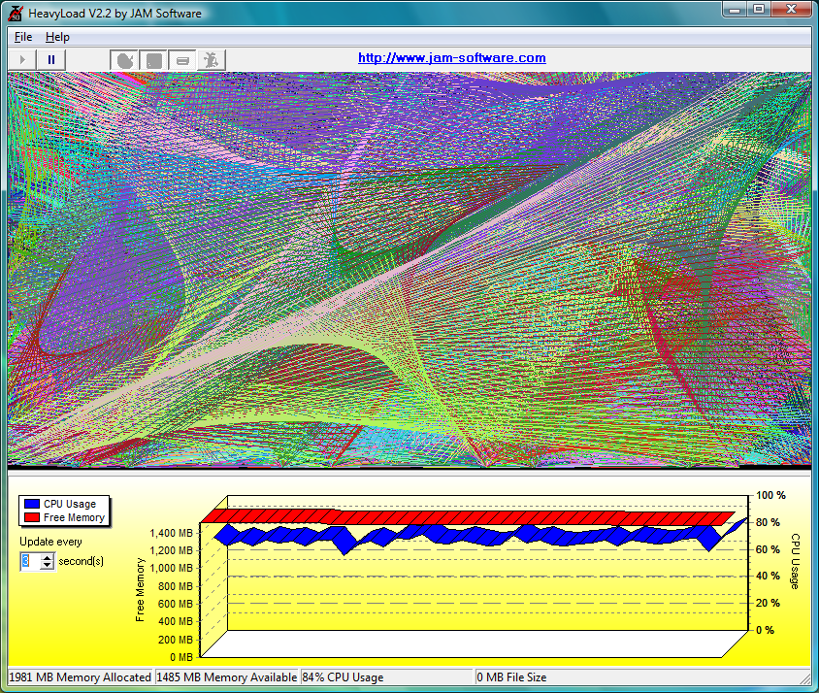
Figure 15 - HeavyLoad screenshot of Vista.

CPU usage (red ribbon) was almost at 100% but I could still use the computer without any delay. With HeavyLoad still running, I tried accessing my files, viewing documents, browsing the internet and even playing a couple of games (solitaire, chess titans, etc) and the responses were still very quick. Almost all physical memory had been taken up, which means almost all that I was doing was operating on virtual memory. Even when running other applications, memory was not reclaimed from HeavyLoad. An instant search preformed using the search in the start menu yielded results almost instantly.
After the same amount of time running HeavyLoad on XP, here’s the screenshot of the whole screen:
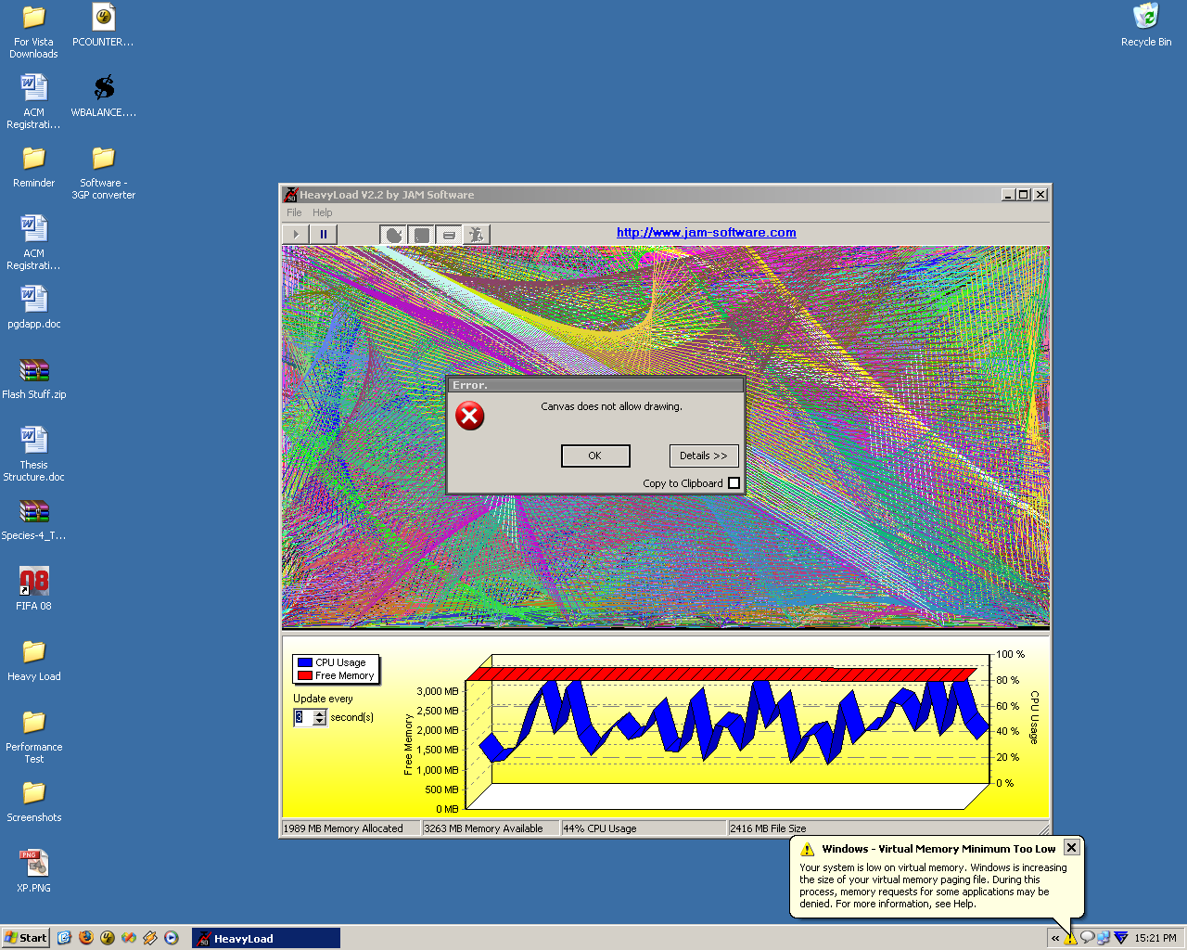
Figure 16 - HeavyLoad on Windows XP

Windows XP had run out of virtual memory (the balloon popup at the bottom right corner) and a window drawing error had been encountered. Despite these problems however, I was still able to use XP just fine. Initial lag was experienced when I tried to open other applications, but after a while, usage felt almost normal. I then performed a search for a file located in the same directory hierarchy as the Vista machine, but the search took longer than Vista to yield its results.
Even under considerable system strain, both operating systems still appeared to hold their own in terms of usage. Whether or not Vista ran out of virtual memory as well and decided not to notify me about it, I don’t know. But XP did. This leads me to draw the conclusion that Vista’s memory management is better than that of XP since it still managed to operate fine without having to give up all of its virtual memory.

5.2 Hard drive Tests

The hard drive tests were conducted using a program known as PassMark’s Performance Test. The test works by performing three tasks on the hard disk. Firstly, it conducts a disk sequential read by creating a large test file and reading the file sequentially from start to end. Secondly, it performs a disk sequential write in a large file which is written to disk sequentially from start to end. Lastly, it does a disk random seek read and write in which another large file is created on disk and then randomly read. This is achieved by performing a “seek” in which a random position is selected in the file and a 64KB block is either read or written.
The test was run five times on both the Vista machine and the XP machines and the results of the final test were taken to be concrete. The following figures show the results from both operating systems:
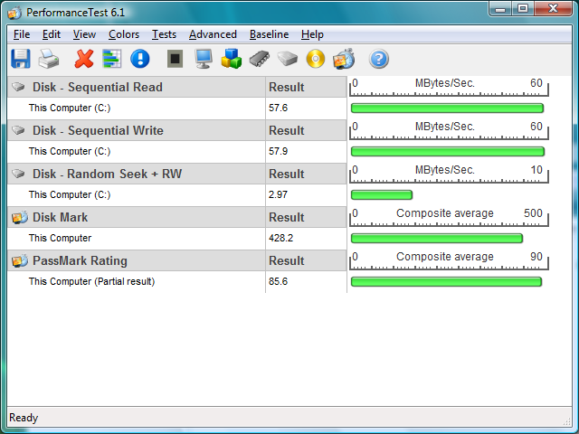
Figure 17 - Vista hard drive performance test

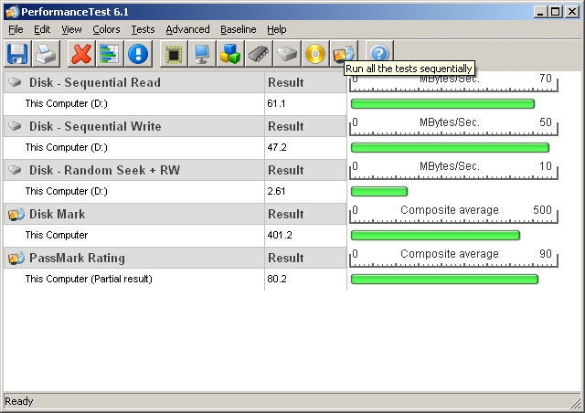
Figure 18 - XP hard drive performance test

As mentioned earlier, both XP and Vista were running on computers that had exactly the same system specifications. However, the XP machine performed all tasks faster than the Vista machine except the sequential write. From the above results, I can only assume that file access is slower on Vista than it is on XP. But with the new file indexing system of Vista, one would expect file access to be quicker.

5.2.1 Searching

Searching was a bit hard to put a time to since XP only searches after the entire search string has been entered. Vista on the other hand searches as the user types. I found this “search as you type” style of Vista to be extremely quick and effective. In a sense, this makes Vista considerably faster than XP. By the time a user finishes typing, it takes no more than a second or two for Vista to present its search results, XP would however only now have been starting the search. The search is over the index file Vista creates of the drives, another thing making the search very fast.

5.2.2 File Copying

The file copying test was performed in two ways, one on a public network to which there are thousands of other machines connected, and another to which I connected only the computer in testing and the server housing the files to be copied. The latter scenario allowed me to test the speed of each machine on a network that had no traffic other than the one being generated by the server and the machine under testing. The former scenario allowed assessment of the machines when there is a lot of noise on the network. In each case, the time taken to copy the files was noted and recorded. I wrote a simple C# program that allowed me to copy files and time how long it took to copy them. The source code can be found attached as Appendix 3.
As with the previous tests, both the Vista and the XP machines were tested, and in each test case, the copying of the files was done three times and the average was taken as the time for that machine in that particular test scenario.

5.2.2.1 Public network

In the following test, each of the machines was connected to my institutions student network and a single public server was accessed for file copying. In the first copy test case, a single folder of size 747 MB, containing 47 (45 visible, 2 hidden) files of various sizes was copied from the server to my test machines. The copy tests were conducted three times on three different days of the week (Monday, Thursday and Saturday). On each day, the copying was done in the morning between 9am and 10am, afternoon between 1pm and 2pm, and finally evening between 5pm and 6pm. The results of each test for each day were averaged out and results were obtained. The results for both the XP and Vista machine are plotted on the graph below:
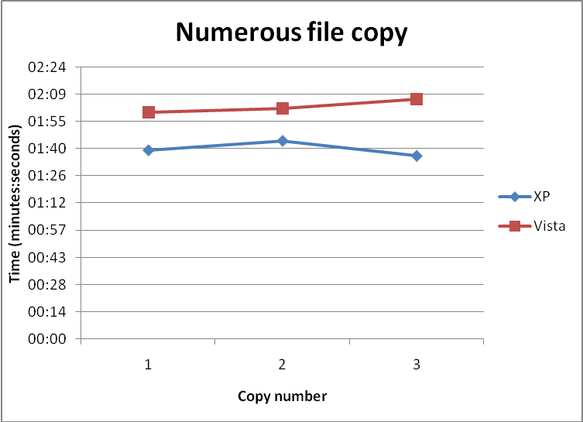
Figure 19 - Numerous file copy results

On all three copy attempts, the XP machine outperformed the Vista machine. This result could be partly related to the file indexing present in Vista. If files being copied are being copied to folders which are indexed, it’s then possible this will slow things down.
For my second test case, I copied a single large file (4.4 GB) from the same server to my test machines. The results of the copy are graphed below:
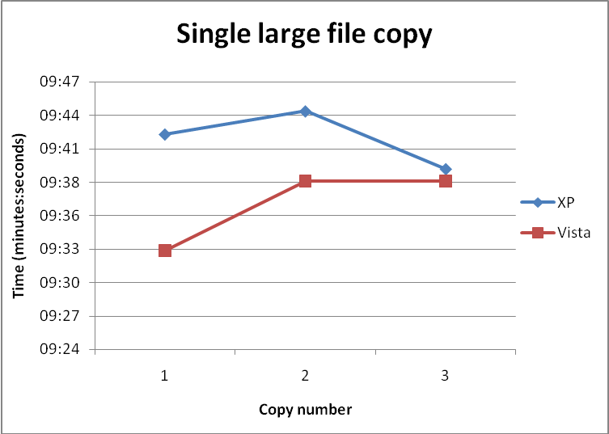
Figure 20 - Single large file copy results

The single large file was copied faster by the Vista machine than the XP one. My suspicion is that there is less indexing happening with a single file, thus decreasing the copying time.
From the above graphs, there isn’t that great a difference when it comes to file access across a network. In the graphs, there were times when the network was quite congested, leading to increases in the time taken to retrieve files for both the XP machine and the Vista one.

5.2.2.2 Two-machined network

In this test case, a domain was setup with a Windows Server 2003 box serving as the machine hosting the files to be copied. The network was achieved through the use of a four port D-link Broadband VPN Router. The machine in testing, both the XP or Vista machine, was connected to the network, and the files were copied from the server to the machine in testing. As with the previous test, two methods of copying were evaluated.
The first test saw the copying of the 747 MB folder consisting of 47 files. The results attained for the tests were considerably deceiving. Each machine took over an hour and a half to copy the files. This I attributed to the router I was using. Overall, there was only a couple of seconds between the XP machine and the Vista machine, with XP copying the files in 1hr33min27sec, whilst Vista achieved 1hr33min40sec.
The second test had me copying the large file (4.4 GB) from the Server 2003 box to the testing machine. This time, each machine took about 3 hours to copy with Vista copying the file about a minute and a half faster than the XP machine.
On average, across all copying tests conducted, there wasn’t that great a difference between the two operating systems.

5.3 Memory Tests

The memory tests were conducted using the program Performance Test, the same program used to conduct the hard drive tests. The program performs the following five tests on system memory:
- Allocate small block – this measures the time taken to allocate and free small zeroed memory blocks around 100KB in size)
- Cached – measures the time take to read a small chunk of memory small enough to be held in cache.
- Un-cached – measures the time taken to read a large block of memory too big to store in cache.
- Write – measures the time taken to write information to memory.
- Large RAM – measures the time taken to allocate large amounts of RAM and the time taken to read this RAM
The tests were ran on both the XP and Vista machines and compared with each other. The screenshots below show the output of the test program on both machines:
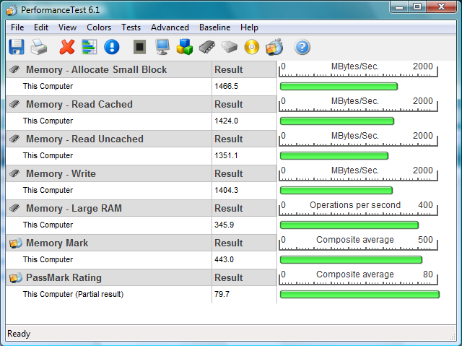
Figure 21 - Vista memory test results
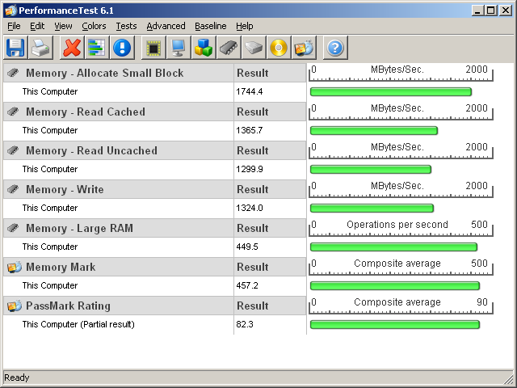
Figure 22 - XP memory tests results

From the above results, it would appear as though memory management in XP is better than Vista since the test program is able to read and write to and from memory faster on XP than on Vista. However, I believe the reason this is the case is based entirely on the SuperFetch memory system in Vista. Since programs are now constantly kept in memory, it would mean that less memory would be available to other requesting programs, such as the test program. In this case, it will probably not be able to get as much memory on Vista as it can on XP, highlighting an earlier mentioned point regarding applications not used often taking longer to start.

5.4 Defragmentation

Defragmentation in Vista has now been automated. The defragmenter now runs, by default, once every week at a time that should be undisruptive to most users. Users can still run it manually at any time. What is notably different is the absence of the graphical display of the level of fragmentation on the disks. Considering that the defragmenter runs as often as it does, it’s highly unlikely that disks will be fragmented and hence the change in the defragmenter interface.

Chapter Summary

Vista handles system strain quite well from the tests I conducted. Even under heavy CPU load and running out of physical memory, I was able to use it without any glitches. A couple of lags were initially experienced, but these quickly faded away. It would appear that the new memory management of Vista allows it to use virtual memory considerably better than XP. However, the new memory management system slows memory access according to the results obtained from running Performance Test. The difference between XP and Vista was not by much, a difference that I think can be tolerated.

Chapter 6 –Compatibility Tests

The compatibility tests take a look at some applications used and what problems were encountered whilst using these applications, if any. In the case of the Office suite tests, each was run for approximately three months on each machine, XP and Vista, used on a near daily basis in order to identify any compatibility issues that may have arisen.

6.1 Office 2003 and 2007

This test did not involve anything that would purposely crash or cause problems for Office. I simply used the application as I would on any other computer, creating documents, formatting text, creating tables, etc.
After running Office 2003 for about three months, I was quite content with its performance. In that time, I never experienced a single system crash, blue screen, or have any compatibility issues.
Office 2007 offered me the same level of performance as Office 2003.
Fears of Office 2003 not running on Vista are all misplaced, as both the office suites work well with Vista as they do with XP. Does one perform better on Vista? It doesn’t look that way to me. Both suites performed quite well.

6.2 Drivers

There has been fear that many applications will not be compatible with Vista. As a result, Microsoft released an applications compatibility update which addresses these compatibility issues [Microsoft Help and Support 1, 2007]. In the article about the compatibility update, Microsoft lists numerous programs, games and firmware that are now supported by Vista. In the same article, Microsoft mentions issues that may arise after the installation of the compatibility update, issues such as CD or DVD devices not working. A link is provided in the article to a possible solution to the problem. According to the article, this problem arises due to a legacy application installing drivers that are incompatible with Vista.
After installing Vista, I found that numerous updates had been downloaded and installed. A restart of the system (which was compulsory after the update) had my system up and running with no problems. Vista comes with a pretty large drivers’ database. The relevant drivers are indentified and installed during system configuration. If a driver is not found in the database, Vista automatically connects to the internet, downloads the relevant driver, and automatically installs and configures it.
I found that the problem with driver issues arose when I installed Vista on a machine that was not connected to the internet. The sound drivers for the machine I had installed Vista on were not in the pre-pack Vista driver database. As a result, I was without sound. However, after connecting the machine to the internet, I found myself being prompted for a restart after updates had had been downloaded and installed. Upon restarting, my audio was working just fine.
That’s not to say Vista will always find compatible drivers for every machine. On my test machine, it appeared as though audio drivers had been installed immediately after installation. However, sound was not coming through. I had to manually install the drivers on the drivers CD before the problem was resolved. It appears as though there are generic drivers for certain model sound cards, e.g. Intel cards of a certain make, however, the motherboard driver CD will have a version of that driver that is specific to that card. Unfortunately, Vista does not seem to determine this. In such a situation, the onus falls on the user to install the appropriate driver.

6.3 Games

Gaming is one of the most important things when it comes to computers in my opinion, and if I am going to be using Vista on a daily basis, I thought it would only be fair to try out some of my favourite games and see how they perform on the new DirectX 10. I have on my system an Intel onboard 128 MB DirectX 9 graphics card. I am making the assumption that most gamers out there will have a graphics card with roughly these same specifications.
The games I tested on the system were Doom 3, Unreal Tournament 2004, Quake 3 and FIFA 08. Doom 3 is known for its high system requirements released before Vista, whilst FIFA 08 has relatively low system requirements but was released after Vista. I chose the above games to test based on their differences such as one requiring high performance hardware (Doom 3), others being dependent on languages such as OpenGL (Quake 3), and one being fairly new (FIFA 08).

Doom 3
Doom was the first game I tried out, and low and behold, I came across problems. When I ran the game, there were no textures in the world or on the characters. Originally I thought it was because of OpenGL being dropped from Vista, but then I realized it couldn’t have been since Quake 3 (an OpenGL based game) is able to run perfectly fine. I then installed the game on a separate Vista machine, still with the same system specifications, but this time, the machine had an nVidia 6600GT AGP card. Needless to say, the game ran just fine leading me to the conclusion that the initial problems experienced were not attributed to Vista, but rather to the graphics card I had onboard.

Quake 3
Quake was the second game to be tested. This one worked just fine. It had wonderful response times, I didn’t have to turn down the video resolution or disable any features. It played just as well as it had on the XP machine.

Unreal Tournament 2004
This game played very well on Vista. In fact, it played considerably better than it did on Windows XP. When ran on the XP machine with the specifications mentioned at the beginning of this paper, it lags and runs at a low frame rate. However, when ran on Vista, it performed considerably better, no lagging, and it ran at a much higher frame rate.

FIFA 08
FIFA 08 was released less than a month ago (October), ten months after Vista was released. Playing it on XP was smooth and welcoming. On Vista however, it lagged. Not too much, but noticeable when compared with XP.

On average it looks like most games will work fine on Vista.

Chapter summary

The Office Suites are definitely compatible with Vista, both 2003 and 2007. In terms of one being better than the other on Vista, it is hard to say. After running them both for roughly three months each, I found no problems or differences in performance of either on the XP and Vista machine. I didn’t come across any driver compatibility issue when installing device drivers on Vista. As mentioned earlier, the only problems that were experienced were on the machine that did not have internet access. In most cases, users with internet connections will be better off than those without. From the games tested, it would appear the new DirectX is a friendly environment for gaming.

Chapter 7 – Vista Deployment

The deployment tests were conducted in order to determine Vista’s ability to be deployed on a large scale from a single source. Currently, the most popular way of large scale deployment is through the use of GHOST. GHOST was used to deploy Vista and attempts were made using Microsoft’s ImageX. The aim was to create a single install image in both test cases and then deploy the image to 49 other machines on the network.

7.1 GHOST

GHOST allows a user to create an image of an existing operating system and deploy that image to all other machines that boot off a common network. GHOST is sector based, meaning it creates a mirror image of the hard drive on which the operating system resides. This image can then be stored on a server and then multi-casted to other machines.

7.1.1 Creating the Vista image

I installed Vista Business on my test machine, along with some common software often available in a tertiary institution’s computer laboratory such as Microsoft Office, Mozilla Firefox, IDEs and Text Editors.
After installation (operating system and chosen software applications) I created an image of my hard drive and placed the image on a server ready for deployment.

7.1.2 Machine setup for Ghosting

49 machines were setup to have Vista deployed to them in order to mimic a computer laboratory situation. The machines had the following specifications:
- Intel Pentium 4 3.0GHz processors
- 1024 MB system memory
- 80 GIG hard drives
- 128 MB onboard Intel graphics cards
But during deployment, some problems were encountered with the machines not being able to establish connections with ICTDUMP, the multicasting server. This error was as a result of changes that had been introduced to the boot manager in Windows Vista.
Previously, Windows boot configuration was stored in a file called boot.ini. In Windows Vista, this has been changed to the Boot Configuration Data Editor (bcdedit.exe) according to Microsoft TechNet 2 [2007]. According to TechNet, the Boot Configuration Data store contains boot configuration parameters and controls how the operating system is started. The bcdedit.exe command tool can also be used to affect the code that runs during the pre-operating system environment to the extent that you can specify which operating system to boot from which partition.
In order to rectify the error encountered earlier, the following commands obtained from Microsoft’s forums [Microsoft Forums 2007] had to be executed in the command prompt (as administrator) on the machine that is about to imaged, basically modifying the Boot Configuration Data:
Enter bcdedit /set {bootmgr} device boot
Enter bcdedit /set {default} device boot
Enter bcdedit /set {default} osdevice boot
Once complete, the machine was ready to be imaged.

7.1.3 Deployment

Two methods of deployment were tested; one in which the ghosting was done on a one-to-one basis, and the second in a laboratory situation.
I connected a machine with exactly the same system specifications as the one from which the image was created to my network and booted it up. The image was picked up immediately, as was expected and as is the case with XP. An hour or so later, Vista was now on my test machine, exactly as it was on my original image machine.
For my second deployment test case, I connected 49 other machines to the setup network and proceeded to booting them up. However, the image originally created was too large for the newly added 49 computers which were housing 80 GIG hard drives as opposed to the 150 GIG that was present on my image machine, understandably so since Ghost is a sector based program. This meant I had to install Vista and the necessary software applications on one of the 49 machines, and create the image from that. I went ahead, installed Vista, and created the image.
I rebooted the remaining 48 machines and waited for the image to finish loading. 30 minutes after the image load had started; there was an error on all the monitors complaining of a recent hardware or software upgrade that might be causing a problem. Unable to determine the exact cause of the problem, I assumed it to be attributed to the software that I had installed on the image. Once I again, I re-installed Vista, only this time, I left out the software applications.
The image was re-created and prepped for deployment. However, another problem of machines having the same names came up. This issue was easily resolved by making use of a tool known as wsname.exe. This program simply takes a name via the command prompt and changes it for every other machine using the DNS server on the network.
With the above mentioned problems now sorted out, I rebooted one machine to test out the process. It was a success. The image was picked up, and the machine had a unique name. The remaining 47 machines were then rebooted. Each picked up the image from the server successfully.
I then recreated the image with all the above mentioned software installed, placed it on the server, and rebooted the other machines. This time, the image was picked up successfully.
Other than the changes to the Vista boot manger (bcdedit.exe), it is relatively easy to deploy Vista using Ghost. Once the image machine has been prepped with the commands mentioned earlier, it is smooth sailing thereafter.

7.2 ImageX

“ImageX is a command-line tool that enables original equipment manufacturers (OEMs) and corporations to capture, modify, and apply file-based disk images for rapid deployment.” According Microsoft TechNet 2 [2007].
Unlike Ghost, ImageX is a file based program and not sector based. As a result, an image created using ImageX can be modified, new programs added or removed, without having to re-image the entire hard drive. Another advantage of ImageX is that it allows an image to be deployed to hard disks of any size, given that you have sufficient space for the image. The hard drives no longer have to have the same hardware abstraction layer as the master computer.

7.2.1 Creating the install image

There are two ways in which the image can be created, by either using the command-line of the ImageX program, or using the graphical interface of the Business Desktop Deployment (BDD). I used the BDD method of doing it to create the install image. With this approach, everything is done in a graphical environment, selecting components to add to the image.

7.2.2 Deployment

With the install image now sitting on the server, I connected a machine to the network and booted it up. The image was picked up from the server and then loaded onto the machine. The image on the server, which was .wim file, was copied and then expanded. As with normal installation, system configuration then took place.
The problem encountered however was related to machines automatically picking the image, that is, the machine would not pick up the image from the server without my explicit permission like GHOST did. This is supposed to be possible, but I was unable to achieve this.

Chapter summary

The changes made to the boot manager of Vista do introduce an element of change when it comes to deployment. However, these are not major stumbling blocks. Also, the introduction of bcdedit.exe, gives people more control over the boot up configuration of the operating system. Deployment with existing tools such as GHOST works perfectly fine, with necessary changes having been made to bcdedit.exe. ImageX introduces a new file based deployment scheme that allows install images to be created from any size hard disk and still be deployed to other machines that have different hard disk sizes. The ability to create the images using either a command line approach or a graphical user interface makes it slightly easier for lots of people to do it. The advanced IT technicians can go with the command line approach which gives them lots of control, whilst new users can use the GUI approach provided by BDD.

Chapter 8 – Conclusions

There are quite a number of new features introduced in Vista that make it a pleasure to work with. Features such as SuperFetch, Aero, etc, make using a Vista machine quite nice. However, most users want to use a computer to get their work done, play a game or two once in a while, browse the Internet here and there and probably nothing more. After a week of enjoying the stylish interface that Aero introduces, one tends to forget about it and get on with their work.
The various editions that Vista comes in are both a pro and con of the operating system. As an IT professional, this will most likely be welcomed since they can purchase the one that bests suites their needs. They do not have to acquire the top of the range, Vista Ultimate, in order to gain access to networking capabilities. The home user who probably does not need all the networking features and encryption technologies does not have to waste a lot of money on Vista Business or Vista Ultimate, but can purchase an edition such as Home Basic or Home Premium. On the other hand, the various editions also serve as a con to Vista. The “lay-man” will probably not know which edition to purchase. As far as they are concerned, they simply want an operating system on which they can perform their simple daily tasks.
As it stands, I don’t see a real “killer application” for Vista that will force people to buy it. Other than Aero, I see no reason why one should rush out and purchase Vista. Like I mentioned earlier, Aero does become obsolete after a while of using Vista. The user simply forgets it’s even there. DirectX10 however could turn out to be a major selling point for Vista in the near future. As game development companies start to take advantage of the DirectX10 capabilities, we could see game lovers running out to purchase Vista simply in response to being able to play their favourite games. However, I don’t see this happening anytime within the next year or two.
One of the more important security features introduced to Vista I think is BitLocker Drive Encryption. However, such security is not necessary for the home user, which Microsoft wisely left out of the Home Editions. Vista Ultimate and Vista Enterprise are the editions housing this technology. However, there are numerous hard drive encryption software applications out there that can encrypt data on ones XP machine. Most of these software applications have been design for the sole purpose of encryption, a purpose that in my opinion might make these applications better than an in-built encryption feature.
To conclude, I think that Windows XP still does what it’s supposed to do. With the release of a service pack three just around the corner, XP is only set to get better.

Chapter 9 – Possible Extensions

Possible extensions to my project is to perform some more tests on some of Vista’s new features including BitLocker Drive Encryption as well Network Access Protection. Each of these features is a security improvement and can form a nice area of considerable study.
Some extensive domain tests can be conducted between Vista and Server 2003, as well as the upcoming Longhorn.
More tools can be obtained to try and test out Vista’s new memory management, hard drive indexing and the new file handling system of Vista.
ImageX can be looked at in more detail to try and deploy operating system images created. One can try and have the image automatically deployed to every client that connects to the network.
Some more rigorous system tests can be conducted to try and put the operating system under more strain and monitoring how it reacts under various situations.

References

Adrian Kingsley-Hughes. Is Vista’s Windows Experience Index fatally flawed? Available: [http://blogs.zdnet.com/hardware/?p=37]. Date accessed: 21 June 2007.

Brien M. Posey. How Vista will interact with Longhorn Server. Available: [http://www.windowsnetworking.com/articles_tutorials/Vista-interact-Longhorn-Server.html] Date accessed: 23 June 2007.

Danielle Reust and Nelson Reust. Deploy Vista with a ‘Thin’ System Image. Available:[http://itmanagement.earthweb.com/article.php/3675806]. Date accessed: 21 June 2007.

Ed Bott, 2007. Is your flash drive fast enough for Vista’s ReadyBoost?. Available: [http://blogs.zdnet.com/Bott/?p=186]. Date accessed: 14 October 2007.

Faud Abazovic, 2006. Memory upgrade slows Vista right down. Available: [http://www.theinquirer.net/default.aspx?article=35078]. Date accessed: 21 June 2007.

Gregg Keizer, 2007. Vista & Office 2007 drive Microsoft profits. Available: [http://www.pcadvisor.co.uk/news/index.cfm?NewsID=9160]. Date accessed: 21 June 2007.

Jem Matzan, 2007. Windows Vista Review. Available: [http://www.softwareinreview.com/cms/content/view/77]. Date accessed: 20 June 2007.

Jerry Honeycutt, 2007. ImageX and WIM Image Format. Available: [http://technet.microsoft.com/en-us/windowsVista/aa905116.aspx]. Date accessed: 9 October 2007.

Jonathan Hassell. Windows Vista and Longhorn Server. How they work better together. Available: [http://www.computerworld.com/action/article.do?command=viewArticleBasic&articleId=9005689]. Date accessed: 23 June 2007.

Loyd Case, 2006. USB Flash Memory for Windows Vista ReadyBoost. Available: [http://www.extremetech.com/article2/0,1697,2017817,00.asp]. Date accessed: 12 April 2006.

Marc Wagner. So what’s wrong with Windows Vista Home Basic? Available: [http://blogs.zdnet.com/BTL/?p=4424]. Date accessed: 9 October 2007

Microsoft 1. Windows Vista Editions Overview. Available: [http://www.microsoft.com/windows/products/windowsVista/editions/default.mspx]. Date accessed: 12 May 2007.

Microsoft 2. The Editions. Available: [http://www.microsoft.com/windows/products/windowsVista/editions/choose.mspx]. Date accessed: 20 May 2007.

Microsoft 3. Windows Aero. Available: [http://www.microsoft.com/uk/windows/products/windowsVista/features/details/aero.mspx]. Date accessed: 20 May 2007.

Microsoft 4. System Requirements. Windows Vista recommended system requirements. Available: [http://www.microsoft.com/windows/products/windowsVista/editions/systemrequirements.mspx]. Date accessed: 20 May 2007.

Microsoft 5. Performance. Available: [http://www.microsoft.com/windows/products/windowsVista/features/details/performance.mspx]. Date accessed: 22 May 2007.

Microsoft 6. Windows ReadyBoost. Available: [http://www.microsoft.com/windows/products/windowsVista/features/details/readyboost.mspx]Date accessed: 21 May 2007.

Microsoft 7. Shadow Copy. Available: [http://www.microsoft.com/windows/products/windowsVista/features/details/shadowcopy.mspx]. Date accessed: 22 May 2007.

Microsoft 8. Microsoft Windows Vista Beta 1 fact sheet. Available: [http://www.microsoft.com/presspass/newsroom/winxp/VistaBeta1FS.mspx]. Date accessed: 8 October 2007

Microsoft 9. Windows Meeting Space. Available: [http://www.microsoft.com/windows/products/windowsVista/features/details/meetingspace.mspx]. Date accessed: 9 October 2007.

Microsoft 10. Windows Experience Index. Available: [http://www.microsoft.com/windows/products/windowsVista/buyorupgrade/experienceindex.mspx]. Date accessed: 23 March 2007.

Microsoft 11. The Editions. Available: [http://www.microsoft.com/windows/products/windowsVista/editions/default.mspx]. Date accessed: 15 May 2007.

Microsoft Forums, 2007. Vista and Symantec Ghost 8.x. Available: [http://forums.microsoft.com/MSDN/ShowPost.aspx?PostID=181082&SiteID=1]. Date accessed: 20 September 2007.

Microsoft Help and Support 1. March 2007 Windows Vista Applications Compatibility Update. Available: [http://support.microsoft.com/kb/932246]. Date accessed: 25 June 2007.

Microsoft Help and Support 2. The Windows Vista Application Compatibility Update. Available: [http://support.microsoft.com/kb/929427]. Date accessed: 25 June 2007.

Microsoft TechNet 2007. User Account Control Overview. Available: [http://technet.microsoft.com/en-us/windowsVista/aa906021.aspx]. Date accessed:21 June 2007.

Microsoft TechNet 2, 2007. What is ImageX? Available: [http://technet2.microsoft.com/WindowsVista/en/library/a8848521-b3ca-4c6c-81f0-6954f671cfe01033.mspx?mfr=true]. Date accessed: 20 August 2007.

Microsoft TechNet 3, 2007. Boot Configuration Editor Frequently Asked Questions. Available: [http://technet2.microsoft.com/WindowsVista/en/library/85cd5efe-c349-427c-b035-c2719d4af7781033.mspx?mfr=true]. Date accessed: 30 October 2007.

My Digital Life. Windows Vista Home Reviews and Comparisons. Available: [http://www.mydigitallife.info/2007/01/31/windows-Vista-home-basic-reviews-and-comparisons/]. Date accessed: 19 June 2007.

Neil McAlister. Is Vista’s security all it’s cracked up to be? Available: [http://www.pcadvisor.co.uk/news/index.cfm?NewsID=8806]. Date accessed: 21 June 2007.

Paul Thurott. Five Great Features of Vista RC1. Available: [http://www.winsupersite.com/showcase/winVista_rc1_best.asp]. Date accessed: 24 June 2007.

Paul Thurott. Windows Vista Feature Focus: Automatic Disk Defragmenter. Available: [http://www.winsupersite.com/showcase/winVista_ff_auto_defrag.asp]. Date accessed: 21 June 2007.

Richard G. Russell, 2006. Windows Vista System Requirements and WinSAT. Available: [download.microsoft.com/download/5/b/9/5b97017b-e28a-4bae-ba48-174cf47d23cd/CPA101_WH06.pptt]. Date accessed: 9 October 2007

Thom Holwerda. Review: Windows Vista Ultimate. Available: [http://www.osnews.com/story.php/16620/Review-Windows-Vista-Ultimate/]. Date accessed: 20 June 2007.

Thomas C Greene. Vista security overview: too little too late. Available: [http://www.theregister.co.uk/2007/02/20/Vista_security_oversold/]. Date accessed: 20 June 2007.

Appendices

Appendix 1 – WinSAT log file

211937 (3144) - winsat\main.cpp:2295: --- START 2007\10\18 0:47:19 AM ---
212875 (3144) - winsat\main.cpp:2567: > IsFormal=TRUE IsMoobe=TRUE.
212968 (3144) - winsat\main.cpp:1995: > DWM not running.
213015 (3144) - winsat\main.cpp:2051: > EMD device detected to be on. EMD will be restored on exit.
213046 (3144) - mlib\syspowertools.cpp:0872: > Read the active power scheme as '381b4222-f694-41f0-9685-ff5bb260df2e'
213093 (3144) - winsat\main.cpp:2108: > power policy saved.
213234 (3144) - mlib\syspowertools.cpp:0904: > Set the active power scheme to 8c5e7fda-e8bf-4a96-9a85-a6e23a8c635c'
213265 (3144) - winsat\main.cpp:2120: > power policy set to maximum.
214140 (3144) - winsat\main.cpp:2756: > IsOfficial=TRUE IsFormal=TRUE IsMoobe=TRUE RanOverTs=FALSE RanOnbatteries=FALSE
214218 (3144) - winsat\main.cpp:1161: > Running Assessment: features ''
261078 (3144) - winsat\main.cpp:1436: > Assessment completed
261109 (3144) - winsat\main.cpp:1161: > Running Assessment: graphicsformal ' -wddm'
262421 (3144) - winsat\main.cpp:1390: > DWM Assessment completed
262484 (3144) - winsat\processresults.cpp:2109: > Wrote video memory bandwidth to the registry 0
262546 (3144) - winsat\main.cpp:1408: > DWM Assessment results processing SUCCESS
262562 (3144) - winsat\main.cpp:1436: > Assessment completed
262562 (3144) - winsat\main.cpp:1161: > Running Assessment: media '-input {winsatencode.wmv} -encode {winsat.prx}'
273390 (3144) - winsat\main.cpp:1436: > Assessment completed
273437 (3144) - winsat\main.cpp:1161: > Running Assessment: moobego ''
273468 (3144) - winsat\main.cpp:1161: > Running Assessment: mfmedia '-input {winsat.wmv} -nopmp'
273484 (3144) - winsat\main.cpp:1243: > No D3D9 Support. Skipping media MF op
273500 (3144) - winsat\main.cpp:1161: > Running Assessment: cpu '-encryption'
284031 (3144) - winsat\main.cpp:1436: > Assessment completed
284046 (3144) - winsat\main.cpp:1161: > Running Assessment: cpu '-compression'
294234 (3144) - winsat\main.cpp:1436: > Assessment completed
294250 (3144) - winsat\main.cpp:1161: > Running Assessment: cpu '-encryption2'
304406 (3144) - winsat\main.cpp:1436: > Assessment completed
304421 (3144) - winsat\main.cpp:1161: > Running Assessment: cpu '-compression2'
314609 (3144) - winsat\main.cpp:1436: > Assessment completed
314625 (3144) - winsat\main.cpp:1161: > Running Assessment: mem ''
319765 (3144) - winsat\main.cpp:1436: > Assessment completed
319875 (3144) - winsat\main.cpp:1161: > Running Assessment: disk '-seq -read -n 0'
333250 (3144) - winsat\main.cpp:1436: > Assessment completed
333265 (3144) - winsat\main.cpp:1161: > Running Assessment: disk '-flush -n 0'
339359 (3144) - winsat\main.cpp:1430: > Assessment FAILED due to an error
339421 (3144) - winsat\processresults.cpp:0672: Total physical mem available to the OS : 1.97 GB (2,119,491,584 bytes)
339453 (3144) - winsat\processresults.cpp:0861: Limiting DWM Score to 1.0 - no DX9 capeability
339468 (3144) - winsat\processresults.cpp:0965: No DX9 capeability - limiting D3D Score to 1.0
339718 (3144) - mlib\syspowertools.cpp:0904: > Set the active power scheme to 381b4222-f694-41f0-9685-ff5bb260df2e'
339734 (3144) - winsat\main.cpp:2155: > Power state restored.
339750 (3144) - winsat\main.cpp:2171: > Successfully reenabled EMD.
339765 (3144) - winsat\main.cpp:2196: INFO: DwmpRestartComposition() did not return OK!
339890 (3144) - winsat\main.cpp:1752: > Finalized MOOBE key
339906 (3144) - winsat\main.cpp:3216: > exit value = 0.

Appendix 2 – Portion WinSAT XML file

<?xml version="1.0" encoding="UTF-16" ?>
- <WinSAT>
<Verbose>false</Verbose>
- <ProgramInfo>
<Name>WinSAT</Name>
<Version>V6.0 Build-6000</Version>
<Title>Windows System Assessment Tool</Title>
<ModulePath>C:\Windows\system32\winsat.exe</ModulePath>
- <CmdLine>
- <![CDATA[
"C:\Windows\system32\winsat.exe" formal -cancelevent d8f36d06-2ec5-4191-8609-12f1f5099fd8
]]>
</CmdLine>
- <Note>
- <![CDATA[
]]>
</Note>
</ProgramInfo>
- <WinSPR>
<SystemScore>3.8</SystemScore>
<MemoryScore>5.5</MemoryScore>
<CpuScore>4.9</CpuScore>
<CPUSubAggScore>4.7</CPUSubAggScore>
<VideoEncodeScore>4.9</VideoEncodeScore>
<GraphicsScore>3.9</GraphicsScore>
<GamingScore>3.8</GamingScore>
<DiskScore>5.6</DiskScore>
</WinSPR>
- <Metrics>
- <CPUMetrics>
<CompressionMetric units="MB/s">95.80872</CompressionMetric>
<EncryptionMetric units="MB/s">47.85275</EncryptionMetric>
<Compression2Metric units="MB/s">269.78885</Compression2Metric>
<Encryption2Metric units="MB/s">441.94385</Encryption2Metric>
<DshowEncodeTime units="s">7.97423</DshowEncodeTime>
</CPUMetrics>
- <MemoryMetrics>
<Bandwidth units="MB/s">4734.13818</Bandwidth>
</MemoryMetrics>
- <GamingMetrics>
<AlphaFps units="F/s">29.50000</AlphaFps>
<ALUFps units="F/s">19.63000</ALUFps>
<TexFps units="F/s">23.87000</TexFps>
</GamingMetrics>
- <GraphicsMetrics>
<DWMFps units="F/s">53.07670</DWMFps>
<VideoMemBandwidth units="MB/s">2808.65000</VideoMemBandwidth>
<MFVideoDecodeDur units="s">1.44291</MFVideoDecodeDur>
</GraphicsMetrics>
- <DiskMetrics>
<AvgThroughput units="MB/s">60.32917</AvgThroughput>
</DiskMetrics>
</Metrics>
<ExecDateTOD Friendly="Saturday October 20, 2007 5:18:18pm">732969:62298007</ExecDateTOD>
<IsOfficial>1</IsOfficial>
<IsFormal />
<RanOverTs>0</RanOverTs>
<RanOnBatteries>0</RanOnBatteries>
- <SystemConfig>
- <OSVersion>
<Major>6</Major>
<Minor>0</Minor>
<Build>6000</Build>
<ProductType>4</ProductType>
<ProductName>Windows Vista (TM) Enterprise</ProductName>
- <OSName>
- <![CDATA[
Windows Vista™ Enterprise
]]>
</OSName>
<BuildLab>6000.vista_gdr.070627-1500</BuildLab>
</OSVersion>
- <Platform>
<IsMobile>0</IsMobile>
<PlatformRole desc="Desktop">1</PlatformRole>
</Platform>

Appendix 3 – Copy Program Code

using System;
using System.Collections.Generic;
using System.ComponentModel;
using System.Data;
using System.Drawing;
using System.Text;
using System.Windows.Forms;
using System.IO;
using System.Threading;
public partial class Form1 : Form
{
private string[] files, folders;
private Thread thread;
private int copied = 0;
private bool copyInProgress, done;
private DateTime start, end;
private List<string> files2 = new List<string>();
private List<string> folders2 = new List<string>();

public Form1()
{
InitializeComponent();
}

/*
* populates listbox to show files to be copied
*/
private void FillListBox(List<string> f)
{
for (int i = 0; i < f.Count; i++)
{
int pos = f[i].LastIndexOf('\\');
listBoxFilesToCopy.Items.Add(f[i].Substring(pos + 1));
}
}

/*
* Note the start time of the copying and the end time. With this, we
* can get the difference and hence determine the time taken to copy
*/
private void CopyFiles()
{
start = DateTime.Now;

// copy all files
for (int i = 0; i < files2.Count; i++)
{
int pos = files2[i].LastIndexOf('\\');
File.Copy(files2[i], textBoxDestination.Text + "\\" + files2[i].Substring(pos + 1), true);
//string temp = listBoxFilesToCopy.Items[i].ToString();
copied++;
}
end = DateTime.Now;
TimeSpan diff = end - start;
MessageBox.Show("Copying complete. Time taken: " +
(diff.Minutes > 9 ? diff.Minutes.ToString() : ("0" + diff.Minutes.ToString())) + ":" +
(diff.Seconds > 9 ? diff.Seconds.ToString() : ("0" + diff.Seconds.ToString())));
done = true;
}

/*
* files source location
*/
private void button1_Click(object sender, EventArgs e)
{
FolderBrowserDialog fbd = new FolderBrowserDialog();
if (fbd.ShowDialog(this) == DialogResult.OK)
{
textBoxSource.Text = fbd.SelectedPath;
files = Directory.GetFiles(textBoxSource.Text);
folders = Directory.GetDirectories(textBoxSource.Text);
for (int i = 0; i < files.Length; i++)
files2.Add(files[i]);
for (int i = 0; i < folders.Length; i++)
folders2.Add(folders[i]);

// get all files in sub folders
for (int i = 0; i < folders2.Count; i++)
{
files = Directory.GetFiles(folders2[i]);
folders = Directory.GetDirectories(folders2[i]);
for (int j = 0; j < files.Length; j++)
files2.Add(files[j]);
for (int j = 0; j < folders.Length; j++)
folders2.Add(folders[j]);
}
FillListBox(files2);
items.Text = listBoxFilesToCopy.Items.Count.ToString();
}
}

/*
* copying destination
*/
private void button2_Click(object sender, EventArgs e)
{
FolderBrowserDialog fbd = new FolderBrowserDialog();
if (fbd.ShowDialog(this) == DialogResult.OK)
{
textBoxDestination.Text = fbd.SelectedPath;
}
}

/*
* Start the copying on its own thread so we can easily
* time its progress
*/
private void button4_Click(object sender, EventArgs e)
{
files = Directory.GetFiles(textBoxSource.Text);
thread = new Thread(new ThreadStart(CopyFiles));
thread.Start();
copyInProgress = true;
}

/*
* Timer to update the progress bar
*/
private void timer1_Tick(object sender, EventArgs e)
{
if (copyInProgress)
progressBar1.Value = copied * progressBar1.Maximum / listBoxFilesToCopy.Items.Count;

if (done)
{
progressBar1.Value = 0;
textBoxDestination.Clear();
textBoxSource.Clear();
listBoxFilesToCopy.Items.Clear();
files2.Clear();
folders2.Clear();
copyInProgress = false;
done = false;
}
}

/*
* Cancel the copying
*/
private void button5_Click(object sender, EventArgs e)
{
if (thread != null)
thread.Abort();
}

/*
* Exit application
*/
private void button6_Click(object sender, EventArgs e)
{
this.Close();
}
}

