Re-establishing and improving the experimental VoIP link with the University of Namibia: A Case Study

Submitted in partial fulfilment of requirements of the degree
Bachelor of Science (Honours) in Computer Science
at Rhodes University

R. M. Ngandu
Supervised By:
Alfredo Terzoli and Mosiuoa Tsietsi

November 2007

Acknowledgements

I would like to thank my supervisors Alfredo Terzoli and Mosiuoa Tsietsi for helping me jump over all obstacles to get me to the finish line. Special thanks to the Namibian connection Tuna Willem, Kauna Mufeti and Gardner Mwansa for supporting me throughout my project. I would especially like to thank University of Namibia and Polytechnic of Namibia for giving me full support in undertaking my project. I acknowledge the financial and technical support of this project of Telkom SA, Business Connexion, Comverse SA, Verso Technologies, Stortech, Tellabs, Amatole, Mars Technologies, Bright Ideas Projects 39 and THRIP through the Telkom Centre of Excellence at Rhodes University.

This thesis is dedicated to my family who has given me all their support and blessings.

Abstract

The sharing of ideas and information comes standard in any area of research. The need for voice communication to do this is relatively high. African universities are no exception to this but the main drawback is that voice communication comes at a price. With the help of the Internet and open source products we may no longer see voice communication costs as an obstacle. This thesis describes what needs to be considered and known for the successful deployment of voice over Internet Protocol between sites with differing network infrastructure and Internet connectivity. This thesis looks at the dynamics of how to manage voice and video communications between SIP agents across different countries. This thesis aims to be a blueprint for connecting African universities together via voice and video over IP on a data network.

Contents
Chapter 1 1
Introduction
1.1 Introduction 2
1.2 Problem Statement 3
1.3 The Solution 3
Chapter 2 5
Related Work
2.1 Introduction 6
2.2 Public Switched Telephone Network (PSTN) 6
2.2.1 PSTN Components 6
2.2.1.1 Voice Encoding 7
2.2.1.2 PSTN Switches 7
2.2.1.3 Private Branch Exchange (PBX) 7
2.2.1.4 Signalling 7
2.2.1.5 Legacy/Traditional Telephones 7
2.3 The Internet 8
2.3.1 Internet Connection Components 9
2.3.1.1 Internet Service Provider 9
2.3.1.2 Computer 9
2.4 Voice over Internet Protocol 10
2.4.1 VoIP Components 10
2.4.1.1 Voice Encoding 11
2.4.1.2 TCP/IP and VoIP protocols 11
2.4.1.3 IP telephony servers and PBXs 12
2.4.1.4 VoIP gateways and routers 13
2.4.1.5 IP Telephones 13
2.4.2 Asterisk 14
2.4.3 iLanga 14
2.5 Quality of Service 15
2.5.1 SIP vs. IAX 16
2.5.2 RTP 17
2.5.3 Codec and Transcoding 17
2.5.4 Traffic Shaping 18
2.6 VoIP in Africa 19
2.7 Conclusion 19
Chapter 3 20
The Test-bed and Initial Testing
3.1 Introduction 21
3.2 Site Internet Links 21
3.3 VoIP Network Test-bed 22
3.3.1 Test-bed Components and Configurations 23
3.3.1.1 Router Configurations 23
3.3.1.2 PC Configurations and Settings 25
3.3.1.3 Network Monitoring and Measuring Software 26
3.4 Analysis 26
3.4.1 Condition One 26
3.4.2 Condition Two 27
3.4.3 Tests Conducted 30
3.5 Results 31
3.6 Conclusion 36
Chapter 4 37
Real Life Implementation and Testing
4.1 iLanga Installation and Configuration at UNAM 38
4.1.1 IAX Configuration 38
4.1.2 SIP Configuration 40
4.1.3 RTP Configuration 42
4.1.4 Dialplan Configuration 42
4.2 Testing with UNAM and Polytechnic of Namibia 44
4.3 Conclusion 45
Chapter 5 47
Future Work and Conclusion
5.1 Summary 48
5.2 Conclusion 48
5.3 Future Work 49
References 50
Appendix A 53
A1. Cisco Router Basic Configuration 53
A2. Cisco Router Class Based Weighted Fair Queue Configuration 54

List of Figures

Figure 1: PSTN using SS7 (diagram adapted from: [8]) 8
Figure 2: Internet subscriber request process 9
Figure 3: SIP trapezoidal model (diagram adapted from: [17]) 12
Figure 4: VoIP network connected to PSTN (diagram adapted from: [8]) 14
Figure 5: Components of iLanga core 15
Figure 6: Project deployment of VoIP network 15
Figure 7: Traffic shaping between UNAM and ISP 18
Figure 8: RU daily Internet bandwidth utilization 22
Figure 9: UNAM daily Internet bandwidth utilization 22
Figure 10: Network Test-bed 23
Figure 11: Information rate without rate-limit command 24
Figure 12: Information rate with rate-limit command 25
Figure 13: FIFO Queuing (diagram adapted from: [27]) 27
Figure 14: CBWFQ process (diagram taken from: [34]) 28
Figure 15: FIFO with no network congestion 32
Figure 16: FIFO with network congestion 33
Figure 17: CBWFQ with no network congestion 34
Figure 18: CBWFQ with network congestion 35

List of Tables

Table 1: Codecs [11] 11
Table 2: Comparison between SIP and IAX [18], [19] 17
Table 3: Comparison between RU and UNAM 21
Table 4: Cisco router interface configurations 23
Table 5: Cisco Router bandwidth configuration 24
Table 6: PC NIC configurations 25
Table 7: CBWFQ class definition 28
Table 8: CBWFQ class mapping 29
Table 9: CBWFQ policy mapping 29
Table 10: CBWFQ activating a policy on an interface 30
Table 11: Summary of Analysis Results 35
Table 12: iax.conf configuration file at UNAM 39
Table 13: iax.conf configuration file at RU 39
Table 14: sip.conf configuration file at UNAM 41
Table 15: rtp.conf configuration file at UNAM 42
Table 16: extensions.conf configuration file at UNAM 43
Table 17: extensions.conf configuration file at RU 43
Table 18: Summary of call quality results 44

Chapter 1

Introduction

This chapter introduces the trends of modern day voice communication and gives a possible insight into why there is a noticeable shift within the voice communication market. At the end of this chapter the problem statement and solution will be explained.

1.1 Introduction
1.2 Problem Statement
1.3 The Solution

Introduction

The use of legacy Public Switched Telephone Networks (PSTNs) as a means of communication has spanned over more than a century and it is a worldwide phenomenon. The selling point used for PSTN is its five-9s (99.999%) reliability. In the last 60 years mobile telephony has carved its way and has become a dominant force in the communications industry. The selling point used for mobile telephony is that the handsets are portable. These two communication means may be adequate but are costly and this is especially so in the African context. The introduction of Voice over Internet Protocol (VoIP) in the mid-1990s added a new dimension to the communications market. The use of VoIP has grown from a small scale market penetration to becoming a trend setter [28]. The reason for its popularity is based on its cost, value added services, and ease of deployment. A key aspect about VoIP is that it can run on a data network. Theoretically all you need is an Internet connection and a VoIP ready device.

A major issue that VoIP has to deal with is to achieve a consistent reliability. Factors such as unreliable networks and software bugs cause inconsistent reliability. As VoIP grows in demand reliability overshadows cost. Users want to be assured that their communication tools are always available for use. A recent case in point brings this to light. In August 2007 Skype experienced a communication downtime of about two days and this lead to a loss in reputation amongst existing and future users [24]. To penetrate further into the communications market VoIP should be secure, reliable and be more than just a voice communications device.

Traditionally voice and data were channelled on separate lines but modern day trends have created a point of convergence that brings together voice, video and data. This convergence is commonly termed as triple play [29]. The question that arises from all of this is how can we all benefit from this modern trend in technology? In most African countries the Internet is still viewed as a luxury, but this luxury can yield a high rate of return on investment if used to its full potential. VoIP taps into this wide ranging potential of uses of the Internet. This thesis looks into how best to implement VoIP under conditions of limited Internet bandwidth and networks with high rates of congestion. This thesis strives to be a blue print that introduces VoIP into a data network.

Problem Statement

Internet access is readily available in most tertiary education institutions in Africa. Depending on financial and infrastructure factors the rate and service of the Internet varies in all institutions. This project focuses on two countries namely South Africa and Namibia. Through national investment South Africa has a direct connection to the SAT-3 international submarine cable and this affords users a cheaper supply of international bandwidth compared to Namibia. Through an agreement with Telkom South Africa, Namibia has access to SAT-3. This indirect connection to SAT-3 increases the cost of international bandwidth supplied to users in Namibia [36]. The amount of available Internet bandwidth in the two countries differs greatly and this is evident within educational institutions. Rhodes University (RU) has a 12 224 Kbps Internet connection whereas the University of Namibia (UNAM) has a 1 024 Kbps Internet connection.

In 2005, there was an attempt to establish the RU-UNAM VoIP link but this link was not reliable due to a high packet loss rate which was caused by a poor network traffic policy. This project was launched to try and re-establish the link, so as to build and sustain reliable communication between RU and UNAM. We hope that this initial link will cause a ripple effect that will have other African universities connected. We also hope that this interconnection will improve the sharing of ideas and knowledge amongst universities.

The Solution

This project tries to answer the following main question:
- Is it possible to have a reliable link between RU and UNAM without impacting negatively on the existing uses of the network?
We investigated the technical and administrative challenges for such a possibility and how best to implement video and voice on a data network. The technical aspects required were knowledge of data networks, VoIP implementation and traffic management. The administrative aspects included liaising with divisional managers and technical personnel (both at UNAM and the Internet Service Provider (ISP) that gives UNAM access to the Internet) to implement network changes that not only suit this project but also maintain the core function of the network within an institution.

The solution provided in this project was not all together successful due to an administrative obstacle that we could not overcome by the time this project report was due. VoIP is viewed as a grey area by Telecom Namibia and they have implemented a policy that does not allow externally originated VoIP traffic to traverse their data network. This policy has filtered down to a subsidiary company of Telecom Namibia which is UNAM’s ISP. Through this policy we were unable to establish a VoIP link to UNAM. The important role of an ISP in a VoIP set-up is discussed in a later chapter in this thesis. The appropriateness of the technique described in this report was established through a link to the Polytechnic of Namibia (PoN), which uses a different ISP. The further success of this project was hampered by a policy at PoN that restricted us from implementing traffic shaping. The main reason for this restriction was due to the fact that core network functionality could not be interrupted because Internet based examinations were being conducted and the running of core network based administrative systems were not to be affected in any way. We were able to overcome this by conducting test-bed experiments.

Chapter 2

Related Work

This chapter discusses the key components of traditional voice communication methods and tries to map them to modern day voice communication methods. This is a background research into related work in traditional and modern voice communication methods. This chapter also looks into previous work done on VoIP implementation in African academic institutions. The emphasis of this chapter is to review some of the changes that have taken place in the communications arena.

2.1 Introduction
2.2 Public Switched Telephone Network (PSTN)
2.3 The Internet
2.4 Voice over Internet Protocol
2.5 Quality of Service
2.6 VoIP in Africa
2.7 Conclusion

Introduction

Communication is a vital tool that human beings use to survive and progress from day-to-day. With this in mind the telecommunications industry has been evolving since the 1800s when Alexander Graham Bell invented and patented the concept of the telephone [6]. In his day he envisioned telephony to be the dominant communication network over the telegraph network. In our time VoIP is fast becoming the dominant communications network over the traditional Public Switched Telephone Network (PSTN) [6]. VoIP falls into the category of Next Generation Networks (NGNs). NGNs are described as recent key architectural evolutions in Information Technology (IT) and telecommunication (mobile, PSTN) [4]. NGNs have developed at a remarkable rate in the last few years. This has been due to the greater use of digital technologies related to the Internet. This literature review tries to show the in-roads made by VoIP into the traditional PSTN and subsequently answer why VoIP is part of the NGN. What is PSTN and why is there are need for change?

Public Switched Telephone Network (PSTN)

PSTN is a traditional network that has stood the test of time. The changes that have taken place over the years have been in the area of switching technologies and the media used to transport voice over the network. The telephone service provided by the PSTN is called Plain Old Telephone Service (POTS). POTS use circuit-switched connections. A circuit-switched connection is one that creates a dedicated line/link between two communicating devices. Through gradual development and refinement PSTNs have come to achieve great quality and reliability of service that we take for granted. The level of reliability that exists is famously known as the ‘five nines’ because PSTNs are guaranteed to be 99.999% up and running [8].

PSTN Components

What protocols and components are present to set up a modern PSTN to provide telephony services?
- Voice Encoding
- PSTN switches
- Private Branch Exchange (PBX)
- Signalling
- Legacy/Traditional Telephones

Voice Encoding

This is an essential component in the PSTN setup. When two end users wish to communicate they produce audio data. This data must be sent via some media from source to destination. When a user speaks the audio data is received by the telephone handset and sent to the entry point of the PSTN. At this point in modern PSTNs the audio data is converted into digital data and transmitted through the PSTN to the destination. At the destination’s PSTN entry point the digital data is converted into audio data and output through the telephone handset. The process of coding and decoding the audio data is called voice encoding. There are several types of encoders available but the one used by PSTNs is G.711 known as the pulse code modulation (PCM). There are two types of PCMs, the G.711u and G.711a.

PSTN Switches

The switches are the ones that create the paths through which the voice data travels. There are two kinds of switches, a local switch and a Tandem switch. A local switch is one that connects the user to the PSTN and the Tandem switch is one that interconnects local switches. The link between a switch is a trunk. A trunk contains multiple voice channels.

Private Branch Exchange (PBX)

This device is usually found in corporate offices and/or small or home offices. The primary goal of this device is to act as a gateway between a private telephone network and the public telephone network. It also has added capabilities and features such an internal switching, conference calls, caller IDs and call waiting.

Signalling

Signalling is used when a voice call is set-up. Signalling helps create a dedicated path for a voice call. These signals inform network devices that a call needs to be set-up, torn-down, or that a device is faulty or unavailable. The signalling protocol that is widely used is Signalling System 7 (SS7). The data transfer of SS7 does not take place in the same network path as the call. It is made up of Signal Transfer Point (STP) and Session Control Point (SCP). When a call is made SS7 will determine the best path to create a dedicated link for the communicating devices.

Legacy/Traditional Telephones

Telephones connect to the PSTN. There are two types of telephones analogue and digital. The older one is the analogue telephone which is found in homes. The digital telephone is more recent and usually found in offices where there is a PBX. Figure 1 shows a PSTN using SS7.
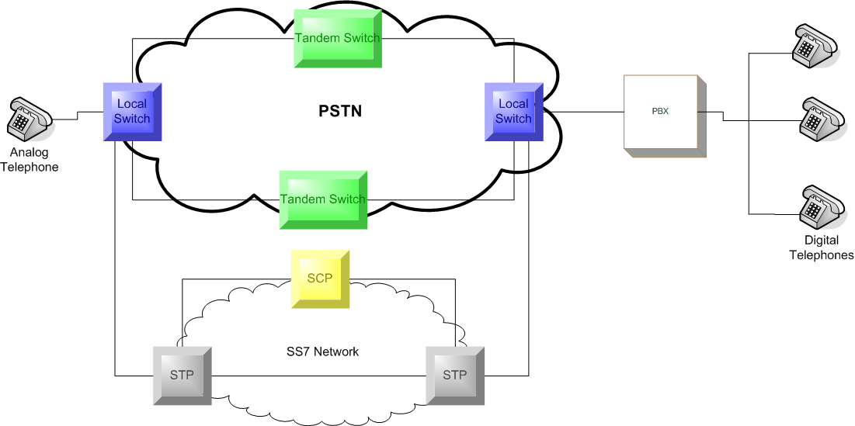
Figure 1: PSTN using SS7 (diagram adapted from: [8])

Figure 1 illustrates how the components of a PSTN are connected to provide a communication service. Taking these components into consideration VoIP should not only replicate but better the current structure of PSTNs so as to make it more scalable, attractive and efficient. Similar to what the telephone was to the telegram, VoIP is to the telephone.

The Internet

The Internet is an international collection of interconnected computers across the world and spans over majority of industries and institutions (business, education, and government) [7]. The Internet has evolved from being an experimental way of transferring data between users in the 1970s to a commercial market place for virtually anything. The main protocol that drives the Internet and keeps data flowing is the Internet Protocol (IP). For devices to communicate across the Internet they need to follow a set of rules to ensure data transfer/exchange. ARPA conceptualised and funded the development of ARPANET which evolved into the Internet. ARPANET worked on packet-switching as a method of connecting communicating devices together [23]. ARPA initiated research on network standards that all communicating devices should adhere to and this resulted in the Internet suite of protocols now known as Transmission Control Protocol/Internet Protocol (TCP/IP). Small networks called Local Area Networks (LANs) are a set of devices that communicate over a small geographic area and are commonly administered by a single network administrator. LANs also needed a set of guidelines on how to communicate and this resulted in the now popular Ethernet technology [7].

Internet Connection Components

To connect to the Internet you will need to have two components in place. These components are always present although in some situations they are hidden from users. Such a setting could be a work environment where a user only knows that to get Internet access you plug your device into a live network point. The components are:
- Internet Service Provider (ISP)
- Computer

Internet Service Provider

An ISP is a service provider who offers access to the Internet for a fee and at a defined information rate. Dial-up and dedicated services are two main links that a subscriber can use to establish an Internet connection. A dial-up service means that only when a user requires an Internet connection is the link established. A dedicated service means that an Internet connection is always present. The costs of dedicated services are higher than those of dial-up because of the continuous presence of the Internet connection. ISPs define the information rate and can also dictate what traffic can traverse their network.

Computer

The computer in this case is a relative term used to represent a device an ISP subscriber uses to communicate with the ISP gateway or remote host. There are several methods through which a subscriber can establish an Internet connection to an ISP (telephone line or wireless). Figure 2 illustrates a basic user request process.
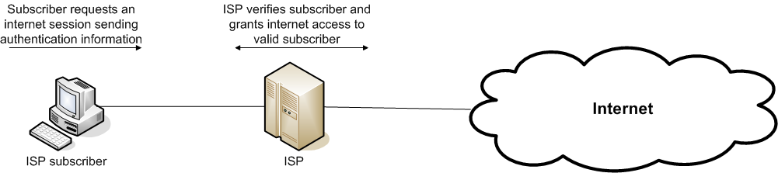
Figure 2: Internet subscriber request process

Although data networks were initially intended for file transfer/exchange it has numerous other capabilities. These capabilities include the handling of real-time voice and video transmission.

Voice over Internet Protocol

VoIP has become an emerging competitor to the dominant traditional telephone network. VoIP essentially is the transmission of voice over a data network. Standards and protocols have been inherited from existing data transmission protocols and standards to ensure that voice is transmitted over a packet-switched link from source to destination [9]. The question to be asked now is how does VoIP work? Two end systems wish to communicate. The source speaks and their analogue data is retrieved and converted into digital data for transmission across the data network to the destination. At the destination the digital data is converted back into analogue data. This is a very simplistic overview of how the process actually works.

Why is VoIP a cheaper service than PSTN? The answer comes in the form of how the two transmit their media. PSTNs use a circuit switched method where as VoIP uses a packet switched method [38]. Circuit switching used in PSTN delivery provides a dedicated link between two end points for the duration of a voice call. This ensures that data reaches desired end points and therefore improves reliability. Dedicated links are costly and this is what makes PSTN services costly. Packet switching used in VoIP delivery does not establish a dedicated predetermined path as circuit switching does but the packets find their own path to the desired destination. This reduces cost because dedicated links are not used but it lowers reliability because packets may get lost or delayed as they find a best path to the desired destination.

VoIP Components

Similar to a traditional telephone network the following components are required for a VoIP telephony service [8].

- Voice Encoding
- TCP/IP and VoIP protocols
- IP telephony servers and PBXs
- VoIP gateways and routers
- IP Telephones

Voice Encoding

Just as in a traditional telephone network analogue data needs to be converted into digital data so that it can be transmitted from source to destination. As opposed to the traditional telephone network there are various voice encoders. The reason for this is that the data network on which voice is transmitted varies in bandwidth size. It is required to choose an optimum codec (codes and decodes audio data from audio to digital and digital to audio respectively) to ensure an optimum quality of service. A codec converts the analogue waveform to a digital form. Table 1 shows some codecs that are available:

Codec | Bandwidth | Sample Period | Ethernet Bandwidth
G.711 (PCM) | 64 Kbps | 20 ms | 95.2 Kbps
G.723.1A (ACELP) | 5.3 Kbps | 30 ms | 26.1 Kbps
G.723.1A (MP-MLQ) | 6.4 Kbps | 30 ms | 27.2 Kbps
G.726 (ADPCM) | 32 Kbps | 20 ms | 63.2 Kbps
G.728 (LD-CELP) | 16 Kbps | 2.5 ms | 78.4 Kbps
Table 1: Codecs [11]

TCP/IP and VoIP protocols

Data networks rely on the TCP/IP suite to ensure data is sent and received on the network. TCP ensures that data sent is received by the destination device. IP ensures that the path from source to destination is known. It is important to note here that due to the fact that VoIP transmissions occur in real-time voice packets that are lost are not recovered because this will lead to delays and thereby creating a poor quality of service [8]. This is why most VoIP data is sent using User Datagram Protocol (UDP) because UDP does not recover lost packets. There are several VoIP protocols used to set-up and tear down sessions but the one that is most prominent is Session Initiation Protocol (SIP) [16]. In a VoIP network SIP maybe used for creating and tearing down voice sessions and UDP is used to encapsulate the packets carrying voice data.

VoIP protocols are higher-layer protocols that work hand-in-hand with lower-layer protocols. SIP use the open architecture of the Internet to set-up and terminate VoIP calls. SIP inherits the HTTP structure and this is what gives it an extra edge over other protocols. After setting up a VoIP call real-time voice streaming needs to take place. The VoIP protocol used is a higher-layer protocol called Real-Time Transport Protocol (RTP). RTP is encapsulated in UDP as it travels across a data network. Figure 3 illustrates the SIP trapezoidal model.

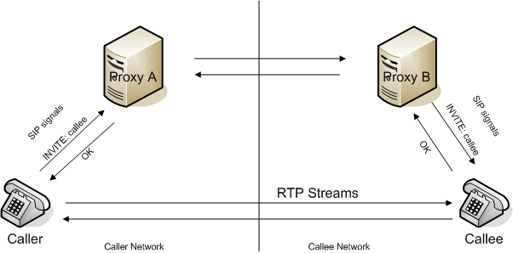
Figure 3: SIP trapezoidal model (diagram adapted from: [17])

IP telephony servers and PBXs

In a VoIP network all devices have client and server capabilities because they can initiate (UAS – User Agent Server) or accept calls (UAC – User Agent Client). There are three main servers to consider in a VoIP environment and they are proxy, registrar and redirect. The proxy server is used to route SIP requests to UAS and route SIP responses to UAC [22]. When a caller requests a call set-up with a callee the proxy server will act as an intermediate across the data network [12]. All calls will be created through the proxies that will have access to SIP URL to device mapping and will perform the search for the callee using the callee’s SIP URL.

Registrar servers are used by the user agents to keep all devices aware that they are alive on the network. The SIP registrar server periodically receives updates from all devices on its network. This process also acts as a way of authentication that only authorised user agents operate on the network. SIP proxy servers make use of the SIP registrar server to lookup the location of user agents when calls are initiated [12].

The SIP redirect server is used to return error messages when destinations are unknown. The redirect server does not forward SIP INVITE requests instead it returns the destination IP address of the requested device to the UAS in a 3XX class response message [12].

PBXs are used in the same way as they are used in a traditional digital telephone network. They act as a gateway/ telephony router for a set of local set of IP phones. For all clients on a network PBX provides voice services such as conference calls, call waiting, call forwarding and many other customised services.

VoIP gateways and routers

The VoIP gateway provides a connection between the VoIP network and the PSTN. Since PSTN networks still exist these gateways are still needed to maximize coverage of VoIP networks. Some VoIP gateways use SS7 signalling to make sure that voice data travels across the two networks. Since PSTN only uses G.711 codecs all VoIP data must be converted to G.711 when they differ. In some VoIP deployments routers are used to determine the paths that VoIP traffic should travel. This means they should be able to disassemble VoIP packets retrieve necessary information to determine the next hop and reassemble them and send them off. Most networks use Ethernet technologies which makes it easier for path determination.

IP Telephones

These are essential components in the VoIP network in that they are the end systems. The analogue data is input into the IP telephones which in turn convert the audio data into digital data. If the devices are old then the PBX will perform the conversion. One thing to consider is that the UAS and UAC must use compatible conversions, if they don’t this will give the PBX some overhead in ensuring that the digital data is compatible [8]. Figure 4 illustrates a connection of PSTN and VoIP network via a VoIP gateway.
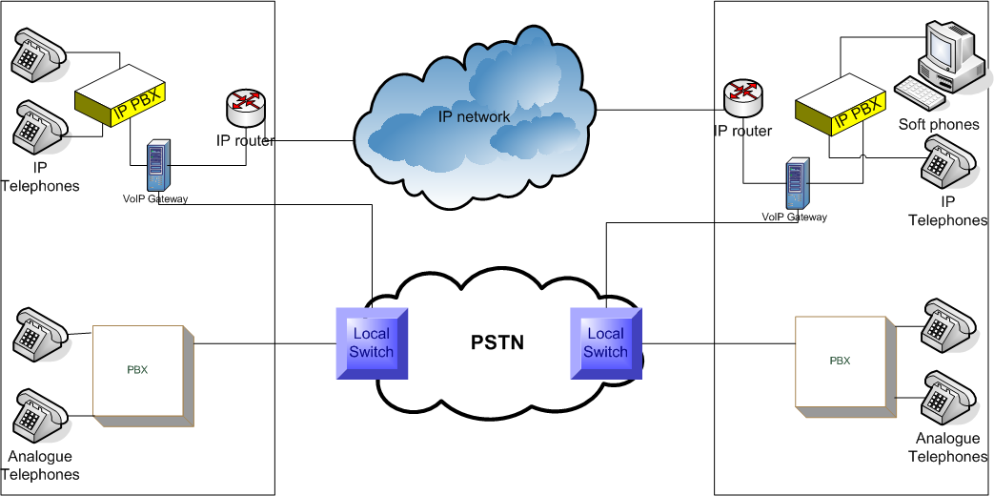
Figure 4: VoIP network connected to PSTN (diagram adapted from: [8])

Asterisk

Asterisk is an open source IP-enabled PBX. It was developed by Mark Spencer of Digium Inc in 1999 and was released under the GNU General Public License (GPL) [13]. Asterisk is software running a PBX system and offers existing traditional PBX services and tailor-made services for its users [6]. The beauty about Asterisk is that it can talk to any communications device from the 1960s to the latest digital wireless VoIP telephone because it supports many codecs, protocols and traditional telephony standards. The word asterisk was chosen because it is a key on the telephone keypad and is also used to denote any character in the pattern of a search string [10].

iLanga

iLanga is a computer based PBX which was integrated in the Computer Science Department at Rhodes University [2]. iLanga has three core open source components [1]:
- Asterisk
- SIP Express Router (SER) – handles SIP traffic
- Gate Keeper (OpenGK) – handles H.323 traffic
Asterisk on its own cannot cater for large scale VoIP networks and that is why the iLanga core has a SER and OpenGK as core components. Figure 5 illustrates how the components combine to create a more effective VoIP box:
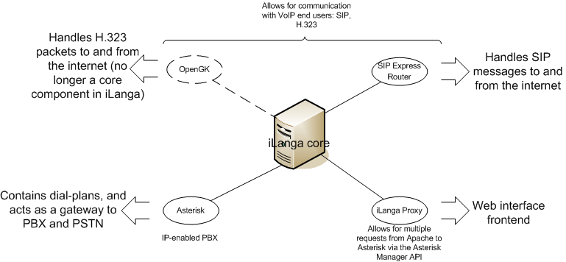
Figure 5: Components of iLanga core

In Figure 5 it should be noted that OpenGK is no longer in use as iLanga prefers SIP agents over H.323 agents. The iLanga core is a suitable fully functional PBX to implement for VoIP deployment and that is why we will be using it for this project. University of Namibia (UNAM) and Rhodes University (RU) will both have these boxes to on their respective LAN. Figure 6 illustrates the VoIP network:

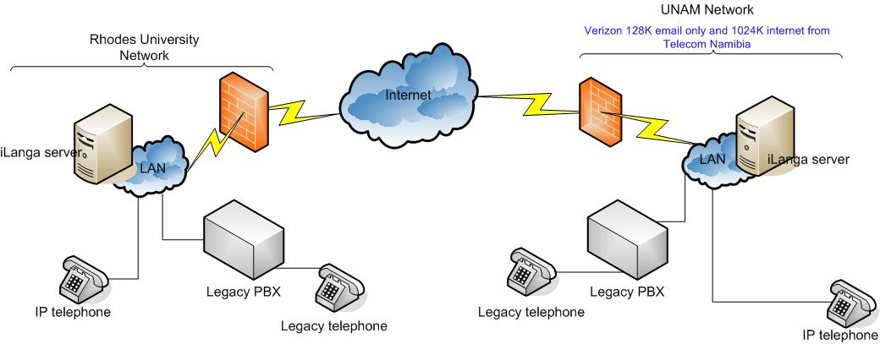
Figure 6: Project deployment of VoIP network

Quality of Service

Quality of Service (QoS) refers to choices on how different users, applications or traffic get treated on the network [8]. What does QoS mean to a VoIP network? The purpose of QoS is to deliver data from source to destination in the bounds of a set time. VoIP is a real-time interaction which relies heavily on voice data arriving on time at a desired destination. If voice is delivered with a maximum delay of 300ms a decent voice conversation can occur but if there more than 500ms of delay then the conversation becomes overlapped and awkward [10]. The main drawback that most VoIP implementations have over large networks is the quality of voice. Skype, the first VoIP client based on peer-to-peer technology is one of the most popular VoIP tools available today. In the early release it did not always adequately deliver voice across data networks as the traditional PSTN do [15]. Many Skype users bear with this poor service because of the cheap costs that VoIP provides as compared to PSTN calls. The minimum uplink and downlink bandwidth required by Skype to deliver reasonable voice output is 2 kilobytes per second sustained, anything below this renders a call unintelligible [15]. QoS is a key factor to consider when deploying a VoIP network especially across a large data network and that means that traffic shaping can be in implemented as a way of meeting the needs of QoS.

SIP vs. IAX

Quality of service has a major role to play in the livelihood and ascendance of VoIP. The time it takes to establish a call must be short, the rate of voice packet drops must be negligible, and the amount of bandwidth used must be low. SIP is a published and well documented Internet Engineering Task Force (IETF) standard and that gives it credibility. Inter-Asterisk Exchange (IAX) is a protocol developed by the creator of Asterisk Mark Spencer to solve SIP drawbacks. IAX is a protocol built with VoIP in mind [18]. Table 2 compares the two standards.

 | SIP | IAX
Standard | IETF standard | Not a published standard (yet?)
Ports | Requires 3 ports to achieve voice communication. 1 port for call setup and 2 ports for voice transmission (RTP) | Requires 1 port to achieve voice communication
LANs | Not costly (data flow) on LANs because of less hardware requirements. RTP does not flow through servers on a LAN | Costly (data flow) on LAN because of hardware requirements. IAX must flow through servers at all times
WANs | Costly on WANs (security) because RTP requires a range of ports to be available for VoIP sessions | Not costly on WANs (security) because less ports are open for VoIP sessions
NAT Handling | NAT traversal is a problem because signalling and voice data travel on different ports. During voice data transmissions the mapping of private to public IP addresses may mismatch | NAT traversal is not a problem because signalling and voice data travel together on the same port and therefore IP address mappings remain the same throughout a session
Complexity | A more intensive implementation process required because it is a general purpose protocol | Less intense implementation because it is an Asterisk based protocol
Video | Supports video and numerous SIP clients and codecs are available | Does not readily support video. Very few IAX clients and video codecs are available
Table 2: Comparison between SIP and IAX [18], [19]

For this project SIP will be used. Since there is competition among packets to reach their desired destinations VoIP traffic will have to be prioritised to ensure a sustained end-to-end voice connection. Traffic shaping is the answer to prioritisation.

RTP

RTP sits at the transport layer of the Open Systems Interconnection (OSI) model and encapsulates RTP in UDP packets. The reason why UDP is used instead of TCP is because of its connectionless characteristic [8]. Within the VoIP framework if a voice packet is lost or dropped there is no need to request a re-send as all conversations occur at real-time. RTP is essential because it holds the payload (voice samples). A high rate of successful end-to-end RTP transmissions results in a high level call quality.

Codec and Transcoding

A codec is important in the VoIP set-up because it performs sampling of analogue audio streams and determines the data rate [8]. Transcoding is also an important part of the VoIP set-up because not all devices use or support similar codecs. Transcoding overcomes this problem by performing conversions between different codecs. Although transcoding gives VoIP a level of interoperability it is costly in terms of delay and call quality. When selecting the appropriate codec in a VoIP set-up a balance must be obtained between maintaining intelligible communication and reducing bandwidth consumption.

Traffic Shaping

Traffic shaping is a form of controlling how packets should flow through a network. The essence of traffic shaping is to guarantee performance [20]. The reason why traffic shaping is important is to ensure that voice is not delayed by more than 500ms and few voice packets are dropped within a session. For this project traffic shaping must take place at the ISP. Figure 7 illustrates where traffic shaping should be implemented on the router interface that connects the ISP to UNAM.

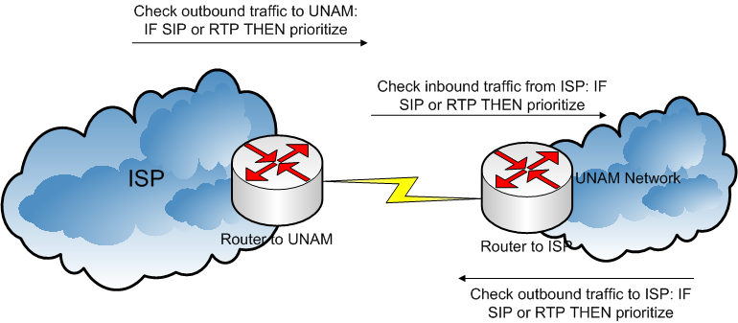
Figure 7: Traffic shaping between UNAM and ISP

In Figure 7, when UNAM bound traffic arrives at the ISP each packet is put into a queue. Each packet is stripped and analysed to determine the class/type of the packet. If the packet is SIP or RTP then it is put into a priority level queue [21]. This means that all traffic in the priority queue will leave the ISP for UNAM first. The same process of class/type determination occurs on the UNAM router for inbound and outbound traffic. The main points to consider are whether the end routers can perform traffic shaping and determine VoIP protocols.

VoIP in Africa

African countries are slowly coming around with accepting VoIP as a legal communications tool. In some countries VoIP is still a grey area and it is illegal to run any form of communication through VoIP. Countries like South Africa, Kenya, and Mauritius have gone as far as awarding licences to companies providing VoIP based services. Regulators in the communications market are trying to hold on to their dominant positions to protect their revenue. In some cases the benefits of VoIP have reached subscribers by way of reduced call charges but others although they use VoIP do to not reduce charges and therefore increase their revenue [39].

In South Africa the Tertiary Education Network (TENET) has finally come around and realised the potential of VoIP for tertiary education institutions. Two years ago TENET requested an investigation into the potential of VoIP. The result of this initial investigation was negative and the idea of VoIP implementation was dropped. Regulators in the communications market have since opened VoIP and TENET has now realised that there is a great potential in terms of economic benefits for tertiary institutions [40]. This year TENET and the National Telephony User Group (NTUG) have signed a collaborative agreement which is setting out to determine whether TENET should add a VoIP service option for participating institutions. This is a national effort and what we are trying to achieve is an international effort.

Conclusion

In this literature review telephony aspects were described so that a firm understanding is gained on the PSTN and VoIP networks and how they work. This leads to a better understanding on how to best tackle the deployment of VoIP at UNAM and to set-up a VoIP link between UNAM and RU. To obtain an optimum link between the two institutions an appropriate bandwidth calculation is required so as to choose the best codec to use between the two links. Due to the fact that UNAM has a 1 024Kbps Internet connection shared campus wide there must be a way to allow delay sensitive traffic to be prioritized during times of network congestion. One way to do this is to implement QoS. It should be noted that when a network is 100% congested not even QoS can ensure reliability for delay sensitive traffic.

Chapter 3

The Test-bed and Initial Testing

This chapter discusses how to solve potential VoIP implementation problems using a controlled environment. This chapter tries to answer the question on whether there is a need for QoS to maintain an intelligible voice conversation over a congested network.

3.1 Introduction
3.2 Site Internet Links
3.3 VoIP Network Test-bed
3.4 Analysis
3.5 Results
3.6 Conclusion

Introduction

A test-bed enables us to observe and analyze the behavior of applications in a lab environment that try to emulate conditions on the current and/or planned production network [26]. Using the test-bed we will assess whether there is a need for traffic shaping to sustain a reliable voice session over a congested network. There are numerous techniques that can be used to implement traffic shaping on a Cisco router but we have focused on one method that is recommended for VoIP.

Site Internet Links

This thesis uses two sites for its case study and they are Rhodes University (RU) and University of Namibia (UNAM). The two institutions have different Internet bandwidth allocations and deploy a different LAN infrastructure. Table 3 is a comparative between RU and UNAM:
 | Internet Link Speed | LAN Speed
RU | 12 224 Kbps | Gigabit
UNAM | 1 024 Kbps | 100/1000 Mbps
Table 3: Comparison between RU and UNAM

From Table 3 it is important to note that the number of users on the network is relatively similar. The demand for Internet bandwidth on both sites is high but RU is more than able to cope with this bandwidth demand due to having a bigger Internet link speed. Figure 8 shows an overall daily usage of RU Internet bandwidth utilization for October 2007. Figure 9 shows an overall daily usage of UNAM Internet bandwidth utilization for October 2006.
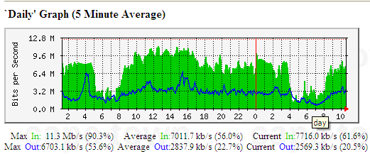
Figure 8: RU daily Internet bandwidth utilization

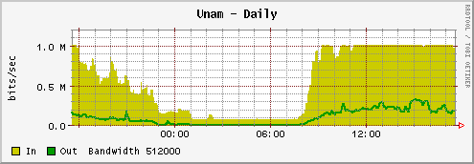
Figure 9: UNAM daily Internet bandwidth utilization

The bandwidth utilization graphs clearly illustrate where network congestion exists. It shows that UNAM’s network reaches its full information rate during working hours for incoming traffic. RU’s graph shows that it does not exhaust the information rate for both incoming and outgoing traffic. This network activity is what the network test-bed will try to emulate.

VoIP Network Test-bed

The main purpose of the test-bed is to emulate the RU-UNAM link and to carry out qualitative tests. The results of these tests will influence the exact nature of VoIP deployment using iLanga. The tests will monitor and analyse how traffic flows between a congested network and a less congested network using different scenarios with varying demands on available bandwidth. Using this data we can then see how best to ensure that reliable and sustainable voice conversations can be made regardless of the level of congestion. In this case the critical packets to be monitored are the voice data packets (UDP carrying voice data). Figure 8 illustrates the test-bed.
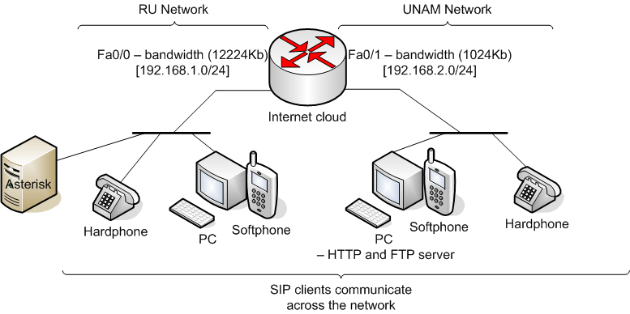
Figure 10: Network Test-bed

Test-bed Components and Configurations

To build the network test-bed the following components were required. Figure 10 illustrates the cabling of the desired network:
- Cisco 2600 series router with two FastEthernet ports
- D-link 8 port switch
- 3 PCs (one running asterisk, one representing RU users, one representing UNAM users)
- 2 hardphones (one representing RU users, one representing UNAM users)
- Cat 5e UTP cables (straight through and cross-over)
- RJ-45 to DB-9 cable (console cable to router)

Router Configurations

The Cisco router was configured to have the following bandwidth and transfer rate allocations. The settings are listed in Table 4.
Setting | FastEthernet 0/0 | FastEthernet 0/1
Bandwidth (kbps) | 12 224 | 1 024
Rate limit (bps) | 12 224 000 | 1 024 000
Max burst (bytes) | 1 528 000 | 128 000
Min bursts (bytes) | 1 528 000 | 128 000
Table 4: Cisco router interface configurations

The code that implements bandwidth allocations to users on each network segment is in Table 5.
!
interface FastEthernet0/0
rate-limit input 12224000 1528000 1528000 conform-action transmit exceed-action drop
rate-limit output 12224000 1528000 1528000 conform-action transmit exceed-action drop
!
interface FastEthernet0/1
rate-limit input 1024000 128000 128000 conform-action transmit exceed-action drop
rate-limit output 1024000 128000 128000 conform-action transmit exceed-action drop
!
Table 5: Cisco Router bandwidth configuration

The rate-limit command regulates the information rate for the connection for both incoming and outgoing traffic on the designated router interface. The format for the command is as follows:
rate-limit <input/output> <bandwidth in bps> <maximum burst in bytes> <minimum burst in bytes> <normal burst action> <burst violation action>
Without this command the end-to-end bandwidth would not reflect the existing Internet links for UNAM and RU.
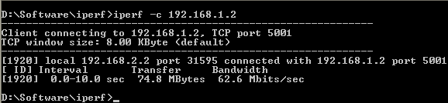
Figure 11: Information rate without rate-limit command

Figure 11 show the end-to-end information rate between RU and UNAM on the test-bed. With a round trip of 10 seconds the measured information rate is open and does not depict the true end-to-end information rate. RU has a cap of 12 224Kbps and UNAM has a cap of 1 024Kbps. The RU end device has IP address 192.168.1.2 and the UNAM end device has IP address 192.168.2.2.
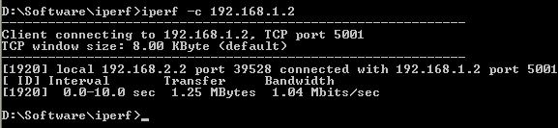
Figure 12: Information rate with rate-limit command

Figure 12 illustrates a more realistic end-to-end information rate where the bottleneck is on the UNAM side and thereby restricting the information rate. This is the reason why the rate-limit command is essential to the test-bed router configuration. The full router configuration code can be found in Appendix A1.

PC Configurations and Settings

The PCs represent RU and UNAM users. The PCs are configured to be on different networks. Table 6 illustrates the Network Interface Card (NIC) settings on each PC:
 | IP Address | Subnet Mask | Default Gateway
RU | 192.168.1.2 | 255.255.255.0 | 192.168.1.1
UNAM | 192.168.2.2 | 255.255.255.0 | 192.168.2.1
Table 6: PC NIC configurations

The PCs are both running Windows XP Professional and Internet Information Services (IIS) for Hypertext Transfer Protocol HTTP and File Transfer Protocol FTP services. The reason why IIS is running on both machines is to enable as much network activity as possible in order to create congestion on the network. Each PC contains a 568MB movie for video streaming and a 568MB file for file transfer activity. SIP-based softphones are also running on each of the PCs. The PCs are also running network monitoring and measuring software which will be discussed later on in this chapter.

The third PC is a Linux box running Asterisk. Asterisk will be used to make the voice calls better regulated and to allow the use of SIP-based hardphones. The call monitoring on Asterisk CLi will be very useful to verify that calls are actively being created as was illustrated in figure 3.

Network Monitoring and Measuring Software

The software used to monitor and measure the network are the following:
- ManageEngine VQManager
- Iperf
- WinDump
- Ethereal

ManageEngine VQManager is a powerful, web-based, 24x7 real-time QoS monitoring tool for VoIP network. It enables IT administrators to monitor their VoIP network for voice quality, call traffic, bandwidth utilization and keep track of active calls and failed calls. VQManager can monitor any device or user-agent that supports SIP, Skinny and RTP/RTCP [30].

Iperf was developed as a modern alternative for measuring TCP and UDP bandwidth performance. It is a tool to measure maximum TCP bandwidth, allowing the tuning of various parameters and UDP characteristics. Iperf reports bandwidth, delay jitter, datagram loss [31].

WinDump is the Windows version of tcpdump, the command line network analyzer for UNIX. WinDump is fully compatible with tcpdump and can be used to watch, diagnose and save to disk network traffic according to various complex rules [32].

Ethereal is a protocol analyzer. The essential use of this tool is to read the output from log files created by WinDump [33].

Analysis

In the analysis we had to come up with reasonable testing techniques that would find the threshold of the network. Two conditions were used in order to achieve a better insight into bandwidth usage on the test-bed.

Condition One

The Cisco router by default uses a First-In-First-Out (FIFO) method for transferring packets from source to destination. The FIFO method ensures that the first packet that comes into the router is the first one out [27]. FIFO does not prioritise any packets in a queue. Figure 13 illustrates how the packets are handled by the router.
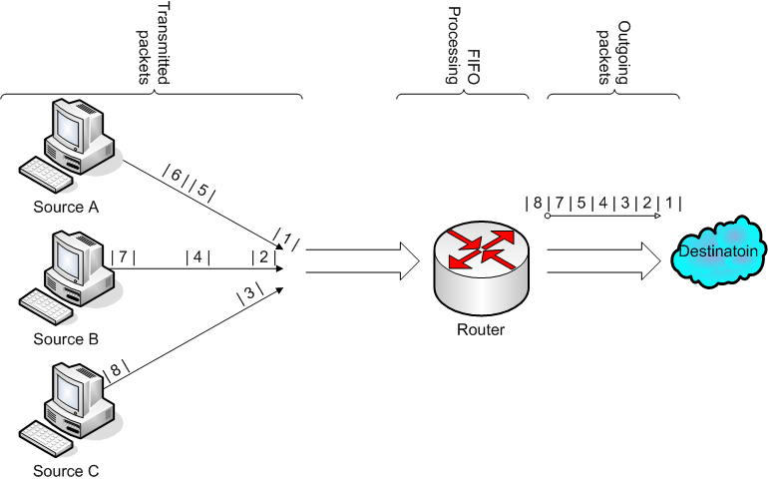
Figure 13: FIFO Queuing (diagram adapted from: [27])

Condition Two

Applications that are delay sensitive cannot rely on FIFO queuing methods especially in congested networks. A solution that allows for greater control of individual packet streams is priority queuing [27]. The priority queuing method we used in condition two is Class Based Weighted Fair Queue (CBWFQ) with priority bandwidth percentage. This method of queuing prioritises packets based on user defined classes. Figure 14 illustrates how CBWFQ works as packets enter and leave a router’s interface.
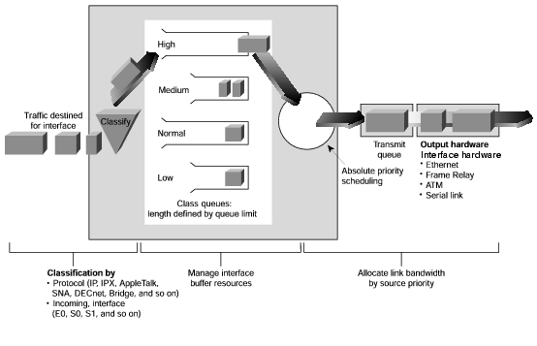
Figure 14: CBWFQ process (diagram taken from: [34])

The configuration of CBWFQ is in four steps:
- Create a class and define the packets that fit into a priority. Access Control Lists (ACLs), protocols, or originating interfaces can be used
- Create a class map. The purpose of this is to map a defined class to a unique class identifier
- Create a policy map. The purpose of this is to define the priority type that should be used
- Apply the policy to an interface. To activate CBWFQ it must be assigned to a router interface
The commands we used to implement CBWFQ are explained the in following points:
  - Create a class: Table 7 shows how class definition is configured.
!
ip access-list extended high
permit tcp any any eq 1720
permit tcp any any eq 5060
permit udp any any eq 5060
permit udp any any range 16384 32768
!
ip access-list extended medium
permit tcp any any eq ftp
permit tcp any any eq www
!
Table 7: CBWFQ class definition
Two classes high and medium are created and their associated packets are defined. The classes were defined using named ACLs. All necessary SIP and RTP packets are assigned to class high. Although SIP packets do not use up a high amount of bandwidth they have been assigned to class high so that users do not receive too many call set-up or call termination delays. RTP which is delay sensitive traffic is placed in the high class so that it has a higher priority when network congestion is on the rise. All ftp and web traffic (www) is assigned to class medium

  - Create a class map: Table 8 shows how class mapping is configured.
!
class-map high
match access-group name high
!
class-map medium
match access-group name medium
!
Table 8: CBWFQ class mapping

The classes that were created and defined in step one are mapped to a name identifier. We decided to use the same ACL names as map identifiers. Here we match the criteria set for each ACL to a unique identifier

  - Create a policy map: Table 9 shows how policy mapping is configured.
!
policy-map voip
class high
priority percent 45
!
policy-map voip
class medium
priority percent 30
!
policy-map voip
class class-default
!
Table 9: CBWFQ policy mapping

Once the class maps are defined they are assigned to a policy map. A policy map defines how each class map should be treated when matched to packets in the queue. In our case we set the priority percentage policy. When congestion is encountered we set the router to allocate 45% of available bandwidth to high class map matching packets and 30% of available bandwidth to medium class match mapping and the remaining amount is for default class map matching. The default class map refers to all other traffic that is not defined in all other class maps

  - Apply the policy to an interface: Table 10 shows how the policies are applied to an interface.
!
int fa0/1
service-policy output voip
!
Table 10: CBWFQ activating a policy on an interface

The interface we assigned the policy to is fast Ethernet interface that connects to the UNAM network. This means that traffic that is travelling towards the UNAM network is analysed by the policy

The full CBWFQ configuration used can be found in Appendix A2.

Tests Conducted

For each condition we performed the following sequence of tests:
- Monitor network activity and measure bandwidth before calls are made
- Generate voice calls and measure the bandwidth utilization and quality of voice call with no network congestion
- Introduce network congestion and monitor network activity and measure bandwidth
- Generate voice calls and measure the bandwidth utilization and quality of voice call with network congestion

For consistency the following method was used to generate voice calls:
- Dial destination number and wait for five seconds
- Answer the call and count up to thirty
- Remain silent for five seconds then hang-up

For consistency the following method of applying network congestion was followed:
  - Generate HTTP traffic by launching a browser and pointing it to a webpage sitting on a web server (RU webpage points to UNAM’s web sever page and UNAM’s webpage point to RU’s web server page)
  - Generate FTP traffic by downloading a 568MB file (RU downloads a file from UNAM and UNAM downloads a file from RU)
  - Generate video streaming (RU plays a video file from UNAM and UNAM plays a video file from RU)
  - Generate icmp activity by using an extended ping command

The tests conducted were a basic measure to see how best to maintain an intelligible voice conversation without increasing available bandwidth.

Results

After a set of five tests for each condition the results were recorded. Iperf was used to take down the bandwidth utilization. ManageEngine VQManager was used to monitor and analyze the traffic that was traversing the network. ManageEngine VQManager also had a voice quality tester and the Mean Option Score scale (MOS) is used to grade the quality of a voice conversation [8]. MOS is an accepted yet basic method of measuring voice quality and is described in ITU P.800. The MOS values range from 1 to 5 where 1 is bad (communications breakdown) and 5 is excellent (perfect auditory reception).

A comprehensive summary of voice calls is stored and generated by ManageEngine VQManager. For traffic analysis a traffic monitor graph and related data is present. For voice quality we opted to show jitter, packet loss and MOS graphs and associated data. Figures 15 – 18 illustrate the results that were captured for the condition tests.
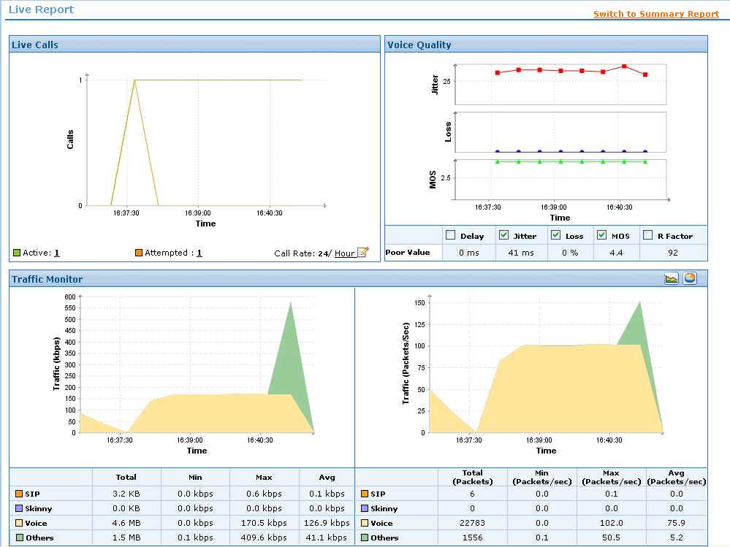
Figure 15: FIFO with no network congestion

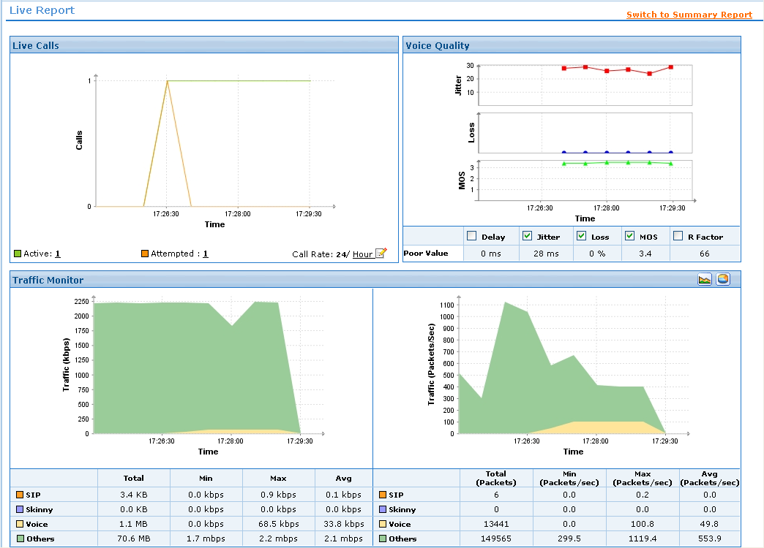
Figure 16: FIFO with network congestion

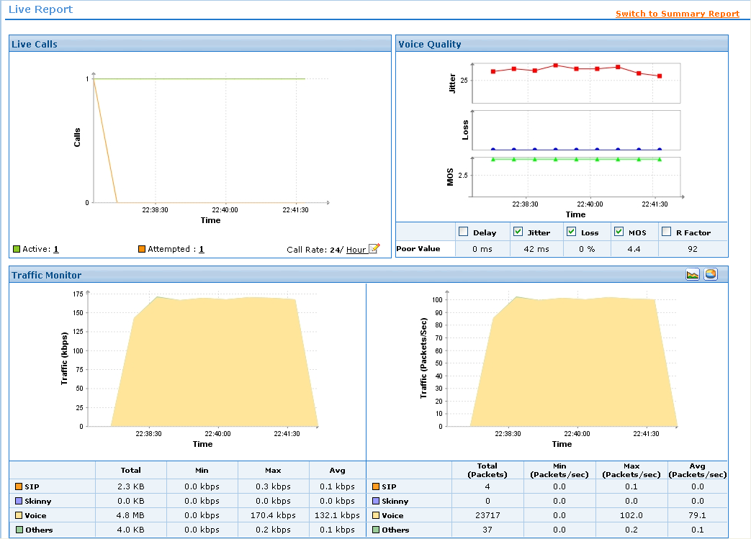
Figure 17: CBWFQ with no network congestion

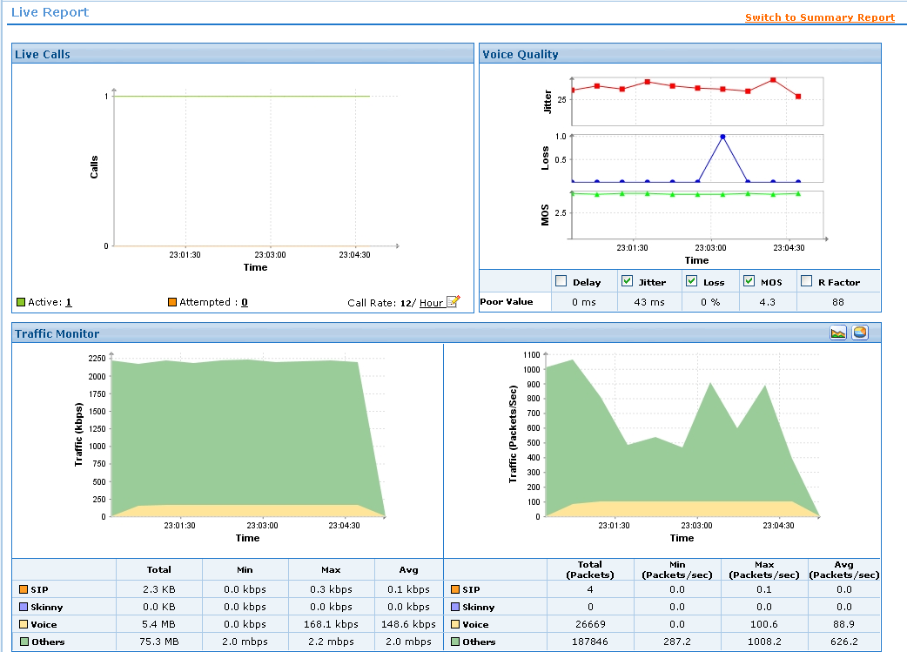
Figure 18: CBWFQ with network congestion

Once all tests were performed the average of collected data was analysed. Table 11 gives a summary of results from all tests.
Test | Result
FIFO | Voice Quality Rating: 4.4  Available end- to-end Bandwidth: 1.04 Mbits/sec
FIFO with network congestion | Voice Quality Rating: 3.5  Available end- to-end Bandwidth: 242 Kbits/sec
CBWFQ | Voice Quality Rating: 4.4  Available end- to-end Bandwidth: 1.05 Mbits/sec
CBWFQ with network congestion | Voice Quality Rating: 4.3  Available end- to-end Bandwidth: 263 Kbits/sec
Table 11: Summary of Analysis Results

MOS values above 4 are taken as toll quality and those below 3.6 are not of satisfactory quality [8]. From the results it can clearly be seen that there is a significant improvement in voice quality when CBWFQ is introduced under congested conditions.

Conclusion

A point to note is that it is important to know the capacity and capability of a network on which VoIP is to be deployed. From what we know so far about VoIP through the background work VoIP cannot achieve five-9s product reliability in terms of voice quality but it should be able to maintain tolerable reliability. If periodic network congestion exists the best method of avoiding poor quality voice conversations is to implement QoS. The results from the network test-bed give a solid answer to the problem of deploying VoIP over low bandwidth networks with high rates of network congestion. In relation to the RU-UNAM link we are now better equipped to solve bandwidth related problems in VoIP deployment. These results will help achieve our overall goal of deploying a sustainable and reliable VoIP service between different sites with differing network infrastructure and Internet connectivity.

Chapter 4

Real Life Implementation and Testing

This chapter looks into the actual deployment of VoIP at University of Namibia (UNAM) and describes the challenges encountered. The critical challenge we encountered at UNAM resulted in us implementing the same VoIP solution at the Polytechnic of Namibia (PoN). The PoN deployment also had its own challenges that lead us not to conduct any traffic shaping implementation and testing. This chapter also discusses these issues and many others that may arise when deploying VoIP on a live network.

4.1 iLanga Installation and Configuration at UNAM
4.2 Testing with UNAM and Polytechnic of Namibia
4.3 Conclusion

iLanga Installation and Configuration at UNAM

To set-up iLanga there are essential hardware and software that must be present. Figure 5 shows the components of iLanga that are needed to make it work. The emphasis of this set-up is to have Rhodes University (RU) and UNAM communicate through iLanga. The installation process for iLanga is not discussed in this thesis as it is well discussed by Jason Penton [2]. The only difference is that we have installed newer versions of iLanga components. This section will discuss the Asterisk configurations which pertain to setting up a VoIP link between RU and UNAM. These settings will deal with IAX, SIP, and dialplan configurations.

IAX Configuration

IAX establishes a peer connection between two PBXs. IAX is configured in the iax.conf file found in /etc/asterisk folder. IAX sends call signals and voice data on one defined UDP port. Section 2.5.1 of this thesis discusses SIP and IAX protocols and indicates the differences between them. The advantage of IAX is that it has a better method of handling NAT traversal and it does not require a huge range of open ports on a network firewall. For these reasons it is a suitable protocol to use for peer connections. Table 12 and 13 show configuration code used for setting up IAX at UNAM and RU.
...
[general]
bindport=4569
; ;
bindaddr=xxx.xxx.xxx.xxx:4569 ; local IP address for UNAM PBX
bindaddr=yyy.yyy.yyyy.yyyy:4569 ; public IP address for UNAM PBX
...
bandwidth=low ; defines the type of internet link

disallow=all ; codecs to negotiate on when establishing connection
allow=speex
allow=gsm
allow=alaw
allow=ulaw
allow=speex

forcejitterbuffer=no
trunkfreq=20
tos=lowdelay ; type of service action - low delay on voice packets
...
[ilanga] ; setting up a user account
type = user
username = ilanga
secret = ilangapass
host = dynamic
context = local

[ilanga-outbound] ; setting up a peer/user account
type=friend
username=ilanga
secret=ilangapass
host=zzz.zzz.zzz.zzz ; RU PBX public IP address
Table 12: iax.conf configuration file at UNAM

[general]
bindport=4569 ; bindport and bindaddr may be specified

bindaddr=xxx.xxx.xxx.xxx:4569 ; IP address for RU PBX
...
bandwidth=high ; defines the type of internet link

disallow=all ; codecs to negotiate on when establishing connection
allow=speex
allow=gsm
allow=alaw
allow=ulaw
allow=speex

forcejitterbuffer=no
trunkfreq=20
tos=lowdelay ; type of service action - low delay on voice packets
...
[unam] ; setting up user account
type = user
username = unam
secret = unampass
host = dynamic
context = local

[unam-outbound] ; setting up peer/user account
type=friend
username=unam
secret=unampass
host=xxx.xxx.xxx.xxx ; UNAM PBX public IP address
Table 13: iax.conf configuration file at RU

Notice that the IAX configuration for UNAM and RU are slightly different. The key configurations to take note of are the bindport, bindaddr, codecs, peer contexts, and user contexts. Some critical differences and important configurations are listed here:
- A bindaddr is determined by the IP address(es) assigned to a PBX. A bindaddr tells Asterisk to listen on a specified IP address on a given port. IP phones use this bindaddr to register on Asterisk
- UNAM has a low bandwidth allocation where as RU has a high bandwidth allocation. The allocation is based on the bandwidth available to a network and is set using a bandwidth command. You can set bandwidth to high, medium or low
- For IAX to peer two PBXs when a call is initiated the iax.conf file should have corresponding user and peer contexts. In the UNAM configuration the contexts are ilanga and ilanga-outbound. These contexts will be used to authenticate IAX peer negotiations when a call is being set-up
- Other important information that IAX needs when establishing a call are voice codec negotiations. The interacting UAs must agree on what codec to use for the voice session. Due to the nature of the link, we have opted to use speex codec as the first/default option. Speex is an open source codec that compresses voice at bitrates ranging from 2 to 44Kbps [35]. Speex as compared to other codecs listed in Table 1 reduces the demand of scarce internet bandwidth between UNAM and its ISP

The down side to using IAX is its limited support for video. There are few codecs supported by IAX and fewer video enabled IAX clients exist.

SIP Configuration

SIP establishes a peer connection between PBXs. SIP is configured in the sip.conf file found in /etc/asterisk folder. SIP is a good protocol to use when there is no NAT traversal required for voice calls because SIP does not handle NAT-ed networks too well. SIP also has an added advantage in that it supports video. In our set-up all UAs are SIP hard IP phones and they must register with Asterisk. For this registration to take place the sip.conf file must be configured. Table 14 shows configuration code used at UNAM.
...
[general]
context=default ; Default context for incoming call

bindport=5060 ; UDP Port to bind to (SIP standard port is 5060)
bindaddr=xxx.xxx.xxx.xxx ;IP address to bind to (0.0.0.0 binds to all)
srvlookup=yes ; Enable DNS SRV lookups on outbound calls
; Note: Asterisk only uses the first host
; in SRV records
; Disabling DNS SRV lookups disables the
; ability to place SIP calls based on domain
; names to some other SIP users on the Internet

disallow=all ; First disallow all codecs
; Allow codecs in order of preference
allow=ulaw
allow=alaw
allow=gsm
allow=g726

externip = yyy.yyy.yyy.yyy ; Address that we're going to put in outbound SIP messages

localnet=xxx.xxx.xxx.0/255.255.255.0 ; All RFC 1918 addresses are local networks

nat=yes ; NAT is used on network

qualify=yes ; ttl for register packets is set to 2000ms

canreinvite=no ; send requestion for UA register

[5929] ; UA account details
type=friend
username=5929
secret=1234
host=dynamic
context=local
canreinvite=no
qualify=1000
disallow=all
allow=ulaw
allow=alaw
allow=gsm

[unamout] ; SIP peer account details
type=peer
secret=asterisk
username= kmufeti
fromdomain=unam.na
host=196.44.139.66
port=5060
nat=yes
disallow=all
allow=gsm
Table 14: sip.conf configuration file at UNAM

The key settings in this file are:
- For SIP phones to register they need to know on which port to send messages on and to what address. This is set in the bindport and bindaddr settings
- UNAM’s PBX sits behind a firewall and for that reason externalip, nat, localnet, and qualify is configured. These settings attempt to solve the NAT traversal problem that comes with SIP. A UA’s IP belongs to the localnet, when an external call out of the network is requested the externalip is mapped to the local IP. Qualify determines the timeout period for status updates for UAs on Asterisk
- The credentials set in the 5929 context will be used to successfully register a SIP hardphone on the UNAM network
- The credentials set in the unamout context will be used to successfully peer two PBXs over SIP. These credentials work in the same way as in IAX. A point to note here is that SIP does not work well with the speex codex and that is why we force the default codec to be gsm. This codec is popular in cellular telephony and at a bitrate of 13 Kbps

RTP Configuration

The protocol for handling voice media streams is RTP. The common UDP port range used for RTP is 16384 to 32767 [27]. For this project we had to limit the port range so as not to leave too many ports open on the firewall. To set the range of ports to be used by RTP the rtp.conf file found in /etc/asterisk folder is configured. Table 15 shows configuration code used at UNAM.
; RTP Configuration
;
[general]
;
; RTP start and RTP end configure start and end addresses
;
; Defaults are rtpstart=5000 and rtpend=31000
;
rtpstart=8000
rtpend=8005
;
...
Table 15: rtp.conf configuration file at UNAM

An interesting point to note here is that RTP opens two ports for communication. One port is for the media stream and the other port is for monitoring and controlling the voice quality. The RTP port for the media stream must be an even port number. The protocol that handles the voice QoS is the RTP Control Protocol (RTCP) [37].

Once all devices are registered and peers can communicate the next step is to configure dialplans to test internal and external communication.

Dialplan Configuration

An Asterisk dialplan is a set of rules/states that are subdivided into tasks using contexts [1]. Each context defines the process needed to be executed to achieve a set result when numbers are dialled. Dialplans are configured in the extensions.conf file found in /etc/asterisk folder. Table 16 and 17 show configuration code used at UNAM and RU respectively.
...
[default]
exten => _.,1,Goto(local,${EXTEN},1) ; dialplan for any call received

[local] ; local context dialplan
;internal calls over SIP to local UA
exten => _5XXX,1,Answer()
exten => _5XXX,2,Dial(SIP/${EXTEN})
exten => _5XXX,3,Hangup()
exten => _5XXX,103,Congestion()

;external calls over IAX to RU UA
exten => _7XXX,1,Answer()
exten => _7XXX,2,Dial(IAX2/unam:unampass@ilanga-outbound/${EXTEN})
exten => _7XXX,3,Hangup()
exten => _7XXX,103,Congestion()

;external calls over SIP to RU UA
exten => _3XXX,1,Answer()
exten => _3XXX,2,Dial(SIP/7526@ruout)
exten => _3XXX,3,Hangup()
exten => _3XXX,103,Congestion()
Table 16: extensions.conf configuration file at UNAM

...
; Unam PBX ;dialplan to cater for calls to UNAM UA
exten => 7805,1,Ringing()
exten => 7805,2,Goto(unam-pbx,s,1)
...

[unam-pbx]
exten => s,1,Playback(prepaid/prepaid-enter-dest)
exten => s,2,WaitExten(5)
exten => _XXXX,1,Dial(IAX2/ilanga:ilangapass@unam-outbound/${EXTEN})
;exten => _XXXX,1,Dial(SIP/${EXTEN}@unamout)
exten => _XXXX,2,Hangup()
exten => t,1,Goto(unam-pbx,s,1)
exten => i,1,Goto(unam-pbx,s,1)
Table 17: extensions.conf configuration file at RU

The main dialplans that are important to note are those that establish IAX and SIP calls between the two sites. For example:
- When 7526 is dialled at UNAM the local context executes the _7XXX statements. These statements initiate an IAX bridge to be created between the two sites. The username ‘unam‘ and password ‘unampass‘ are sent to the PBX defined in ilanga-outbound in the iax.conf file. Once authentication is successful the IAX peer is tasked with calling UA 7526
- When 3001 is dialled at UNAM the local context executes the _3XXX statements. These statements initiate a SIP bridge to be created between the two sites. In this case a PBX defined in ruout in the sip.conf file is tasked with calling the UA 7526

For a bridge to be established between peers the network must be fully functional and VoIP ready. A fully functional network is one that permits the peers to be reachable and permits them to communicate with each other over defined ports. A network is VoIP ready if it can handle VoIP based traffic. If ports are closed or there is a high packet loss due to network congestion then signalling and voice data cannot reach their desired destination.

Testing with UNAM and Polytechnic of Namibia

All configurations on the UNAM PBX were correct but we were only able to establish local UNAM calls and failed to establish external calls to RU. The reason for this was due to a technical and unforeseen bureaucratic policy. UNAM’s ISP states in its policy that no VoIP traffic should be used on their networks. This policy has been implemented on all their routing devices and this resulted in dropped VoIP packets. Our attempts to gain temporal exclusion from this rule were unsuccessful and hence all attempts to set-up voice calls between UNAM and RU could not be established. Through traffic analysis we could see signalling messages leave the call initiating network but a port unreachable response was returned by the ISP filtering device. The unreachable state caused the set number of call set-up retries to be reached and thus call termination was initiated. We opted to test these configurations at another site using a different ISP. Polytechnic of Namibia (PoN) agreed to be a test site and the following configurations were requested on their network:
- Install and configure iLanga with the same settings as the UNAM PBX - done
- Statically assign a public IP address to the PoN PBX - done
- Configure the firewall to open test ports for SIP, RTP and IAX. The ports we opened are UDP ports 4569 (IAX), 5060 (SIP), 8000 - 8005 (RTP) - done
- Implement traffic shaping techniques and test call quality and impact on the network – not done

We were able to perform all requests except for implementing and testing traffic shaping. This was due to PoN’s policy restrictions and the need to keep the network reliable for administrative functions and examination purposes. With the configurations we had proposed we were able to make calls during working and non-working hours. Table 18 shows results of the call quality tests:
 | RU | PoN
Working Hours | Tolerable | Less tolerable
Non- working Hours | Good | Good
Table 18: Summary of call quality results

Bridged calls over SIP and IAX seemed to yield the same results in terms of voice quality. IAX faired better than SIP during working hours because of the less demanding codec used for IAX. The gsm codec used by SIP requires 13 Kbps whereas speex, the IAX codec ranges from 2 to 44 Kbps depending on the available bandwidth. The duration of each test call was set to 5 minutes so as to see if the line would be dropped or voice quality would improve or worsen. Using PuTTY, which is a telnet and SSH program and TShark which is a network protocol analyser we were able to monitor the VoIP traffic on PoN’s PBX. The network remained stable during each call test although there was a higher media packet loss during working hour call than non-working hour calls.

Conclusion

Through live testing it was established that calls could be initiated from RU and PoN over IAX and SIP. Some recommendations that should be looked into when considering VoIP implementation:
- When setting the RTP configurations make sure to define a range of more than two ports. The reason for this is that RTP requires two ports to communicate. One port for the media stream which should be an even port number and the other port for monitoring which should be the next highest number
- It is advisable that the PBX is assigned a public IP address so as to avoid NAT traversals for PBX peering
- To establish SIP calls it is advisable to peer PBXs together so that PBXs remain reachable and known to each other during idle times
- For SIP UAs behind NATs make sure to set the externalip and localnet settings so that a mapping can be seamless between external and local IPs
- For networks with high congestion rates it is advisable that a codec with low bitrates is used and traffic shaping is implemented to improve voice quality of calls
- It is fundamental to understand the policies of an ISP. ISPs have the prerogative to filter traffic based on their policies. We were unable to implement the RU-UNAM VoIP link because of the restrictions on VoIP traffic from UNAM’s ISP

We now know that it is possible to set-up a VoIP link across different countries with different network infrastructure and Internet bandwidth. To complete this project so that the link can be used next year a separate Internet connection needs to set-up through an ISP who will permit VoIP traffic.

Chapter 5

Future Work and Conclusion

This chapter summarizes this project report and discusses future work and possible extensions to the project. The emphasis here is to identify the next step and what pertinent issues were uncovered and remain unsolved.

5.1 Summary
5.2 Conclusion
5.3 Future Work

Summary

The main question this project tried to answer was whether a reliable VoIP link could be established between Rhodes University (RU) and the University of Namibia (UNAM) without impacting negatively on the core functions of the network in either location. Through this research we gained a firm understanding of what critical aspects we should monitor when trying to obtain a reliable VoIP link. We experimented with traffic shaping on a network test-bed. The results obtained confirmed the advantage that traffic shaping brings to VoIP deployment, improving call quality on congested networks. The real life VoIP implementation came with a combination of challenges, failures and successes. The main challenge we faced was administrative. The administrative challenge was a VoIP policy instituted by UNAM’s Internet Service Provider (ISP), which denies VoIP packets traversing their network. The result was the inability to set-up a fully working VoIP link between RU and UNAM. Signalling was sent through but media streams could not be activated. The main success we achieved was establishing a stable VoIP link between RU and the Polytechnic of Namibia (PoN). We first established a link using IAX and later on established a link using SIP.

Conclusion

With a slow yet growing trend of African countries legalizing VoIP and increasing Internet bandwidth we may see VoIP steadily gaining ground in today’s communications market on an African setting. For VoIP to be deployed and for it to function properly on a network, the network must be VoIP ready. It should be able to handle the traffic size and requirements of VoIP based protocols. iLanga and other full house telephony systems like it should be configured in such a way that they can handle multiple voice and video calls. This project successfully established a VoIP link between RU and PoN, characterised by differing network infrastructure and Internet bandwidth capacities. Although we were unable to test traffic shaping to improve voice quality during congested periods, the network test-bed has reliably proven that traffic shaping can do this.

With the success of the establishment of the VoIP link between RU and PoN, the next logical step is to establish a working VoIP link between RU and UNAM. If the position of the ISP to UNAM remains the same, the obvious conclusion from the work reported here is to use another ISP with an open policy to VoIP for the voice and video connection needed for the partnership between RU and UNAM that is starting next year.

Future Work

Providing a complete communications package is advantageous to those who will use the system. Future work:
- Implement and test live video over SIP
- Testing the capability and quality of live video on a VoIP link. It would be good to know which video codecs are best to use on congested networks
- Testing video over IAX as a possible alternative to video over SIP. IAX is very good over NAT-ed networks but it doesn’t handle video at this stage

References

[1] Hitchcock, Jonathan. Decorating Asterisk: Experiments in Service Creation for a Multi-protocol Telephony Environment Using Open Source Tools. Master’s Thesis, Rhodes University. [on-line]. Available: http://www.cs.ru.ac.za/courses/Honours/RTMM/software/Hitchcock-Masters.pdf. March 2006. Last Accessed: June 2007
[2] Penton, Jason. iLanga: A Next Generation VoIP-based, TDM-enabled PBX. South African Telecommunications Networks and Applications Conference. September 2004
[3] Voice over IP. [on-line]. Available: http://en.wikipedia.org/wiki/VoIP. Last accessed: June 2007
[4] Next Generation Networking. [on-line]. Available: http://en.wikipedia.org/wiki/Next_Generation_Networking. Last accessed: June 2007
[5] La Corte, Aurelio. Sicari, Sabrina. Assessed quality of service and voice and data integration: A case study. [on-line]. Available: http://www.sciencedirect.com/science?_ob=ArticleURL&_udi=B6TYP-4J3P0MH-1&_user=736737&_coverDate=07%2F26%2F2006&_rdoc=1&_fmt=&_orig=search&_sort=d&view=c&_acct=C000040938&_version=1&_urlVersion=0&_userid=736737&md5=cbe556760fc97f1887a54d0b2e7566c2. December 2005. Last Accessed: June 2007
[6] Porter, Thomas et. al. Practical VoIP Security. Syngress, Canada 2006
[7] Minoli, Daniel. Minoli, Emma. Delivering Voice over IP Networks. Wiley, Canada 1998
[8] Walker, Q, John. Hicks, T, Jeffrey. Taking Charge of Your VoIP Project. Cisco Press, USA 2004
[9] Wikipedia. [on-line]. Available: http://en.wikipedia.org/wiki/VoIP. Last accessed: June 2007
[10] Van Meggelen, Jim. Smith, Jared. Madsen, Leif. Asterisk: The Future Of Telephony. O’Reilly, USA September 2005
[11] Newport Networks. [on-line]. Available: http://www.newport-networks.com/whitepapers/voip-bandwidth1.html. VoIP Bandwidth Calculation. 2005 Last accessed: July 2007
[12] Johnston, B, Alan. Understanding the Session Initiation Protocol. Cartech House, USA 2001
[13] Asterisk. [on-line]. Available: http://www.asterisk.org/about. Last accessed: August 2007
[14] Marlborough, R, Brendan. SIP / H.323 / AIX telephone customization. [on-line]. Available: http://research.ict.ru.ac.za/g02m1213/HnsThesis.pdf. Honours Paper, Rhodes University. November 2005. Last Accessed: August 2007
[15] Baset, A, Salman. Schulzrinne, Henning. An Analysis of the Skype Peer-to-Peer Internet Telephony Protocol. [on-line]. Available: http://www1.cs.columbia.edu/~library/TR-repository/reports/reports-2004/cucs-039-04.pdf. September 2004. Last Accessed: August 2007
[16] Packetizer. [on-line]. Available: http://www.packetizer.com/voip/papers/understanding_voip/voip_protocols.html.
Last accessed: August 2007
[17] Rosenburg, et. al. RFC 3261 SIP: Session Initiation Protocol. [on-line]. Available: http://www.ietf.org/rfc/rfc3261.txt. June 2002. Last accessed: August 2007
[18] VoipForo. IAX vs SIP. [on-line]. Available: http://www.en.voipforo.com/IAX/IAXvsSIP.php. Last accessed: August 2007
[19] Spencer, Mark. IAX versus SIP. [on-line]. Available: http://www.voip-info.org/wiki-IAX+versus+SIP. January 2005. Last accessed: August 2007
[20] Wikipedia. [on-line]. Available: http://en.wikipedia.org/wiki/Traffic_shaping. Last accessed: August 2007
[21] Cisco. Comparing Traffic Policing and Traffic Shaping for Bandwidth Limiting. [on-line]. Available: http://www.cisco.com/warp/public/105/policevsshape.pdf. August 2005. Last accessed: August 2007
[22] Radvision. Understanding SIP Servers. [on-line]. Available: http://www.sipcenter.com/sip.nsf/html/WEBB5YVM93/$FILE/RADVISION_Understanding_SIP_Servers.pdf. August 2002. Last accessed: August 2007
[23] Hauben, Michael. History of ARPANET. [on-line]. Available: http://www.dei.isep.ipp.pt/~acc/docs/arpa--1.html. Last visited: August 2007
[24] Skype. August 2007 – Skype. Take A Deep Breath. [on-line]. Available: http://heartbeat.skype.com/2007/08/ . Last Accessed: September 2007
[25] Digium. [FAQ] Integration - AGI/FastAGI, Manager API & AJAM. [on-line]. Available: http://forums.digium.com/viewtopic.php?p=10164&. December 2006 Accessed: September 2007
[26] Telecom Reseller. Using a Virtual Network to Ensure VoIP Success. [on-line]. Available: http://www.telecomreseller.com/migration/voip_success_1.html. Last Accessed: September 2007
[27] Riley, Charles et al. Best Damn Cisco Internetworking Book Period. Syngress, USA 2003
[28] IT Facts. VoIP. [on-line]. Available: http://www.itfacts.biz/index.php?id=C0_28_1. Last Accessed: September 2007
[29] Banerjee, Andy. Madden, Gary. Tan, Joachim. Regulatory trends: New enabling environment. [on-line]. Available: http://www.itu.int/osg/spu/newslog/Regulatory+Trends+New+Enabling+Environment.aspx. Last Accessed: October 2007
[30] ManageEngine. VoIP Monitoring Software, IP Telephony Monitoring Solution. [on-line]. Available: http://manageengine.adventnet.com/products/vqmanager/index.html. Last Accessed: September 2007
[31] NLANR. Iperf. [on-line]. Available: http://dast.nlanr.net/Projects/Iperf/. Last Accessed: September 2007
[32] Winpcap. WinDump: tcpdump for Windows. [on-line]. Available: http://www.winpcap.org/windump/. Last Accessed: September 2007
[33] Ethereal. Powerful Multi-Platform Analysis. [on-line]. Available: http://www.ethereal.com/. Last Accessed: September 2007
[34] Cisco. Qualty of Service (QoS). [on-line]. Available: http://cisco.com/univercd/cc/td/doc/cisintwk/ito_doc/qos.htm#wp1020725. Last Accessed: September 2007
[35] Speex. Speex: A Free Codec For Free Speech. [on-line]. Available: http://www.speex.org/. Last Accessed: October 2007
[36] My Digital Life. W Africans talk cheaper bandwidth. [on-line]. Available: http://www.mydigitallife.co.za/index.php?option=com_content&task=view&id=6721&Itemid=42 . Last Accessed: October 2007
[37] RTP. [on-line]. Available: http://www.voip-info.org/wiki-RTP. Last Accessed: October 2007
[38] Circuit Switching vs. Packet Switching. [on-line]. Available: http://voip.about.com/od/voipbasics/a/switchingtypes.htm. Last Accessed: November 2007
[39] InfoWorld. Africa makes progress on VoIP. [on-line]. Available: http://www.infoworld.com/article/05/10/14/HNafricavoip_1.html. Last Accessed: November 2007
[40] TENET. Collaborative Procurement of VoIP Services. [on-line]. Available: http://www.tenet.ac.za/VoIPConceptDocument.pdf. Last Accessed: November 2007

Appendix A

A1. Cisco Router Basic Configuration

!
hostname TestBed
!
enable secret 5 $1$GE2.$29wG7IViwOXTx5gi/4xZv/
!
ip subnet-zero
!
interface Loopback0
description Loopback interface - testing
ip address 192.168.3.2 255.255.255.0
!
interface FastEthernet0/0
description connection to RU
ip address 192.168.1.1 255.255.255.0
bandwidth 12224
rate-limit input 12224000 1528000 1528000 conform-action transmit exceed-action drop
rate-limit output 12224000 1528000 1528000 conform-action transmit exceed-action drop
no shutdown
!
interface FastEthernet0/1
description connection to UNAM
ip address 192.168.2.1 255.255.255.0
bandwidth 1024
rate-limit input 1024000 128000 128000 conform-action transmit exceed-action drop
rate-limit output 1024000 128000 128000 conform-action transmit exceed-action drop
no shutdown
!
router rip
network 192.168.1.0
network 192.168.2.0
!
ip classless
ip http server
ip routing
snmp-server community public RO
!
banner motd ^X*** VoIP Project ***^X
!
line con 0
password rhodes
login
line aux 0
password rhodes
login
line vty 0 4
password rhodes
login
!

A2. Cisco Router Class Based Weighted Fair Queue Configuration

!define class maps
!
ip access-list extended high
permit tcp any any eq 1720
permit tcp any any eq 5060
permit udp any any range 16384 32768
!
ip access-list extended medium
permit tcp any any eq ftp
permit tcp any any eq www
!
class-map high
match access-group name high
!
class-map medium
match access-group name medium
!
!create policy maps
!
policy-map voip
class high
priority percent 45
!
policy-map voip
class medium
priority percent 30
!
policy-map voip
class class-default
!
!attach policies to interfaces
!
int fa0/1
service-policy output voip
!

