An Investigation into Virtual Reality Navigation: Travel and Wayfinding in A Virtual Maze

Abstract
This paper explores several aspects of Virtual Reality (VR) navigation. Immersive travel techniques are studied as well as current research concerning wayfinding. Four immersive travel techniques have been designed and implemented. These are tested within a three dimensional Virtual Environment (VE) maze structure. Several aspects of navigation are examined, including ease of learning and use of the travel techniques, level of spatial awareness the techniques afford, as well as the degree of wayfinding the various travel techniques afford. Results of experimentation show that the HMD based technique is the most favoured technique due its inherent intuitiveness and stability leading to increased comfort, ease of use, spatial awareness and wayfinding affordances.


Acknowledgements
Thank you to my supervisor, Shaun Bangay, for all the help and guidance.
Thanks to all participants of the experiments for the feedback and suggestions.

Table of Contents
1. Introduction 2
1.1 Problem Statement 2
1.3 What is Virtual Reality? 2
1.3 Why focus on Immersive VR Travel? 2
1.4 Research Goals 2
1.5 Document Structure 2
2. Related Work 2
2.1 Virtual Travel in Immersive Environments 2
2.1.1 Bowman's Evaluation Framework for Immersive Travel Techniques 2
2.1.2 Bowman’s Immersive Travel Experiments 2
2.1.3 Suggested Design Guidelines for Travel Techniques 2
2.2 Virtual Locomotion (Non-Virtual Motion) 2
2.2.1 Chance and Gaunets' Experiments with VR Locomotion (1998) 2
2.2.2 Iwata and Yoshidas' Research with the Torus Treadmill (1999) 2
2.2.2 Other research related to VR locomotion 2
2.3 Virtual Environment Wayfinding 2
2.3.1 Spatial Information 2
2.3.2 Spatial Knowledge 2
2.3.3 Spatial Ability 2
2.3.4 Cognitive Mapping 2
2.3.5 Passini's Framework for Wayfinding 2
2.3.6 Navigational Aiding in VEs 2
2.4 Ergonomic Side-Effects of Virtual Environments 2
2.5 Summary 2
3. Design 2
3.1 Travel Techniques 2
3.1.1 Keyboard Based Travel Technique 2
3.1.2 HMD (Gaze-Oriented) Based Travel Technique 2
3.1.3 Hand Based Travel Technique 2
3.1.4 HMD-and-Hand Based Travel Technique 2
3.2 The Virtual Environment 2
3.2.1 The VE Maze 2
3.2.2 The Objects 2
3.3 Test Creation 2
3.4 Summary 2
4. Implementation 2
4.1 Hardware and Software Used 2
4.1.1 Hardware 2
4.1.2 Software 2
4.2 Virtual Environment Implementation 2
4.2.1 The Virtual Maze 2
4.2.2 Collision Detection 2
4.2.3 Object Creation 2
4.3 Travel Technique Implementation 2
4.3.1 Keyboard Based Travel Technique 2
4.3.2 HMD (Gaze-Oriented) Based Travel Technique 2
4.3.3 Hand Based Travel Technique 2
4.3.4 HMD-and-Hand Based Travel Technique 2
4.4 Evaluation Implementation 2
4.5 Pretesting 2
4.6 Testing 2
4.7 Summary 2
5. Results 2
5.1 Performance Measurements 2
5.1.1 Distance Measurements 2
5.1.2 Other Performance Measurements 2
5.2 Feedback 2
5.2.1 The VE Application 2
5.2.2 Feedback Comparing Techniques 2
5.2.3 Individual Technique Feedback 2
5.3 Observations 2
5.3.1 Keyboard Based Technique 2
5.3.2 HMD Based Technique 2
5.3.3 Hand Based Technique 2
5.3.4 HMD-and-Head Based Technique 2
5.4 Combined Results 2
5.5 Specific Problems and Improvements 2
5.5 Summary 2
6. Conclusion 2
6.1 Contributions 2
6.2 Future Work 2
References 2
Appendix 1 – Screenshots and Objects 2
Appendix 2 – Questionnaire 2
Appendix 3 – Data Collected 2
Appendix 4 – Code Samples 2


Chapter 1

Introduction

1. Introduction
This introductory chapter begins by stating the problem addressed by the research and goes on to give a brief overview of virtual reality (VR). Following this, immersive VR and VR travel techniques are described and discussed. The research goals are then presented and finally the rest of the research document is summarized.

1.1 Problem Statement
The aim of this research is to further the study of immersive VR navigation, with a focus on travel and wayfinding, by creating a number of travel techniques for the Rhodes University VR Toolkit, Dane. The travel techniques are specifically focused around viewpoint navigation. Through the creation of well thought out travel techniques and the study of certain aspects of these techniques within the context of a specifically designed virtual environment (VE), it is intended that important aspects of navigation in VEs will be revealed. These aspects include ease of use, ease of learning, the degree to which the travel technique affords wayfinding and exploration, navigational aiding and spatial awareness.

In order for one to fully utilize and interact within immersive Virtual Environments (VE) one needs a basic enabler – travel. Getting from point A to B in a VE can be a harrowing task depending on the travel technique used to do so. There have been many proposed immersive travel techniques tried and tested. Each has its advantages and disadvantages, limits and drawbacks.

By assessing the results of experimentation we aim to determine which of the techniques created is most suitable for individuals wishing to navigate through an immersive VE and to provide a list of desirable characteristics which describe a successful travel technique.

1.3 What is Virtual Reality?
The field of virtual reality and its applications is vastly becoming a common place of study in computer science. From its earliest conception in science fiction novels such as William Gibson's ‘Neuromancer’, virtual reality (VR) has always had an appeal to people seeking the excitement of experiencing other worlds. With the emergence of this fascinating field, a great deal of interest has grown, especially at the Department of Computer Science at Rhodes University. For a number of years now this department has investigated virtual environments (VE), their implementation, design and applications.

Thanks to the work of a number of scientists at Rhodes University, we now have a VR toolkit that can be used to create virtual worlds. This toolkit, as it has been developed over the years, has evolved into what is currently called CoRgi (C++ version) or Dane (Java version). This virtual reality toolkit can be effectively used to develop and test techniques of making the immersed user feel more at ease and comfortable within a VE.

But what exactly is virtual reality? Rorke [Rorke, 99] broadly defines VR as:
“The use of advanced technology to visualize large and complicated sets of
data more easily.”
Isdale [Isdale, 98] groups the fields of VR into a number of different areas depending on the interface presented to the user by the VR application. He describes five main areas of VR. These include:
Telepresence – involves a user performing some action at a location and having that action be electronically reproduced at a remote location.
Mixed (Augmented) Reality Systems – combines the real world with a computer generated environment.
Video Mapping – involves mapping video onto a 3D object and changing the users’ views of the video depending on their relative positions and orientations to the 3D object.
Immersive Systems – makes use of non-standard input and output devices to make the user feel that they are inside an environment rather than observing the system from the outside.
Window on the World Systems – these systems make use of standard 2D displays to display 3D systems.

The focus of this project takes place within the context of an immersive VR system. Immersive forms of travel are focused on and the affect they have on the users of the system.

1.3 Why focus on Immersive VR Travel?
In order to understand why the focus of the project is on immersive VR travel techniques, it is necessary to understand what immersive virtual reality is. Immersive VR applications are applications that place the user within an application environment [Rorke, 99]. Immersive VR systems typically involve the user utilizing some specific hardware devices to provide a greater sense of presence in the virtual environment. Presence, as defined by Bystrom, Barfield & Hendrix, is the degree to which participants feel they are somewhere other than where they physically are whilst immersed in a virtual environment application [Bystrom, 99].

Standard hardware devices include head mounted displays (HMD), some kind of motion trackers such as the Polhemus trackers used in Dane and some sort of audio feedback device such as speakers in the HMD. The HMD provides visual input to each of the user’s eyes whilst the tracking devices enable the application to track the user’s position within the VE.

Whilst immersed in a VE one needs some form of “transport” or means of travelling about. Bowman describes travel as:
“one of the most basic and universal interactions found in VE applications”
[Bowman, 97]

Travel is probably the most common form of interaction in virtual environments. The user should be able to move within the 3D space effectively and efficiently in order to obtain different views of the environment as well as develop a greater sense of presence. It is therefore imperative that travel techniques be understood and designed well.

Immersive VR travel can be defined as the control of the users viewpoint orientation as well as his/her viewpoint motion in a virtual environment. Wayfinding, as described by Bowman, et al., is the cognitive process of determining a path based on visual cues , knowledge of the environment and aids such as maps or compasses. Wayfinding goes hand in hand with travel to make up what is known as navigation [Bowman, 97].

1.4 Research Goals
The primary goal of this research project is to develop an efficient and effective way for the user to navigate in a VE application. This will involve developing different navigational techniques, testing these on users and analysing data collected to determine which seems the most viable form of transport. The research concentrates primarily on travel in the VE but does pay some attention to wayfinding. An adequate virtual environment will be created in which to test the techniques.

The research goals therefore include:
Design and develop several techniques of immersive travel and develop an understanding of their strengths and weaknesses.
Determine which of the techniques is most suited to the users needs and develop an understanding as to why this is so.

It is intended that these goals be accomplished and that an understanding of immersive VR travel be attained through the use of experimental testing on a number of different users.

1.5 Document Structure
The thesis is arranged as follows:
Chapter 2 deals with related work in the field of immersive VR Travel and Wayfinding. Various travel techniques which have been tried and tested are presented as well as other interesting aspects of navigation.
Chapter 3 deals with the design of the experimental units. These include the actual VE, the travel techniques and other aspects that needed to be taken into consideration.
Chapter 4 deals with the implementation of the experiment. This includes both the development of the virtual environment, travel techniques, questionnaire and other hardware aspects needed to be considered.
In Chapter 5 the results from the study are presented.
Chapter 6 details the conclusions gained from the project as well as detailing the future work that can be performed on the system.


Chapter 2
Related Research

2. Related Work
The research presented in this project focuses on the field of navigation in VEs and has roots in several diverse fields. In this chapter we briefly discuss prior work in related disciplines that have an overall bearing on this work. This includes concepts from the work in the field of immersive virtual reality travel and locomotion as well as research in virtual environment wayfinding. Also discussed are the ergonomical side-effects of virtual reality.

The author has chosen to categorize virtual reality travel into two categories. These categories include:
1. Virtual Travel – these travel techniques are unnatural mechanisms for travel. This category of travel techniques is described in full in Section 2.1.
2. Virtual Locomotion – these travel techniques implement more natural mechanisms of travel in VEs such as walking. This category of travel techniques is described in full in Section 2.2.

2.1 Virtual Travel in Immersive Environments
The work covered in this section pertains to immersive virtual travel. Douglas Bowman, of the Georgia Institute of Technology, Atlanta, USA, presented his doctoral thesis in June 1999, which focused on interaction within immersive virtual environments. His research was entitled "Interactive Techniques for Common Tasks in Immersive Virtual Environments - Design, Evaluation and Application" [Bowman, 99a]. A key focus of his research was VR Travel.

Bowman noted that travel is almost certainly the most common interaction in VE applications and that "Travel, or Viewpoint Motion Control, is one of the most basic and universal interactions found in virtual environment applications" [Bowman, 99a]. Because people must be able to move effectively and often efficiently in a VE to establish a sense of presence and obtain spatial awareness, it is essential that the ubiquitous travel technique be well designed and understood for the VE application to succeed. Formal evaluation and analysis is necessary in order to evaluate any particular technique [Bowman, 99a]. It has been asserted that by Herndon that the study of human navigation and motion control is very important when trying to understand how to build effective VE travel interfaces [Herndon, 94].

2.1.1 Bowman's Evaluation Framework for Immersive Travel Techniques
It seems important to make use of an evaluation framework when attempting to create immersive travel techniques as it helps manage the complex interactions between travel technique, the VE, the task at hand and the user. In his thesis, Bowman devised a formalized framework within which to evaluate virtual travel techniques [Bowman, 99a]. It is important to note that the scope of the framework presented by Bowman is limited to those travel techniques in which movement is virtual (that is, travel techniques that use physical motions such as walking in place or on a treadmill are not considered in his work). The framework consists of a taxonomy of travel techniques in general as well as a set of performance metrics to help evaluate the technique.

The original taxonomy, which is presented in Figure 1, splits the travel technique into three components which apply to the technique regardless of the type of travel being done (e.g. manoeuvering, exploring, searching etc.). The three components are described as follows:

Direction/Target Selection: the method by which the direction or object of travel is specified. If the control of direction is continuous the user is said to "steer". Two common types of steering techniques are gaze-directed steering, where the user moves in the direction they are looking, and pointing, where the user moves in the direction they want to go by pointing. The non-continuous control of direction is called discrete selection. An example of this is when the user selects a destination from a list.

Velocity/Acceleration Selection: techniques which allow user to variate speed of movement. Bowman asserts that in most VE applications travel velocity is constant [Bowman, 99a].

Conditions of Input: conditions required by the system in order to begin, continue and end travel. In some cases the motion may be constant and no input is required. Alternatively input may be continuous (e.g. holding a button down) or simply at the beginning of and the end of a movement.
Direction/Target Selection
Gaze-directed steering
Pointing/gesture steering (including props)

Discrete Selection

2D pointing
Lists (e.g. menus)
Environment/direct targets (objects in VE)

Velocity/Acceleration Selection
Constant velocity/acceleration
Gesture-based (including props)

Explicit selection

User/environment scaling
Automatic/adaptive
Discrete (1 of N)
Continuous range
Input Conditions
Constant travel/no input
Continuous input
Start/stop inputs
Automatic start or stop

This original taxonomy is useful to designers of immersive travel techniques because it can be used to break the technique into three components that can be studied separately. It is also useful in that it encourages a well thought out, guided design.

There are a vast range of VE applications with individual performance standards and it would be impractical to evaluate the travel techniques within each. Bowman proposed a general methodology involving the mapping of the travel technique to a set of performance metrics. The original set of performance metrics were deemed unsatisfactory after three initial experiments were completed (these experiments are discussed in section 2.1.2.1-3). The expanded framework includes variables related to task, user, system and environment characteristics [Bowman, 99a].

Task Characteristics: factors related to task that could affect performance.
They include:
Distance to be Travelled
Amount of curvature or number of turns in path
Visibility of Target
Number of degrees of freedom of motion required
Accuracy required
Complexity of Task; cognitive load induced by user
Information required by user
[Bowman, 99a]

User Characteristics: factors relating to differences in individual users of VE application.
These include:
Age
Gender
Visual Acuity
Height
Ability to fuse stereo images
Experience with VE
Experience with Computers
Technical/ non-technical background
Spatial Ability
[Bowman, 99a]
Environment Characteristics: these are characteristics of the VE .
These include:
Visibility within the environment
Number of obstacles or distracters
Activity or motion within the environment
Size of environment
Level of visual detail and fidelity
Homogeneity (amount of variation) in environment
Structure
Alignment with standard axes
[Bowman, 99a]

System Characteristic - aspects of hardware and software used to run the VE application.
These include:
Rendering technique
Lighting tool
Frame rate
Latency
Display Characteristics
Collision Detection
Virtual body representation
[Bowman, 99a]

Using these new performance metrics Bowman performed a fourth experiment (see section 2.1.2.4). After the experiment was completed Bowman realized that the original evaluation framework provided a great deal of power in explaining performance differences but that the initial taxonomy was not as general and complete as it could be [Bowman, 99b]. He therefore developed another taxonomy based on simple task analysis. Figure 2 represents this alternative taxonomy for travel techniques.

Start To Move
Indicate Position
Indicate Orientation
Stop Moving
Specify Position
Discrete target specification
(select object in VE, select from list, position 3D cursor, automatic selection...)
One time route specification
(set series of markers, specify curvature and distance...)
Continuous specification
(gaze-directed, pointing, physical steering props, virtual controls, 2D pointing...)
Specify Acceleration
Specify Velocity

Figure 2. Bowman’s Alternative Taxonomy of Travel Techniques with Detail on
Position Indication Subtask [Bowman, 99a]
This alternative taxonomy covers the same space of travel techniques as the original taxonomy but addresses the different distinctions between techniques. The taxonomy looks particularly at separating travel techniques according to the amount of control the user has over their motion. Bowman realized that the task of motion control consisted mainly of two parts. These include (1) setting viewpoint position and (2) setting viewpoint orientation. Bowman recognized that within each of the parts there were two different methods that could be employed. These include discrete target specification and continuous target specification.

With continuous specification the user maintains complete control over their movement and with discrete target specification the user only controls the two endpoints of motion. Between these two extremes are what have been defined as "one-time-route specification" which is a kind of compromise, allowing the user to specify the endpoints of motion as well as intermediate points or an entire path. Bowman asserts that by separating these strategies in task analysis, one can more closely and accurately fit the various technique components from the original taxonomy [Bowman, 99b].

After Bowman had completed the alternative taxonomy (see Figure 2) he designed two new techniques making use of the concept of guided design (design based on the taxonomy and not intuition alone). The first technique sought to make use of a one-time route specification technique. This was implemented by providing the user with a 3D scale model of the VE on which markers were placed. When the user was immersed in the VE he/she simply pressed the start button and the system would take him/her along a piecewise linear path connecting the markers in the full-scale environment. Thus all route specification was done prior to the movement. The second new technique created was based on the HOMER technique (Hand-centered Object Manipulation Extending Ray-casting) in which a selected object is used as a pivot point for viewpoint movement [Bowman, 99a].

The following list is a list of a number of travel techniques created by Bowman and his associates. It included:
Gaze-directed (explained in 2.1.2.2)
Pointing (explained in 2.1.2.2)
Torso-directed (explained in 2.1.2.4)
Ray-casting (explained in 2.1.2.6)
HOMER (explained in 2.1.2.6)
Go-Go (explained in 2.1.2.6)
Map dragging (explained in 2.1.2.6)
[Bowman, 99a]

2.1.2 Bowman’s Immersive Travel Experiments
Bowman performed a number of experiments that tested the evaluation framework he developed. These experiments are described very briefly below. The first three experiments used a within-subjects design with the travel technique as the main independent variable and task completion time as the response variable (for full details of these experiments see [Bowman, 99a]).

2.1.2.1 Experiment 1 (Spatial Awareness Experiment)
This experiment focused on spatial awareness. Various velocity and acceleration schemes where tested for their affect on altering the users’ level of spatial awareness. These included constant velocity (both slow and fast), "slow-in, slow-out" acceleration as well as infinite velocity (also known as "jumping" or "teleportation"). The results of the experiment showed that with the use of the jumping technique, the subjects’ level of spatial awareness was significantly lower. None of the other techniques showed significant differences in performance.

2.1.2.2 Experiment 2 (Absolute Motion Experiment)
This experiment sought to obtain some basic information about the speed and the accuracy of two common steering techniques. These included gaze-directed steering (direction of motion is determined by user’s gaze) and pointing (user’s hand orientation determines direction of travel; however gaze and travel can be in different directions). Users traveled from a starting point to a sphere using one of the techniques provided. The size to the sphere and the distance to the sphere were varied. No statistically significant difference was found between the techniques.

2.1.2.3 Experiment 3 (Relative Motion Experiment)
This experiment required users to travel to a point that was relative to an object in a 3D space making use of the two techniques described in 2.1.2.2. Speed and accuracy where measured. Results showed that the pointing technique was significantly faster for this task because the users were able to look in one direction and travel in another.

2.1.2.4 Experiment 4 (Information Gathering Experiment)
This experiment incorporated the expanded evaluation framework mentioned in the previous section (2.1.1; Figure 2). Three direction selection techniques were tested on the amount of information users could gather while travelling. These techniques include gaze-directed, pointing and torso-directed (move in direction of torso but may observe in other directions). Twenty-six subjects travelled along paths as quickly as possible whilst trying to gather as much information as possible. A testbed experimental design was used where travel technique, path dimension and the use of collision detection were independent variables. The users' scores on the test of their memory of the path was the dependent variable. The interaction techniques used did not prove to be significant in affecting performance. This was because the most cognitively difficult techniques also support better information gathering and visa versa. It was discovered, however, that the dimensionality of the environment (1D, 2D and 3D paths) was a significant factor [Bowman, 99a].

2.1.2.5 Experiment 5 (Spatial Orientation Experiment)
In this experiment one technique from each of the three metaphors described by Bowman’s alternative taxonomy (steering, discrete target selection, route planning) were used in a test conducted to see which one would yield the greatest levels of spatial orientation in users during and after travel. Spatial orientation refers to knowledge maintained by users of their own location and orientation (direction) within space [Bowman, 99a].

Three travel techniques were used. These represented different levels of user vs. system control. It was hoped that a metaphor would be discovered that offered the highest level of spatial orientation. The travel techniques included were:
- System-automated technique – gave user no control over their path but moved the user from the beginning of the corridor to the end.
- Pointing technique – allowed user to continually specify the direction of motion.
- Route-planning technique – user set the path before moving and where then moved along the path by the system.
A maze traversal task was chosen followed by a pointing task to measure spatial orientation. The mazes were corridors with three objects in each corridor. At the end of each corridor the subjects where “virtually blindfolded” (corridor and objects disappeared from view) and the subjects were asked to point in the direction of one of the objects. The response variable was the angular error, measured in degrees, for the pointing task. Subjects were instructed to pay close attention to the environment and no time restrictions were placed on the corridor traversal. Other variables that could potentially affect spatial orientation were also included. These included VE complexity (2D vs. 3D), degree of the turns of corridor angles and lastly a map of the VE was either given or not given to the subjects before the traversal trial [Bowman, 99a].

Analysis of the angular error response variable showed that the dimension of the corridor was of significant effect – subjects performed better in 2D corridors than in 3D corridors. Results indicated no significant difference between the three techniques used. The system-controlled technique produced the lowest average error but differences were not statistically significant. The angle condition variable (angle of turns in corridor) was found to produce no significant affects. Interesting results were found in the strategies users employed to maximize their performance on the pointing task (Refer to [Bowman, 99a]).

2.1.2.6 Experiment 6 (Travel Testbed)
In this experiment Bowman designed a testbed evaluation of travel techniques based on the alternative taxonomy (section 2.1.1; Figure 2) in order to allow the testing of any travel technique on a variety of travel tasks. The tasks that were implemented included two search tasks. These searched tasks included a naive search and a primed search. A naive search is a search involving travel to a target whose location is not previously known. A primed search involves travel to a location that has been visited before [Bowman, 99a].

A medium sized environment was created in which there were hidden areas from any particular viewpoint and in which travel from one side to the other would take a significant amount of time. Seven travel techniques were implemented and used in this experiment. These included three steering techniques (torso-directed, gaze-directed and pointing), two target specification techniques (ray-casting and map dragging) and two manipulation-based techniques (HOMER and Go-Go) [Bowman, 99a].

With the ray-casting technique, the users point a virtual light ray at an object to select it after which the user is moved from the current object of selection to the target object. Map dragging, the second target specification technique, involves dragging an icon on a two-dimensional map held in the non-dominant hand. The map shows the layout of the environment and the icon represents the users’ position. When the icon is released, the user is transported (flown) smoothly from the current location to the corresponding new location in the environment. The Go-Go technique uses non-linear mapping to allow the users’ to stretch their virtual hand far away from the body. The user clicks a button to ”grab the air” at the current location of the virtual hand and then uses hand motions to move the viewpoint around the environment. With the HOMER technique an object is selected using ray casting then the selected object is used as a pivot point for viewpoint movement [Bowman, 99a].

From the 44 subjects used in the experiment, four did not complete the experiment due to sickness or discomfort. From the evaluation, it was shown that if speed of completion is the most important performance measure then steering techniques are the best choice. It was also shown that users tended to prefer these techniques to the others offered. Upon analysis of the comfort rating measures, it was found that the Go-Go method produced discomforts in some users such arm-strain, dizziness and nausea. These problems were also encountered with the HOMER technique. Gaze-directed steering caused some significant discomfort and Bowman proposes that this was likely due to the rapid and repeated head movements. He also noted that discomfort might also have been caused because of visual lags due to tracker latency. Of the seven techniques the only techniques not to cause any significant discomfort where the pointing and ray-casting techniques. An analysis of the demographic data found no correlation between task performance and age, gender, VE experience or spatial ability [Bowman, 99a].

2.1.3 Suggested Design Guidelines for Travel Techniques
These are some guidelines as presented by Bowman [Bowman, 99a].
Make travel tasks simple using target-specification techniques.
Constrain the user's travel to 2D if possible to reduce cognitive load.
Use non-head-coupled techniques for efficiency in relative motion tasks. If relative motion is not important use gaze-directed steering to reduce cognitive load.
Provide smooth transitional motion between locations and avoid the use of teleportation.
Users should be trained in the use of strategies to acquire survey knowledge when steering techniques are used. Target-specification and route-planning techniques should be used if spatial orientation is required but training is not possible.

2.2 Virtual Locomotion (Non-Virtual Motion)
Whilst the previous section concentrated on virtual travel, this section takes a closer look at more natural forms of travel in VEs such as walking in a room or on a treadmill. Darken, et al., suggest that the best locomotion mechanism for virtual environments would be walking [Darken, 98].

To understand why we should consider using such forms of travel in a VE application we must have a clear understanding about how the human body actually works when navigating.

Chance, et al., assert that one of the primary bases for navigation is path-integration [Chance, 98]. Path-integration is the continuous updating of one's position and orientation using information about self-velocity and self-acceleration over time [Mittelstaedt, 80]. Path-integration promotes the development of a coherent representation of an environment from disjointed environmental features through the acquisition of certain sensory information. There are number of possible sources of this information. Chance describes two important sources of information: allothetic and idiothetic. Allothetic information is derived from sensing the environment and includes optic flow and acoustic flow. Idiothetic information is generated internally during movement and includes vestibular signals, afferent proprioceptive signals and efferent copy of the commands issued to the musculature [Chance, 98].

2.2.1 Chance and Gaunets’ Experiments with VR Locomotion (1998)
Chance's, et al., research was concerned with learning more about sensory input to path integration. They performed two experiments where subjects’ travelled through virtual mazes (2D), encountering target objects along the way. The subject’s task was to indicate the direction of the objects from a terminal location in the maze. Three locomotion modes were tested [Chance, 98].

These included:
1. Walk Mode - subjects walked normally in an experimental room. Body position and heading were tracked and the tracking information was used to continually update the visual imagery in the HMD.
2. Virtual Turn Mode - subjects moved through the environment using a joystick to track their motion. The only sensory information the subjects received was optical.
3. Real Turn Mode - subjects physically turned in place to steer while traversing the virtual maze whilst forward speed was kept constant by the system. Therefore traversing the maze was signaled only by computer generated imagery and rotations (steering) was signaled by the imagery as well as proprioceptive and vestibular information [Chance, 98].
The dependant measure in this experiment was the absolute error of subjects’ directional estimate to each target from the terminal location. It was found that performance in the Walk Mode was significantly better than in the Visual Mode but that other trends were no significant. A secondary finding was that the degree of motion sickness was dependent upon locomotion mode. The lowest incidence being in the Walk Mode. Chance's, et al., findings suggest that when traversing a VE, real rotations and translations should be used in the talks involving spatial orientation [Chance, 98].

2.2.2 Iwata and Yoshidas’ Research with the Torus Treadmill (1999)
Iwata, et al., assert that the proprioceptive feedback of walking is not provided in most VE applications [Iwata, 99]. They attempted to create a new locomotion device to provide a sense of walking. To create such a device they postulated that an infinite surface would be ideal. They chose a torus shaped surface to realize the locomotion interface. The surface is implemented using 12 treadmills connected side-by-side and driven in perpendicular directions. They named the device the Torus Treadmill [Iwata, 99].

Magnetic sensors measure the motion of the feet and the floor moves in the opposite direction so that the step is cancelled. The position of the walker is therefore fixed in the real world but he/she can change direction. An image of the VE is displayed to the walker via a HMD corresponding to the virtual position of the walker [Iwata, 99].

Navigational performance was measured using path-reproduction tests. Subject were immersed in a virtual grass-covered plain on which a cone shaped target object was placed. The subjects first travelled to the target object after which it disappeared and the subjects were placed back in their starting position. They were then asked to travel back to where the target object was. The researchers also set two target objects and the subjects travelled along a bent path. Two locomotion modes were tested. These include walking on the Torus Treadmill and navigation using joystick operation only [Iwata, 99].

The results of the experimentation showed that the accuracy of the path reproduction using Torus Treadmill was much better than with the alternative method. This shows that proprioceptive and vestibular feedback contributes to path-reproduction ability. The second finding was that subjects found the Torus Treadmill technique very easy to use and none suffered from instability while walking or changing direction [Iwata, 99].

2.2.2 Other research related to VR locomotion
Satalich conducted a VE study in which exploration strategies (self-exploration versus active guided versus passive guided), map study (5 minute map study before entering the VE versus none) and exploration with maps (with or without) were investigated. Results of the study were interesting. Part of the study revealed that the map groups were superior to the exploration groups in predicting distances. This is conflicted with previous wayfinding research. Other parts of the study confirmed previous wayfinding research (map groups had advantages in gaining survey knowledge). It has been suggested that if the design of the VE lacks critical cues (e.g. direction and distance) and the time spent in the VE is relatively short, then skills that are readily applied in the natural world are lost in VR [Satalich, 95].

Darken created an open-sea VE in an attempt to measure individuals wayfinding performance. In this study participants were set difficult tasks in the VE and given different navigational aids. The navigational aids tested included several tools as well as some combinations of these tools. These tools were a radial grid versus a map versus a radial grid together with a map versus no tools at all. Results showed that map groups (with and without a radial grid) performed better then no map/no grid and no map with grid groups. The grid groups where shown to provide superior directional information as compared to the no map/no grid group [Darken, 96].

2.3 Virtual Environment Wayfinding
Subjects in the experiments mentioned in the above sections are generally asked to perform spatial tasks in the VE. This includes tasks (such as moving, searching, observing and retrieving) which are similar to what would be done in the real world. Darken and Sibert reported a fundamental issue in the usability of VEs: users find it difficult to maintain knowledge of their location and orientation while moving within the VE [Darken, 93]. As a result the subjects end up spending a great deal of their time figuring out the spatial layout of the environment rather than focusing themselves on the task objectives. Jul and Furnas stated that navigation has been found to be one of the most significant usability issues influencing VEs [Jul, 97].

Gluck defines wayfinding as "the process used to orientate and navigate. The overall goal of wayfinding is to accurately relocate from one place to another in a large scale space " [Gluck, 90]. Peponis, et al., described wayfinding as "the ability to find a way to a particular location in an expedient manner and to recognize the destination when reached" [Peponis, 90].

In order to understand wayfinding it is necessary to understand some of the key areas of concern. These are defined next.

2.3.1 Spatial Information
Spatial information can be classified within two classes. The first class is locational information. Locational information contributes to identifying "where" phenomenons are and this leads to a subjective geometry of space. Locational information can be defined in terms of distance and direction e.g. "due south" (direction) or "half an hour by foot" (distance). The second class of spatial knowledge is attributive information which explains what kind of phenomenon are "out there" or "why" anyone would want to go "there" [Downs, 73].

2.3.2 Spatial Knowledge
Spatial knowledge is a summation of the spatial information retrieved by an individual. Chen and Stanney assert that spatial knowledge could be divided into three levels: landmark knowledge, procedure knowledge, and survey knowledge [Chen, 99].
2.3.2.1 Landmark Knowledge
Landmark Knowledge represents information about the visual details of specific locations in an environment. People gather such knowledge by either directly viewing the object in the environment or indirectly by viewing representations of them (e.g. pictures of video). Location recognition depends on accurate landmark knowledge [Chen, 99].

Satalich explains that landmark knowledge can be tested through the landmark recognition task, the landmark placement task, and landmark orientation. The landmark recognition task requires a person to distinguish between sites that have and have not been seen during exploration. The landmark placement task involves having subjects place landmarks in their proper position on a map. The landmark orientation task tests subjects to see if they can determine where a landmark is in relation to other objects [Satalich, 95].

2.3.2.2 Procedure Knowledge
Procedure Knowledge represents information about the sequence of actions needed to follow a certain route. It is usually gained by personal exploration of a new area [Satalich, 95]. Procedure representations consist of a series of procedure descriptions involving a sequence path which can be generally described as follows: starting point, anchor points, subsequent landmarks, intermediate stopping points and a final destination. Procedure knowledge, also known as route knowledge or primary spatial knowledge, is derived directly from the experience of navigating the represented path [Chen, 99]. Darken added that landmark and procedure knowledge are defined in terms of an egocentric (first person) frame of reference [Darken, 98].

2.3.2.3 Survey Knowledge
Survey Knowledge represents the configuration relations among locations and routes in an environment. Topographic properties of the space are encoded with respect to a fixed, global coordinate system, the inter-object Euclidean (straight-line) distances, and possibly the global shape of large spatial objects that cannot be identified from any particular viewpoint. Survey knowledge, also referred to as configuration knowledge or secondary spatial knowledge can be acquired directly from maps or the study of some other media [Chen, 99].

Chen, et al., assert that landmark knowledge is believed to be a fundamental component of both procedure knowledge and survey knowledge. Procedure knowledge is most useful when travelling between two locations but in an unfamiliar environment, when procedure knowledge is not available, survey knowledge is the only form of information users can rely on to assist them in finding their intended destination [Chen, 99].

2.3.3 Spatial Ability
There is no consensus as to a formal definition for spatial orientation. Spatial ability comprises several dimensions. Three major dimensions commonly addressed include spatial orientation, spatial visualization and spatial relations. Spatial orientation "involves the ability to mentally transform or move stimuli while retaining their relationships" and "involves the mental manipulation of an object using oneself for reference" [Satalich, 95]. Spatial visualization looks at a person’s ability to manipulate the relationships within an object. Spatial relations, the third dimension, consist of the ability to imagine how an object will align from different perspectives. The Guilford-Zimmerman Spatial Orientation Test was recently shown to predict spatial ability performance in large-scale spaces [Satalich, 95].

2.3.4 Cognitive Mapping
Cognitive mapping, as defined by Downs and Stea is the process of acquiring, forming and maintaining spatial information and spatial knowledge [Downs, 73]. The total environmental information stored in memory is called a cognitive map (CM). CMs are generally considered a mental device and store that helps to simplify, code and order the information gathered from the environment [Satalich, 95]. Kitchin suggested that CMs are used to solve spatial problems, and recognized that wayfinding and navigation are the most essential spatial problems [Kitchin, 94].

2.3.5 Passini's Framework for Wayfinding
Passini proposed a framework for the wayfinding and navigation processes. Passini's framework suggests that wayfinding can be specified by three different processes [Passini, 80]. These include:
1. Cognitive mapping or an information-generating process - here individuals develop an understanding of the world around them by retrieving information and assimilating it.
2. Decision making process - here individuals plan actions and structure them into an overall wayfinding plan.
3. Decision execution process - this is where the plans are transferred into actual implementations i.e. physical behavioral actions.

Reaching the finish destination is the final wayfinding task. This may be considered a spatial problem solving procedure. In order to accomplish this goal a number of cues are taken from the environment that relate to the wayfinding task. These cues are considered spatial information [Passini, 80]. Other general information about spatial settings (or similar settings) are required to accomplish the wayfinding goal. Passini defined three categories that are a combination of spatial information and general information [Passini, 80]. These categories include sensory information, memory information and inferred information. Sensory information is only available through the senses, memory information can be recalled from memory over time and inferred information is obtained from an inference achieved by the combination of the first two. Cognitive processes may be required to generate inferred information [Passini, 80].

The sort of wayfinding strategy adopted by the user is dependant on they type of information obtainable by the wayfinder. Thus different wayfinding strategies may be adopted depending on the availability of collectable information and an individual’s personal wayfinding style [Chen, 99].

2.3.6 Navigational Aiding in VEs
Chen and Stanney proposed a number of navigational aiding strategies during the design of VEs. These strategies will be highlighted after navigational tools have been described [Chen, 99].

2.3.6.1 Navigational Tools
Navigational tools are tools/aids used in order to make the task of wayfinding and navigation easier. Chen and Stanney defined a taxonomy classifying navigational tools. They asserted that navigational tools could be placed into five categories.
- Tools that display an individuals current position.
- Tools that can display an individuals current orientation.
- Tools that can log an individuals movements.
- Tools that can demonstrate the surrounding environment
- Guided navigational systems.
[Chen, 99]

An example of category 1 is a map display with the wayfinders current position highlighted on it. In VEs this can be implemented easily, as it is easy to track the wayfinder.

Magnetic compasses are examples of category 2. These tools can be used to direct an individual’s orientation. These types of tools could be implemented in VEs without a great deal of difficulty [Chen, 99].

Creating a log that provides the user with a history of their movements would be considered a category 3 tool [Chen, 99].

Tools categorized as category 4 not only assist individuals in performing spatial orientation but also assist in the collection of spatial information in the surrounding environment. Such tools can expand the wayfinders views to find more landmarks e.g. users can collect out-of-sight spatial information through the use of binoculars or maps [Chen, 99].

Category 5 tools are different from the previous 4 categories. Category 5 tools afford individuals the option not to make their own wayfinding/navigation plans. They provide users with directional information and individuals generally find the target position with minimal mental effort. VE applications could implement methods incorporated under category 5 in a number of ways e.g. provide signs or automatically take an individual to desired locations avoiding the need for wayfinding [Chen, 99].

It is important to remember that a navigational tool could incorporate attributes of several categories [Chen, 99].

2.3.6.2 A Strategy for Navigational Aiding in VEs
Chen and Stanney proposed the following navigational aiding strategies.
- Designers can provide category 1 and 2 tools to assist wayfinders with spatial orientation (current position and orientation) in VEs.
- If both spatial information augmentation and spatial orientation aiding are desired then category 3 and 4 tools can be integrated into the design of the VE.
- If the VE is complex or of large scale and a difficulty in the development of CMs is expected then category 3 and 4 tools that display available routes could be provided to assist individuals in building cognitive maps.
- If the acquisition of spatial knowledge is not important to the VE experience the guided systems (category 5) can be used to eliminate the need for wayfinding.
- If the acquisition of survey knowledge is essential to a VE experience and the VE design is complex or of large scale the general maps (category 4) can be used to provide survey knowledge.
- If the acquisition of procedure knowledge is essential to a VE experience and the VE design is complex or large scale (therefore hindering the development of an accurate CM) then route map (category 4) can be used. This will aid in providing procedure knowledge to individuals, while still requiring the individuals to engage in the wayfinding process.

2.4 Ergonomic Side-Effects of Virtual Environments
Many of the researchers mentioned in the above sections comment that during the experiments they ran participants felt nauseous or dizzy (e.g. Bowman, 99a; Chance, 98). An increasing body of ergonomics research has been focused on the side-effects that might result for the users of VEs [Wilson, 97]. Wilson proposes that it is likely that there is a connection between what is responsible for side-effects and who is susceptible and what it is that provides feelings of presence and involvement in the VE. For both areas of work the influence of technical characteristics (e.g. lags or latency) and individual characteristics must be considered [Wilson, 97].

Some of the concerns over the effects of VE have been differentiated as follows:
Suggestions of harmful visual and musculoskeletal effects.
Possible disorientation
Sickness and nausea
Concern over behavioral change as a result of working or playing in VEs
Ethics of building certain types of worlds
[Wilson, 97]

Wilson implemented a study to investigate the side-effects experienced by participants in an immersive VE as well as any consequences of their participation on subsequent work performance. The experiment consisted of the testing of 223 subjects experiencing immersion in one of three HMD VR systems for between 20 minutes and 2 hours. Measurement of the effect was carried out using physiological monitoring, self-report of symptoms and other experiences, postural assessment and visual, physical and psychomotor performance tests [Wilson, 97].

Wilson defined a new term for the side-effects found in VR: Virtual Reality Induced Symptoms and Effects (VRISE). From the results it was discovered that approximately 80% of the subjects across all experiments reported some increase in symptoms similar to motion sickness; for most participants symptoms were mild and short lived but for 5% symptoms were so severe they had to end their participation. From a variety of physiological tests evidence showed that there was a significant change in post-immersion, including postural instability, heart rate levels and variability, as well as changes in urine and salivatory-cortisol composition [Wilson, 97].

Wilson concluded that sensory conflict might lie at the root of some VRISE. Factors identified as of the greatest importance include:
Tracker and system latency
User behavior required by the VE
Length and frequency of immersion
User characteristics
[Wilson, 97]

2.5 Summary
This chapter covered aspects of VR navigation deemed important to the research. Several important aspects of immersive VR travel techniques have been identified including user characteristics, task characteristics, environment characteristics and system characteristics. A set of guidelines were given to help in the design of such techniques. Virtual locomotion was described and it was revealed that users of natural movement techniques generally produced better results in terms of spatial awareness and wayfinding than when they used unnatural travel techniques. Spatial awareness plays a vital role in wayfinding and several navigational aids can be created to increase users level of spatial awareness. A short study of the side-effects of VR revealed that motion sickness (nausea and dizziness) can be caused by a VE application and that sensory conflict might lie at the root of some VRISE.


Chapter 3
design

3. Design
The aim of this project is to assess various methods of virtual travel within an immersive environment. It is intended that through well thought-out, extensive testbed experimentation, factors affecting results will be found which indicate which travel technique is most suited to wayfinding. As well as this we aim to determine which technique is statistically most favoured by experimental subjects and the reasons for this favouritism.

This chapter details what elements of the virtual world need to be considered in order for the experimentation to work successfully. The design of the different travel techniques to be developed are described individually in detail. The design of the virtual environment in which users will test the travel techniques is described, followed by other considerations that need to be taken into account. The test creation (experimental design) is explained thereafter.

3.1 Travel Techniques
The techniques to be developed have to be realistically implementable with consideration to be given to the constraints of hardware and software available. It has been decided to design four virtual travel techniques. Examples of virtual travel techniques are mentioned in Chapter 2, Section 2.1. Natural VR travel such as walking in a room or on a treadmill (described in Chapter 2, Section 2.2) have not been considered as viable options due to hardware constraints and lack of development time necessary to implement such techniques.

All the techniques will be designed to provide the user with complete control over movement and can be described as continuous specification techniques (constantly steering or setting direction of motion). By focusing only on continuous specification techniques we will be able to draw conclusions specifically related to this type of travel technique. The focus also provides us with the opportunity of designing new radical techniques in this category and studying the particular affects they may have on users.

The techniques will all have the same constant velocity with no acceleration. Bowman reported in the findings of his first experiment that there was no significant difference in performance when different velocity and acceleration schemes were used, excepting when the infinite velocity technique (“jumping”) was used (see section 2.1.2.1, [Bowman, 99a]). Constant velocity has therefore been chosen. By keeping velocity constant we also reduce the number of variables being tested.

The four techniques to be designed are described in terms of Bowman’s original taxonomy. Bowman’s original taxonomy is used to describe the techniques rather than the alternative taxonomy. This is because the alternative taxonomy and the original taxonomy address different distinctions between techniques. The alternative taxonomy separates travel according to the amount of control the user has over their motion [Bowman, 99b]. In light of the fact that the four travel techniques will all allow complete user control over motion, the author feels that the original taxonomy would be sufficient .

A HMD will be used for all the techniques to provide visual output. Various input devices will be used by the different techniques. The techniques are named according to the input mechanism used. The four techniques will be individually described in detail below. They include:
Keyboard Based Travel Technique (section 3.1.1)
HMD (Gaze-Oriented) Based Travel Technique (section 3.1.2)
Hand Based Travel Technique (section 3.1.3)
HMD-and-Hand Based Travel Technique (section 3.1.4)

3.1.1 Keyboard Based Travel Technique
The keyboard based immersive travel technique will use a keyboard as the input device. Keys will be specified which allow the user to specify orientation (direction) as well as motion. This technique is described by this researcher as a static-movement technique because the user will not be required to physically move any major parts of his/her body (e.g. head or torso) in any direction. The user will only have to move his/her fingers on the keyboard in order to travel. No head tracking will occur thus the user will not need to move his/her head to look around.

This virtual travel technique is much like those techniques one would find implemented in a first-person shooter game such as Quake III. Two keyboard buttons will be used to move the users position in the VE forward and backward and six other keyboard buttons will be used to change the users orientation in the VE. The six buttons will relate to the three planes in the 3D space. Two buttons for counter-clockwise and clockwise movement in the x-plane, two for counter-clockwise and clockwise movement in the y-plane and two for counter-clockwise and clockwise movement in the z-plane.

Another interesting idea in the design of this technique is to assign orientation changes relative to the current viewpoint of the wayfinder. Generally one would assume that the change would be a global change in orientation rather than local change. This means that buttons pressed will move the user clockwise or counter-clockwise, in the particular plane, relative to the wayfinders current orientation.

Figure 3 shows the design of the keyboard based technique in terms of Bowman’s original taxonomy.

3.1.2 HMD (Gaze-Oriented) Based Travel Technique
Direction/Target
Selection
Keyboard Keys
Velocity/Acceleration Selection
Constant Velocity
Input Conditions
Continuous Input
Figure 3. Application of Bowman’s Original Taxonomy to Keyboard
Based Travel Technique
The HMD based travel technique is not a new technique. It has been designed and implemented under different names by several VE application creators (e.g. Bowman, 99a). With this technique the orientation (direction) in which the user is to travel is determined by the orientation of his/her head. That is, the direction in which the user is looking is the direction in which he will travel.

This technique is a powerful technique to make use of for a number of reasons. It is an intuitively easy and cognitively simple technique. People naturally use their heads as devices to orientate their visual input, therefore mimicking these natural movements in the VE should come intuitively. By not having other input devices to use for directing the viewpoint, it is thought that this technique is cognitively simple and will not be an excessive burden to the task of cognitive mapping (see section 2.3.4). It is therefore felt that users of this travel technique will be able to more easily and accurately develop CMs of the VE.

As in the keyboard based travel technique, the HMD based technique makes use of continuous input from the user in order to move. The user will have to keep some button depressed in order to move.

Figure 4 shows the design of the HMD based travel technique in terms of Bowman’s original taxonomy.
Direction/Target
Selection
Gaze-directed steering
Velocity/Acceleration Selection
Constant Velocity
Input Conditions
Continuous Input
Figure 4. Application of Bowman’s Original Taxonomy to the HMD
Based Travel Technique

3.1.3 Hand Based Travel Technique
The hand based travel technique will make use of hand movement tracking in order to gather information about the viewpoint orientation. The users of this technique will use the motion of their hands in order to choose the direction in which to travel. The motions of the hand should mimic those the head would make in order to look in any particular direction. This should be achieved by either strapping a tracker to the hand or making use of some kind of joystick device.

The HMD will serve as a visual output device for users. As in the HMD based technique this technique will make use of continuous input from the user in order to move. The user will have to keep some button depressed in order to move. The form of user input will be the same as that of the previous technique.

By implementing a continuous steering technique that requires the user to move his hand in the same way as he would move his head, interesting results may be found between the HMD based technique and this one. It is hypothesized that this technique may be less easy to learn and use than the HMD based technique due to the decreased level of intuitive grasp as well as increased levels of cognitive demands.

Figure 5 shows the design of the Hand Based travel technique in terms of Bowman’s original taxonomy.
Direction/Target
Selection
Hand-directed steering
Velocity/Acceleration Selection
Constant Velocity
Input Conditions
Continuous Input
Figure 5. Application of Bowman’s Original Taxonomy to the Hand
Based Travel Technique

3.1.4 HMD-and-Hand Based Travel Technique
The HMD-and-Hand based technique will be a combination of the previous two techniques described in the previous two sections (3.1.2, 3.1.3). This technique will track both hand and head movement. The movement of the hand and the head will, however, be disparate. A hand will be used to specify the direction of motion and the head will be used to vary the users viewpoint orientation. Thus, the user will be able to look in one direction and move in another.

This technique is very similar to the pointing technique Bowman used in some of his experiments (see section 2.1.2.2). The pointing technique used by Bowman in these experiments also allowed the user to specify direction of travel with their hand whilst allowing gaze and travel to be in different directions. Bowman explained that the gaze-directed technique implemented was “simple but constraining” and the pointing technique implemented was “expressive but more complex” [Bowman, 99a].

It is hypothesized that because of the complexities of this technique users will find it the most difficult technique to learn but once learnt is will not prove difficult to use. It is also hypothesized that the more cognitively simple techniques (HMD Based and Hand Based) will perform better than this technique in terms of total distance covered by the users during experimentation, and they will have a fewer number of collisions with walls.

Figure 6 below shows the design of the HMD-and-Hand Based travel technique in terms of Bowman’s original taxonomy.
Direction/Target
Selection
Hand-directed steering
Velocity/Acceleration Selection
Constant Velocity
Input Conditions
Continuous Input
Figure 6. Application of Bowman’s Original Taxonomy to the HMD-
and-Hand Based Travel Technique

3.2 The Virtual Environment
The aim of the research is not only to investigate elements of travel techniques but also to study the affect that the travel techniques, and their particular implementation, have on the users wayfinding abilities and level of presence. Bystrom believes that the level of immersion felt by the user relates to their task performance. He asserts that a particularly engaging task may lead the user to allocate more attentional resources to the VE and therefore produce a greater sense of presence [Bystrom, 99]. It was decided that the VE in which the experiments would be run needed to be complex and that the task to be completed be non-trivial. This would prompt the users of the travel technique to come to grips with the use of the technique so that they could get on with the task at hand i.e. finding their way through the VE.

It has been decided that the VE to be implemented will be a virtual maze. The VE maze design is described in the following section (3.2.1). To further the study of wayfinding in the VE it was decided to incorporate 3D objects in to the VE. Section 3.2.2 describes the design of these objects.

3.2.1 The VE Maze
The VE to be created will be a maze. It is felt that in order to create complex environments in which to test users, a maze would be the perfect option. Users will have to not only come to grips with the travel technique but they will also be challenged by the task of finding the finishing cell. Finding one’s way through a virtual maze would be a true wayfinding task.

Pullen asserts that, in general, mazes can be described according to six different classifications. These include: dimension, topology, tessellation, routing, texture, and focus. He further explains that a maze can take one item from each of the classes in any combination [Pullen, 99].

Dimension: how many dimensions in space the maze occupies e.g. 2D, 3D, weave.
Topology: describes the geometry of the space the maze exists in e.g. normal, planar.
Tessellation: describes the geometry of the individual cells that make up the maze e.g. orthogonal, delta, sigma, crack.
Routing: refers to the types of passages within whatever geometry defined in the categories above e.g. perfect, braid, unicursal.
Texture: describes the style of the passages in the maze e.g. solid colours, opacity.
Focus: shows that maze creation can be separated into two broad types: wall adders, and passage carvers. This difference is more of an algorithmic nature concerned with generating the maze, as opposed to a visual difference when observing, but is still useful to consider.
(For more information on maze classification see [Pullen, 99].)

It has been decided that the maze to be built will be what is known as a “perfect” maze. A perfect maze is a maze which contains only one path from any point in the maze to any other point. Therefore, the maze has no inaccessible sections, no circular paths, no open areas [Kirkland, 00]. A perfect maze was chosen because it will provide wayfinders with a solvable maze. It will also mean that the wayfinder will be able to explore the entire maze because there are no inaccessible areas. As well as this, it is felt that open areas, which are inherent to several other types of mazes, may provide added landmark knowledge and it is aimed to restrict such knowledge to objects placed in the maze – therefore there are no open areas.

The maze will be a three dimensional maze enabling wayfinders to travel in all directions. This will add to the complexity of the environment. The maze will have a normal topology and an orthogonal tessellation. The focus of the maze will be that of passage carver as described by Pullen [Pullen, 99]. The walls will be solid colours with the ceiling and floors being of different colours to the walls.

3.2.2 The Objects
The objects will provide added spatial knowledge for the user to use when attempting to navigate through the maze. The spatial knowledge the objects will provide is called landmark knowledge (see section 2.3.2 for more details on landmark knowledge). There are a number of different categories of objects, defined by the researcher, to be designed. These include End Point Objects, Landmark Objects and Drop Objects.

End Point Objects: will be used to indicate to the wayfinder the start and finish cells. The start cell in the maze is where the user will start navigating from. The finish cell is location which the user will be looking to find. The end point objects must clearly indicate to the subject what they are. It has been decided that these objects will be 3D words displaying “start” and “finish”.

Landmark Objects: will be positioned randomly in the VE maze to provide wayfinders with points of reference. They have a further use: users will be asked to identify which object they saw during navigation. There are two reasons for the use of such objects. They may, firstly, lead to interesting results regarding cognitive load of the different travel techniques. If, for example, users identify more of the objects they encountered with one technique than with another technique this would indicate that the technique was less cognitively demanding. Secondly, if the users saw all the objects in the maze then it would indicate that they had explored the entire maze. This would be an indication that the technique was an effective wayfinding technique. Each landmark object will be unique designed so that no two landmark objects are the same.

Drop Objects: the user will also be given a “sack” of objects to drop in the environment. The users will be able to drop objects, if they wish, at any location to be used as markers (like the crumbs used in Hansel and Gretel). It will be interesting to see if these objects are used, and if they are used more with any particular technique. It is hypothesized that users will make use of drop objects when they are comfortable with the travel technique and concentrating mainly on wayfinding. This will be an indication that the technique affords a greater level of immersion and ease of use and learning.

3.3 Test Creation
A testbed experimentation technique will be used to gather data about the various travel techniques. Testbed evaluations “combine multiple tasks, multiple independent variables, and multiple response measures to obtain a more complete picture of the performance characteristics of an IT (interaction technique)” [Bowman, 99d]. A common feedback, observation and performance measurement technique has been chosen. Users will be exposed to all four travel techniques in a series of four trials. Each trial will have a set time limit. When the time runs out the user will be notified.

Feedback: The feedback will be in the form of a questionnaire. The users will be asked to supply some general demographic information such as age, gender, amount of VR experience, level of computer skills etc. They will also be asked to complete a series of questions after each trial. The set of questions asked after each trial will be identical. This repetition of questions is used to get the same kind of data from each trial so that they can be compared. The questions asked set out to provide the researcher with the information about users opinions regarding: the ease of use of the technique, the use learnability, the degree of time spent using the technique versus the time spent wayfinding, the level of spatial awareness users felt and the level of comfort felt for each technique. Qualitative questions are also included to get users’ opinions on various aspects of the system. These aspects include problems experienced with the techniques and the VE as well as suggested solutions. After all four trials are completed the users will be required to fill out a few general questions relating to their experience with all four techniques. Users will be asked to rate the techniques in order of preference. As well as this users will also be asked whether they used the drop objects or not. This may help determine whether the drop objects are a viable navigational aid to wayfinding.

Observation: The participants will be observed during each trial and the observations will be recorded. From observing, the participants discoveries may be made about strategies used during wayfinding, methods used by participants in utilizing the techniques and problems participants experience during trials.

Performance Measurement: A number of performance measures will be recorded during the experiment. These include:
Distance travelled for each technique – by recording this variable it is intended to determine which technique yields the highest average total distance travelled as well as analyse any trends which may develop. The forward, backward and summation of the two distances will be recorded per time period for the entire trial time period. It is intended to determine whether any learning curve exists and if it does is it different for the various techniques. This may give evidence as to which technique is the easiest technique to learn as well as which technique affords the user with the greatest opportunity to explore the maze. It is felt that techniques yielding the highest average distances will also have the highest degree of success in finding the finishing cell.
Level of success in finding finish cell – this measurement will be taken to determine the level of success individuals have using the travel techniques. If certain techniques yield on average higher levels of success, then it would indicate that they are better techniques to use for wayfinding tasks.
Number of drop objects dropped – it is felt that the more objects dropped during a trial, the more wayfinding the user is actually doing and the less cognitive effort the user is dedicating to the actual use of the travel technique. This will help determine which technique is best suited to exploration as well as help determine which techniques provide the least cognitive load on the user.
Number of landmark objects seen – the more landmark objects seen, the more of the maze has been explored, the greater the level of wayfinding the travel technique affords.

3.4 Summary
This chapter described the aspects of design covered in this research. The different areas needed to be considered in the design process have been explored and explained and reasons given for the various design decisions made. The design of four travel techniques including the keyboard based technique, the HMD based technique, the hand based technique and the HMD-and-Hand based technique was described. These techniques all use continuous input and constant velocity but differ in the way users provide input for orientation and steering. The design of the VE application involved developing a perfect maze VE which contained several kinds of objects. The objects included within the maze are landmark objects, end point objects and drop objects. A test has been designed to analyse various aspects of the travel techniques and the VE. Some important aspects to be examined include ease of use, ease of learning, level of spatial orientation, effectiveness of navigational aids and level of wayfinding. The next chapter looks at how these designs were realized.
Chapter 4
implementation

4. Implementation
This chapter describes how the design considerations described in the previous chapter have been implemented. Hardware and software considerations are highlighted first followed by the implementation of the virtual environment. This is followed by the implementation of the travel techniques. The evaluation measure implementations are described and the results from the pretesting trials are then highlighted, followed by a description of the testing itself.

4.1 Hardware and Software Used
The choices available to the design of the experiment are very equipment dependant. This was taken into consideration during the design process. The VR system used to implement the VE and travel techniques is a fair representation of common immersive VR systems in use at present. In the next two sections (4.1.1 and 4.1.2) the VR system is described.

4.1.1 Hardware
The machine used to generate the VE is a dual-processor Pentium III 500 MHz with 512 Mb of RAM. A GeForce 2 graphics accelerator card is used to render the VE. Input and output devices include:
General Reality Company CyberEye HMD
Polhemus trackers
Stick II – device held in the hand with a button for each finger
Custom Made Joystick – this device was made for this experiment by the research. It is basically a stick for the user to grip with a Polhemus tracker attached to the top to track movement.
Data from the input devices is collected by a Pentium 133 MHz machine and this data is transmitted across the network to the machine running the VE application.

4.1.2 Software
Thanks to the work of a number of scientists at Rhodes University, a VR toolkit known as RhoVeR (Rhodes VR - umbrella project) has been developed that can be used to create virtual worlds. This toolkit, as it has been developed over the years, has evolved and is currently called CoRgi (C++ version) or Dane (Java version). This virtual reality toolkit can be effectively used to develop and test VE applications. The VE application, VEMaze, was implemented by using classes from the Dane libraries as well as developing new class structures and specialized classes were needed. By developing the VE application using the OO approach, it was made easier to reduce overall complexity of design. New classes could be added and incorporated into the application with virtually no problems.

4.2 Virtual Environment Implementation
This section details the implementation of the VE itself. The implementation of the virtual maze is described followed by collision detection implementation and object creation.

4.2.1 The Virtual Maze
As described in section 3.2.1 the maze to be implemented must be three dimensional with a normal topology and a orthogonal tessellation. The maze algorithm to be developed will be a passage carver. A passage carver algorithm was chosen, rather than a wall builder due to the simplicity of implementation of such an algorithm. It was decided that a maze class would be implemented that created a different maze each time. This would prevent wayfinders becoming familiar with any particular route and ensure that each maze produced was unique.

A depth-first search algorithm is used to produce the random mazes. According to Kirkland, the depth-first search algorithm is the simplest maze generation algorithm. [Kirkland, 00] This algorithm is a passage carver. A grid-like structure needed to be defined. The grid-like structure is made up of individual maze cells. These are
cube structures with all their walls intact. The dimensions of the maze are defined at runtime. The dimensions are the x, y and z values which determine the size of the 3D maze. If, for example, a two dimensional maze is wanted with corridors 10 cells by 10 cells long, then one would simply need to assign x = 10, y = 10 and z = 1. With this kind of flexibility inherent in the code, a perfect maze of any proportions could be created depending on the circumstances. This allowed the dimensions of the maze to tailored during pretesting to the “perfect” size.

The depth-first search algorithm works as follows:
Start with a random maze cell in the grid structure.
Look for a random neighbor cell which hasn’t been visited yet.
If one is found, move to it, knocking down the wall between the two maze cells. If you don't find one, backtrack to the previous cell.
Repeat steps 2 and 3 until every cell in the grid has been visited.
[Kirkland, 00]

Once the maze generation algorithm was completed, the output display of the maze needed to be implemented. OpenGL is used in order to do this. An instance of the maze class is created. Using the maze structure each cell is drawn individually with respect to the entire maze structure. The existence of each wall is checked and if it exists then a wall is drawn in the VE. The ceiling and floor walls are colored white, the north and south walls a shade of blue, and the east and west walls another shade of blue.

A full code listing of the maze algorithms (including Maze3D.java, VRMazeActor.java) is available on the CD provided. For a listing of the VEMaze class see Appendix 4. Figure 7 and 8 show the VE maze.

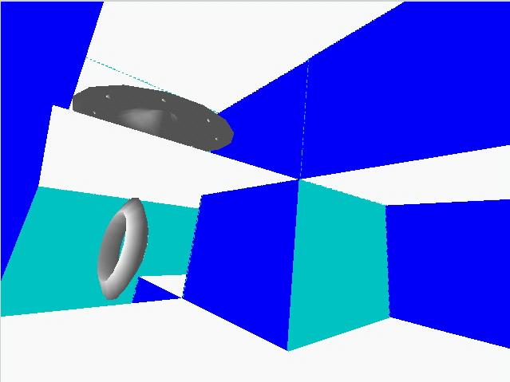
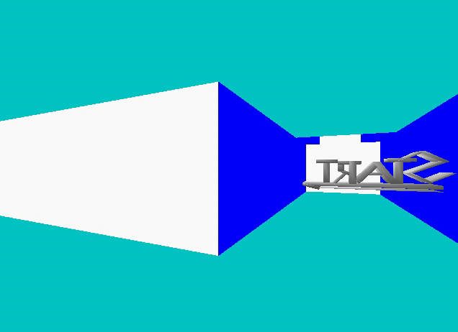
4.2.2 Collision Detection
Figure 7. A view of the VEMaze with two
objects.

Figure 8. A view of the VEMaze
from the start cell.

Collision detection is included in the maze in order to stop wayfinders from flying through the walls. It was decided that a lack of collision detection would lead to disorientation and would not contribute to exploration efforts.

The collision detection algorithm works as follows:
get viewers current position
get the cell the viewer is currently in
get viewers end position
get the cell the viewer will end up in
check if wall between the source cell and the destination cell is intact
if wall is intact than don’t allow movement m, else allow movement

See Appendix 4 for the code implementation of this algorithm.

4.2.3 Object Creation
The objects are created using AC3D under the Linux OS. The objects are saved as .off files and displayed in the VE through the use of object classes. The start and finish objects are given their own classes. The drop objects also have their own class. These objects (drop objects) are designed so that when they are dropped they will indicate the direction the users viewpoint is at the time the object is dropped. This provides an additional navigational aid to the user and it remains to be seen if users use this feature. Figure 9 and figure 10 show examples of the drop objects created. Ten Landmark Objects were created. The Landmark Objects as well as the End Point Objects are programmed to move to create some motion in the maze. They are made to spin along one or more of their axis. The set of landmark objects as well as the end point objects can be seen in Appendix 1, Object Group A.
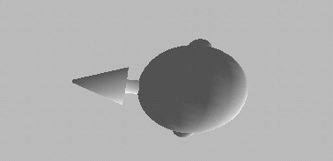
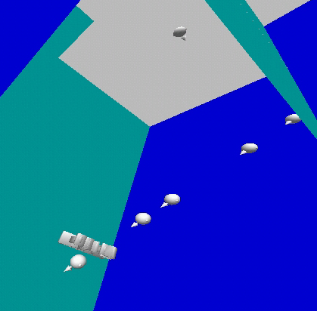

Figure 9 (above). A drop object
Figure 10 (right). A few drop objects in the

VEMaze

4.3 Travel Technique Implementation
The travel techniques are created by defining a class for each. This is done so that if a travel technique is needed, all that one needs to do is create an instance of its particular class. The four travel technique classes are programmed specifically for this VE application, with performance measurement counters and collision detection built in. As well as this specific set of travel classes, a generic set is also defined to be added to the Dane library. The generic set of travel classes do not have any performance measures or collision detection built in and can be used by anyone creating a VE application. The user of these classes can however use the OO capabilities inherent in Dane to very easily create specialized classes for specific VE applications.

4.3.1 Keyboard Based Travel Technique
The keyboard based travel technique was created to make use of key input by the user. The orientation keys included: ‘q’, ‘a’ , ’w’, ‘s’ and the left and right arrow keys. The movement keys included the forward and backward arrow keys. To drop an object the user would have to press the ‘d’ key. The keys were arranged in this manner because it allows each hand to have an even number of keys and thus prevents one hand having to deal with too many keys. It may have been better to arrange all the orientation keys in one area of the keyboard and the movement keys in another area. It has been decided to leave the key configuration like it is and gather data during experimentation about whether it is a wise decision to arrange keys in this manner. It was decided during the design process that the orientation changes would be relative to the current viewpoint of the wayfinder. This was implemented by finding the current orientation of the participants viewpoint and altering the viewpoint from that.

4.3.2 HMD (Gaze-Oriented) Based Travel Technique
The HMD based technique was implemented by attaching a Polhemus tracker to the HMD and tracking the users head movements. The user’s viewpoint would change according to head movements made. The movement (forward and backward) and the dropping of objects was implemented using the Stick II as input. The user would depress the index finger button on the device to move forward, depress the middle finger button to move backward and press the thumb button to drop objects.

4.3.3 Hand Based Travel Technique
The hand based technique needed to receive input from one of the participant’s hands in order to alter the user’s orientation. Initially, it was decided that a Polhemus tracker would be strapped to a hand. It was decided during design that the hand movement to change orientation should mimic that of the head movement. That is, if the user wanted to look up, she/he would orientate the tracker upwards. The leverage the wrist offered in terms of angling was found to be insufficient . It was therefore decided that some kind of joystick device was needed. The researcher attached a Polhemus tracker to the end of a stick (almost like a head on a neck). This device proved far more useful in terms of angling the viewpoint. The Stick II was implemented in the same way as it was in the previous section (4.3.2) for the movement (forward and backward) and the dropping of objects.

4.3.4 HMD-and-Hand Based Travel Technique
This technique was a combination of the previous two techniques. With this technique the head motion is tracked to provide the user with visual input of where he/she is looking. A hand is used to orientate the direction of travel. The two orientations are disparate so the user can be looking in one direction and travelling in another direction. This was implemented by using a Polhemus tracker on the HMD and the joystick created for the hand based technique. It is felt that this technique provides the most flexibility and power of all the techniques.

4.4 Evaluation Implementation
The goal of the experiment is to analyse various aspects of the travel techniques which may affect users ability to use them. Aspects include ease of use, ease of learning, level of spatial awareness, degree to which navigational tools (such as the landmark objects and drop objects) help aid exploration and degree of wayfinding individual travel techniques afford. As well as these major aspects the researcher also wants to gather information relating the VE and determine whether its design adds to the level of immersion felt by participants.
The feedback was recorded in a questionnaire. The questionnaire, as described in section 3.3, was created. It consisted of six main sections. The first section required general details such as age and computer experience to be filled in. The next four sections pertained to the actual test trials. Several questions have been set to help analyse the various aspects that were described in the feedback design section. The final section was a general feedback section asking for the participants’ ratings of the techniques and other such questions. This was done in order to get participants’ personal ratings of the techniques so that the mean favourite techniques could be determined. It was also intended to determine whether users felt the drop objects were necessary navigational aids and thus decide whether they are worth including in tasks involving exploration. The actual questionnaire used in the testing can be found in Appendix 2.

An observation sheet was created which would be used to record the order in which the techniques were tested in. The order in which techniques were tested was varied e.g. technique 1-2-3-4 or technique 2-3-4-1 or technique 3-4-1-2. This was done in an attempt to remove any possible biases that might develop in the data set as a result of certain techniques preceding others. It also contained sections where observations for each technique could be written and a section for general comments. This observation sheet can be seen in Appendix 2. The objects seen by the participants were recorded by the researcher who would watch the monitor which showed what the participants were seeing in the VE.

The performance measures defined in the design included distance travelled for each technique, level of success in finding finish cell, number of drop objects dropped and number of landmark objects seen. The first four performance measures were implemented in code. The distance covered every five seconds by the subject was recorded and the total distance covered when the time was up was recorded. The total number of drop objects dropped was recorded at the end of each trial as well as the total number of landmark objects seen.

4.5 Pretesting
Three participants were run through the experiment before actual testing started. This was done in order to check that the experiment could work, how long it would take and if any improvements or add-ons were needed. It was also important to finalize the format of the testing procedure so that the tests would be consistent and comparable.

The format of the pretest worked well. One participant was tested at a time. The purpose of the experiment was explained to the participant and they were then given a questionnaire. They were asked to fill out some general demographic details. They were then run through each of the trials. The participant was seated on a swivel chair in the Kennel (a dark room housing the input and output devices) and the HMD was fitted. Before each trial the manner in which the travel technique worked was explained to the participant and after each trial the participant was asked to fill out a section of the questionnaire pertaining to that trial. Once all this was done the participant was asked to fill out the last section of the questionnaire.

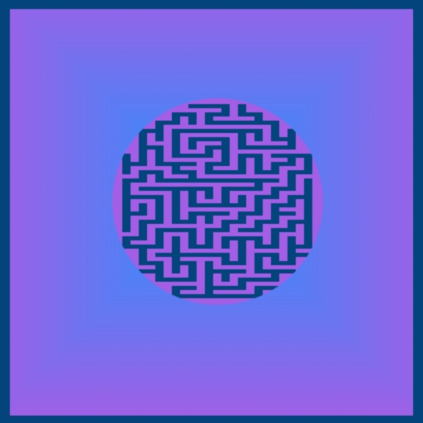
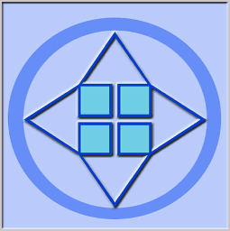
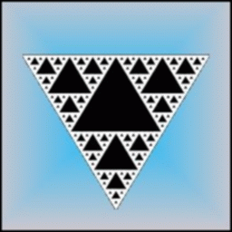
From the pretesting it was determined that a number of areas of the test and the VE application needed to be adjusted. It was found that participants were finding it hard to spatially orientate themselves with solid wall colors and it was thus decided to texture the walls. The textures were created using the GIMP under LINUX. The textures are shown in figures 11 to 13 below.
Figure 11. Wall Texture
Figure 12. Floor Texture
Figure 13. Ceiling Texture

It was also requested that an audio cue be added for when users collided with walls so that they could tell when they had collided. It was decided that two of the four techniques would contain audio cues and that users would be asked whether these cues helped them or not. This would add to the findings. An audio cue was also added that would be played when the trial time was up.

Originally it was decided to ask the participants to describe the objects they had seen in the maze. After the pretesting it was decided that instead of asking the participants to describe each object they would simply need to write down the numbers of the objects they had seen from a chart of objects that was given to them. It was also decided to create a different set of landmark objects for each trail so that participants didn’t get objects seen in one trial confused with those seen in another. The charts of objects created can be seen in Appendix 2, Objects Group A to D.

The size of the maze in terms of number of cells in the x, y and z planes needed to be adjusted. Originally a maze with the proportions 5x5x5 was implemented but this was too big and complex, given the time limit of 450 seconds, for the subjects to find the finish cell. The size of the maze was therefore altered to 3x4x5 so that the complexity would not be so great that the finish cell would never be found.

It was also suggested that a standard explanation of the experiment be created so that all participants were given exactly the same information. As well as this a few suggestions where given regarding the travel techniques that subjects may find useful. The explanation and suggestions were as follows:

Purpose of Experiment
The aim of this experiment is to examine immersive virtual reality (VR) travel techniques developed as well as other aspects of the user’s navigation. Immersive VR travel techniques are ways of navigating around a Virtual Environment (VE). You will be travelling through a virtual reality maze. There is a start and finish point. You should look for the finish point but this is not the end goal. The goal is rather to explore the maze and get to know the travel technique. Before you start you will be asked to fill out some general details. You will then be asked to test out each of the 4 travel techniques under study. After each trial you will be asked to answer a number of questions relating to your experience.

Two out of the four techniques you will be using contain audio cues for when/if you collide with a corridor wall. You will also receive an audio cue for when your time has run out.

Some useful hints when travelling around the maze include:
Using the swivel chair to rotate your viewpoint.
Note the objects you encounter.
Listen for the timeout signal (3 bangs) indicating the end of the trial.

With the changes made to the VE application the pretest was carried through to testing.

4.6 Testing
A total of twenty people were tested. The testing went well, with each test taking an average of 50 minutes to complete. The subjects had varying degrees of computer and VR experience. Personal ratings suggested mean level of computer experience of 4.1 (max 5) with lowest rating being 1 and the highest equaling 5. Of the twenty participants, fourteen had had prior VR experience, mainly with past CoRgi VE applications such as the Atlantis demo and the Roller-coaster demo. Both these two VE applications did not make use of any immersive VR travel techniques.

Only one female was tested and the rest of the participants were male. Out of the entire group of participants, three had to stop during trials due to nausea and sickness. Two stopped during the hand based technique and one during the HMD-and-Hand based technique. The age of the participants varied between 20 and 31 years. The mean age was 22.65. Of the twenty participants, only three answered that they suffered from motion sickness. Of those three, one had to stop the trial due to nausea and dizziness. Nineteen of the participants answered that they had played first person shooter games before.

4.7 Summary
This chapter described the implementation of the various aspects of the VE application that needed to be done in order for the testing to be carried out. An OO approach to code implementation was taken. The maze structure was implemented using a depth first algorithm and was brought to life using openGL. A number of landmark objects were created as well as a standard shape developed for the drop objects. All the travel techniques were created to use the HMD to provide users with visual input and a variety of devices were utilized by each technique for user input. The keyboard based technique makes use of the keyboard for input, the HMD based technique uses the Stick II for movement and dropping objects and tracks users head movements to provide orientation input. The hand based technique makes use of joystick created by the researcher for orientation input and makes use of the Stick II in the same way as the HMD based technique. The HMD-and-Hand based technique is a combination of the latter two techniques and provides disparate input for direction of movement and direction of the viewpoint. The evaluation measure implementations were described and the results from the pretesting trials highlighted. Changes had to be made after pretesting, included changes to the VE itself (textures) and the addition of audio input for collision detection. Finally a description of the testing itself was given. The next chapter looks at the results of the testing process.


Chapter 5
Results

5. Results
This chapter takes an in-depth look at the data collected during the testing period discussed in the previous chapter. The data pertaining to the three evaluation categories (performance measurement, feedback and observation) will be presented individually in the first three sections. The chapter ends with a summary of the results.

Appendix C contains some of the data collected during the testing that pertains to the charts presented in this chapter. A full set of data is available on the CD provided.

5.1 Performance Measurements
The performance measures discussed in this section include those captured digitally during the experimentation phase. These include distance measurements, number of objects dropped and measures of success in finishing the finish cell. Each immersive travel technique will be discussed in relation to these performance measures.

5.1.1 Distance Measurements
During each trial the forward, backward and total (a summation of forward and backward) distance per time period was recorded for each participant. The distance data collected was recorded in a spreadsheet package and the sum of distances travelled for each trial, for each participant, was calculated. Chart A1 displays a pie chart of the total distances travelled on average by each technique. Chart A2 displays the mean distance recorded per travel technique and includes the mean distances for forward, backward and combined distances travelled.
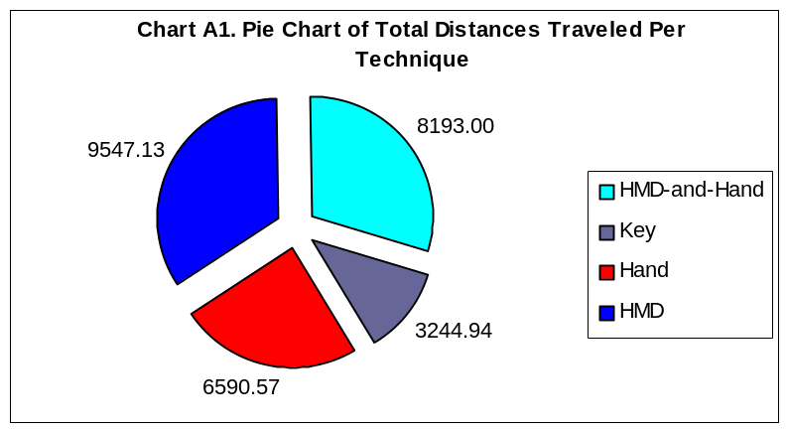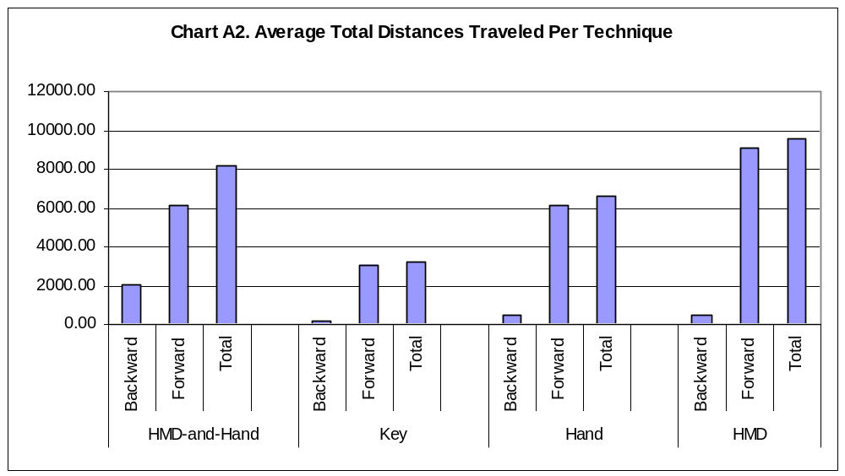

Distance is considered an important performance measurement in determining the usefulness of a technique. This is because it is felt that the further a subject travels the more exploring they will doing, and therefore the greater the chance will be of finding the finishing cell. Distance can also be used for a measurement of learning levels of the techniques. Certain techniques may be easier to learn than others or more intuitive than others. Such techniques will lead to the user reaching a consistent average distance per time interval more quickly. Distance can also be seen as an indication of effectiveness and efficiency. Techniques that participants travel further in can be deemed more efficient and effective than other techniques.

Analysis of the distance data proved very interesting. A number of conclusions can be drawn about each technique based on this performance measurement. It can be seen from Chart A1 and Chart A2 that the HMD based technique outperformed all the other techniques in terms of mean total distances travelled. This was mainly due to the mean forward distance traversed. The HMD-and-Hand based technique has the greatest mean backward movement by a long shot. From Chart A2 it can be seen that the HMD based technique and the HMD-and-Hand based technique are fairly similar in terms of mean total distance travelled with a difference of only 1394.13. The keyboard based technique performs the worst in terms of distance traversed in any direction followed by the hand based technique.

From the analysis of the mean total distances it is deduced that the HMD based technique is the most efficient technique used. It can also be assumed that the HMD-and-Hand based technique provides the greatest affordances for utilizing the directional utilities out of all the travel techniques. This would lead the researcher to believe that this technique afforded the greatest degree of utilization of travel technique attributes as the ability to travel backwards is well used. The other techniques show little sign of backward movement utilization. It can be inferred that the keyboard based technique was the most ineffective an inefficient of all the techniques. The charts show a large gap between the mean total distances for this technique and the other three techniques.
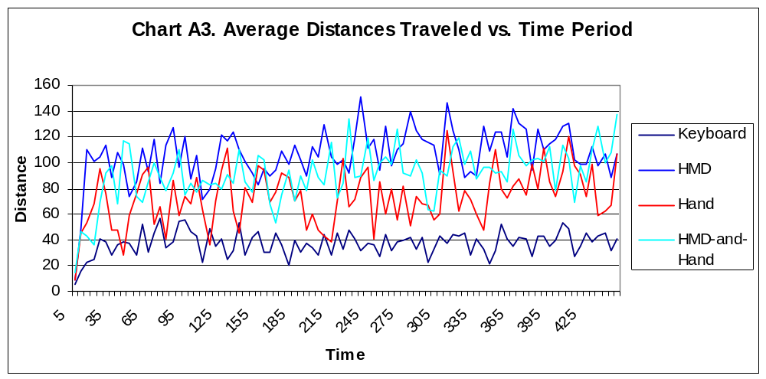
Chart A3, Chart A4 and Chart A5 reveal other interesting phenomena concerning the travel techniques. Chart A3 presents the average distances travelled per time period for each technique. Chart A4 and Chart A5 present two regression formulae that were applied to the data. These regression formulae include linear regression and power regression.

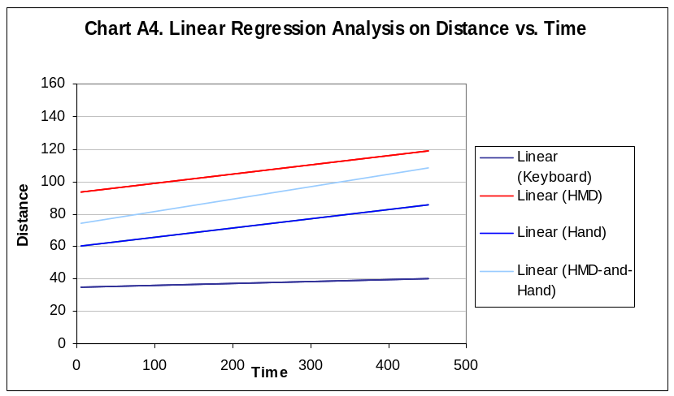
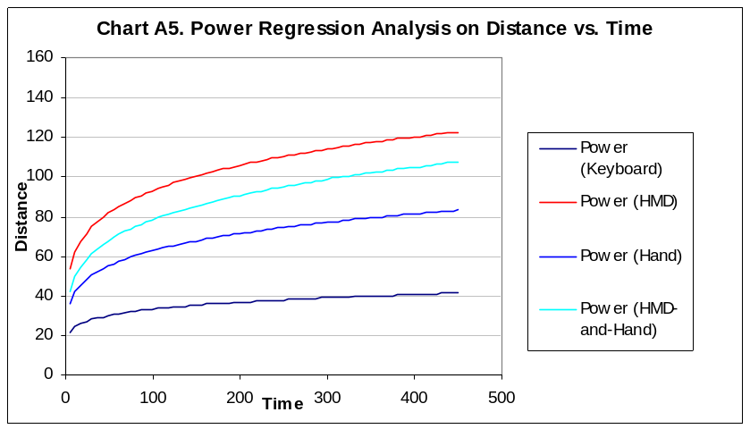
The regression lines indicate a number of aspects concerning the travel techniques. From Chart A4 it appears that as time elapses the distances travelled per time period increases. This implies that some kind of learning has taken place. It can be seen from this chart that the keyboard based technique is the most consistent technique in terms of distance covered per time period. Because the angle of the line is the least steep of all the travel techniques, it seems as though the keyboard based technique is the easiest technique to learn. However, very little improvement in distance covered per time interval is made as the time increases. As well as this, this technique has the smallest average amount of distance covered between time intervals. This indicates that the keyboard based technique is the hardest technique to use and that participants find it consistently difficult to use over the entire time period.

Chart A5 distinctly shows learning curves for all the travel techniques. This chart shows that distances for the techniques rapidly increases in distance per time period between 0 and 60 seconds, indicating that most of the learning for the techniques occurs in the first minute or so. After the first sixty seconds, the curve straightens out to a steady angle. The angle of curve after sixty seconds is smallest for the keyboard based technique. Coupled with the lack of distance covered as compared to the other techniques, the point raised earlier is reiterated: that this particular technique is the most consistently difficult technique to use.

Similar conclusions can be drawn for the other travel techniques. The HMD-and-Hand based technique has the steepest curve once the initial learning curve straightens out. This, together with the fact that it has the second highest average distances covered per time period, indicates that this technique is a difficult technique to learn initially but users find it increasingly easy to use over time.

Of the three techniques, the technique with highest average distance covered per time period is the HMD based technique. This technique also has the least steep curve. This indicates that this technique is the easiest technique to learn and that users increased in competency with the technique over time. From the distance data collected it appears that this technique is the most efficient.

Of the three techniques including the HMD, hand and HMD-and-Hand based techniques, the hand based technique has the lowest average distances covered per time period. Its curve is steeper than the HMD based techniques curve but less steep than the HMD-and-Hand based technique. This indicates that this technique is the hardest technique to learn and use of the three techniques but that users become better at using it over time.

5.1.2 Other Performance Measurements
The performance measures to be discussed in this section include drop objects, collision detection and success in finding the finish cell.

5.1.2.1 Drop Objects
Drop objects can be used as a performance measure because they give an indication of the level of wayfinding being done by the participant during the trials and are a form of navigational tool. The participants use the drop objects when they are concentrating on navigating and not when they are concentrating solely on learning to use the technique. Chart A6 displays the average number of objects dropped per participant for each technique.
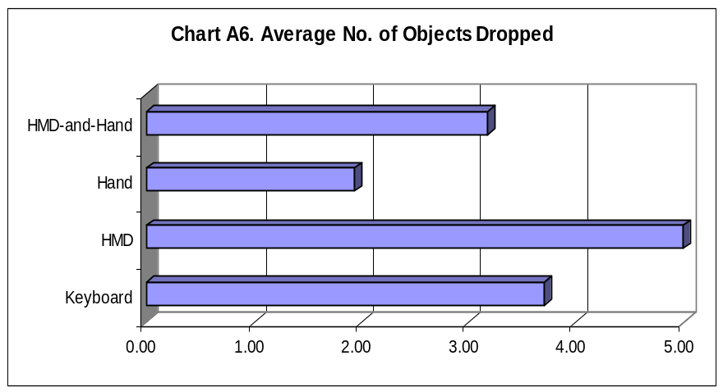
From Chart A6 it can be seen that the HMD based technique had the highest number of drop objects dropped per participant, closely followed by the keyboard based technique. This indicates that participants concentrate on wayfinding the most with the HMD based technique, followed closely by the keyboard based technique. The hand based technique has the lowest number of objects dropped. This indicates that users spend most of their time concentrating on learning to use this technique. It should be noted, however, that the difference in the number of objects dropped is very small and due to this, no concrete conclusions can be drawn from these results. It can however be noted that many subjects did use these drop objects for navigational purposes. They are therefore effective navigational tools to be included when tasks such as exploration and wayfinding are needed.

5.1.2.2 Success in Finding the Finish Cell
Successfully finding the finish cell can lead to a number of conclusions. If it can be shown that certain techniques lead to a consistently greater number of successes, then it indicates that those techniques lend themselves more to wayfinding. It also indicates that these techniques may be better suited to tasks that require exploration. By successfully navigating the maze to find the finish cell it can be asserted that the users have a greater degree of spatial awareness. Chart A7 shows the number of successes per technique.
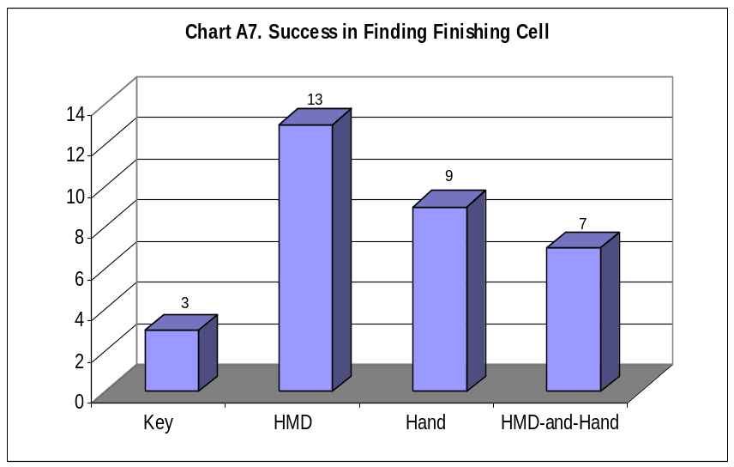
The HMD based technique has the highest recorded number of successes and it could be suggested that if a particular VE application task requires exploration then this would be the technique to choose. The keyboard based technique has the least number of successes. These results indicate that participants explore more of the maze and have a better idea of the maze when using the HMD based technique, than when using the other techniques.

5.1.2.3 Landmark Objects
Participants were asked to remember as many landmark objects as they could whilst immersed in the VE. They were then asked to look at a chart of objects they may have seen and write down which ones they had seen. The number objects seen by each participant was recorded. From the data it is hoped that some sort of relationship between the travel techniques and number of objects seen will be found. It is felt that if certain techniques yielded better results between the number of objects participants thought they had seen and the number of objects actually seen, then assumptions about the level of cognitive load required by the techniques could be made. As well as this, if certain techniques have, on average, more landmark objects seen by participants than others, then it indicates that these techniques afford the user with a greater opportunity for exploration and wayfinding. As with the previous section, these results depended on the speed at which participants could learn the technique and traverse the maze. Chart A8 shows the difference in the number of objects seen vs. the number of objects the users thought they had seen. Chart A9 shows the average number of objects seen per technique.
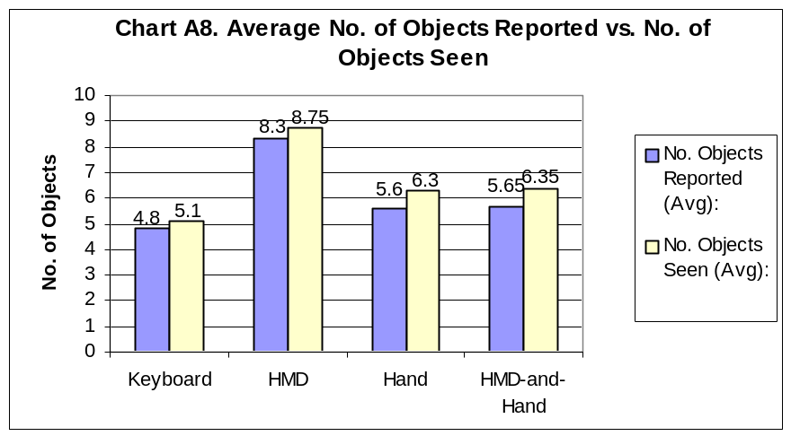
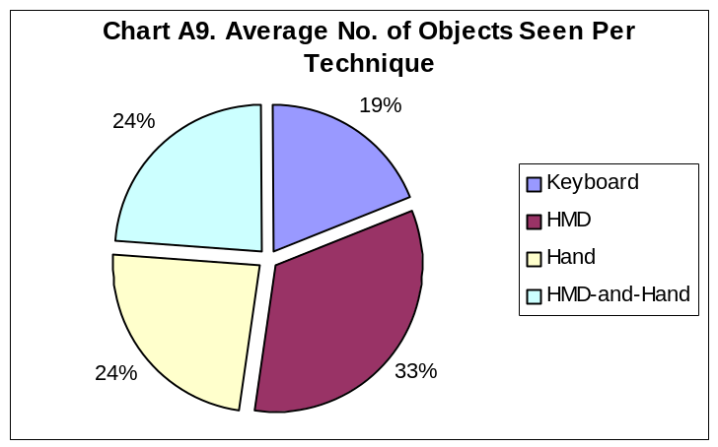
From the chart it is clear that the participants saw the most landmark objects using the HMD based technique. This indicates that subjects traverse more of the maze using this technique and that the levels of exploration are the highest for this technique. Both the hand based technique and the HMD-and-Hand based technique have on average the same number of landmark objects seen. The keyboard based technique, which also had the least distance covered on average and the least number of successes in finding the finish cell, had the least number of landmark object seen on average.

In terms of mean error in the number of objects reported versus the number of objects actually seen, it is interesting to note that on average, subjects report to have seen fewer objects than they had, for all the travel techniques. The keyboard based technique has the smallest mean difference (0.3) followed by the HMD based technique (0.45), the hand based technique (0.7), and the HMD-and-Hand based technique (0.7). From these findings it is felt that the differences are not significantly large enough to justify a difference in the level of cognitive load of each travel technique.

5.2 Feedback
This section looks at the results of the data collected from the questionnaire completed by the participants. The data collected includes qualitative feedback concerning the individual travel techniques and the VE application. This section is divided into a number of subsections. These subsections include feedback about the VE itself (including collision detection and drop objects), feedback comparing all the travel techniques and feedback concerning individual techniques.

5.2.1 The VE Application
Most of the participants enjoyed navigating through the VE but there were a number of criticisms. Many felt that the colours of the walls were too bright and that they should be altered. It was suggested that different textures be used which would help more with navigating. Some participants suggested using images on the walls instead of abstract textures. It was recommended that a variety of textures be used in different areas of the maze and that by doing so it would be easier to remember where one was in the maze. A number of participants felt that some kind of ambient sound in the background would help them feel more immersed in the environment. They also felt that poor picture quality may have decreased the level of immersion they felt. It was felt that if the maze were more lifelike then participants would feel more immersed.

5.2.1.1 Hardware and Software
A number of problems with the hardware and software became evident once the feedback data was analysed. Most of the participants complained that the cords attached to the HMD, joystick and Stick II got in the way and detracted from their VR experience. Many participants found that their eyes were uncomfortable and strained using the HMD. These complaints are consistent with earlier work done by Mundell using the same devices. Mundell reported that criticism of the HMD included eye straining and discomfort after only a few minutes use [Mundell, 99]. Many subjects also complained about the lag in the visual output and some suggested that this lag might be the cause of the nausea they were feeling. The lag is caused by software. There is a bottleneck in the system caused by the data being sent from the Pentium 133 machine to the machine running the VE application. This results in a very slight delay that many subjects picked up.

5.2.1.2 Collision Detection
All the participants agreed that the audio cue helped them realize that they had collided with the walls and that it should be included in the design. Some commented that they wanted the audio cue in the techniques that did not have them, so that they could tell more quickly when they had collided with a wall. A suggestion was made that when one collided with a wall one could slide along the wall instead of just stopping dead. It is therefore recommended that audio cues be included in VE design to provide some sign of an event occurring when no physical feedback is possible (such as a sore head when you run into a wall!).

5.2.1.3 Drop Objects
Chart B1 shows a pie chart of those subjects who made use of the drop objects (70%) versus those who didn't make use of them (30%). The participants commented that the drop objects helped them stop moving in circles and helped them mark where they had been. One participant suggested making the drop object a different color than the other objects in the maze, so that it could be more easily distinguishable. Most of the participants who made use of this navigational tool used the drop objects to mark corridors which they had been down. One participant said that he had used the drop objects in the Hansel and Gretel manner. Feedback about the drop objects suggests that they are useful navigational tools and are worth including in tasks relating to exploration.
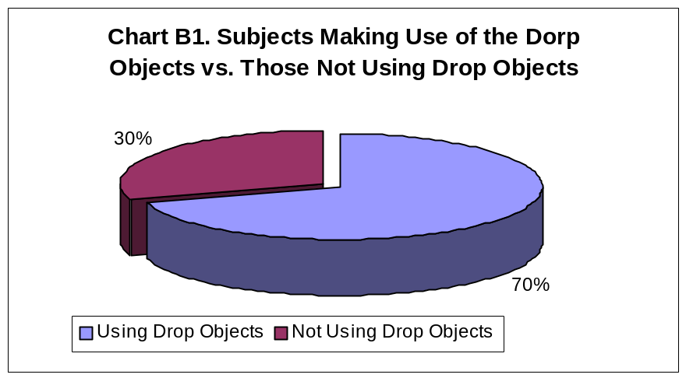

5.2.1.4 Landmark Objects
Many of the subjects asserted that they had used the landmark objects as points of reference to help them remember where they were in the maze. Some suggested that the objects be more realistic and that less abstract shapes be used, as they had trouble remembering which ones they had seen. It is felt that by shading the objects in different colors and textures they could have been more easily distinguishable. Some participants used the landmark objects as a target to aim for when travelling. They said that these objects helped them travel in a set direction.

5.2.2 Feedback Comparing Techniques
This section uses feedback from the various travel technique questions, which participants had to answer, to compare and contrast the different travel techniques. The results of several questions that were asked after each trial are used. These results pertain to the questions about ease of use of the techniques (Q1), the difficulty to learn the techniques (Q2), the amount of time spent concentrating on the technique versus the amount of time spent wayfinding (Q7, 8, 9), the level of spatial awareness felt (Q10) and finally the degree of comfort felt using the techniques (Q13). Appendix 3, Chart 1 presents a bar chart of all the results of these questions. The data used to draw the following charts is available in Appendix 3.

5.2.2.1 Ease of Use
Chart B2 shows the mean ratings given by the participants for the techniques’ degree of difficulty. A rating of one means that the technique is very difficult to use and a rating of 5 means that it is very easy to use. From the chart it can be seen that users find the keyboard based technique the most difficult to use with an average rating of 2.15 given. This is followed by the hand based technique (2.9), then the HMD-and-Hand based technique (3.2) and finally the HMD based technique which got the highest rating for ease of use. These results are consistent with those results found in the regression analysis of the distances covered. It is thought that the keyboard based technique is the most difficult to use, based on the relatively small amount of distance covered per time period. This is mirrored by the HMD based technique, which has the highest average distance covered per time period. It is interesting to note the correlation between the average total distances travelled and the mean ease of use ratings given per technique. Both follow the same pattern, with HMD having the highest scores, then the HMD-and-Hand based technique, followed by the Hand based technique and finally the lowest scores coming from the keyboard based technique. These findings suggest that there is a definite correlation between the ease of use of techniques and the average distances that can be covered using these techniques.
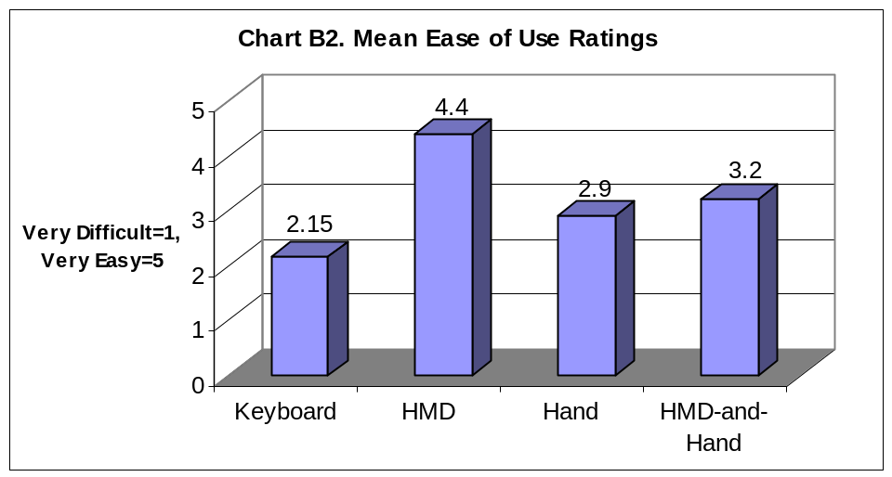

5.2.2.2 Difficulty to Learn Techniques
Chart B3 displays the mean ratings for the degree of learning difficulty participants gave for each technique. The closer the rating is to five the easier the technique is to learn and the closer the rating is to 1 the more difficult it is to learn. From the chart it can be seen that the HMD based technique is the easiest technique to learn. This is likely due to the fact that it is an intuitive technique that subjects come to terms with very quickly and without too much cognitive effort. The hand based technique has on average the lowest rating. It is interesting that on average the HMD-and-Hand based technique was seen as easier to use than the hand based technique. This is due to the fact that the subjects have more control over where they are looking because of the head tracking, and only have to concentrate on synchronizing the hand and the head. The hand based technique does not offer the same stability as the head tracking provided in the HMD-and-Hand based technique and this results in the participants finding the hand based technique harder to use.
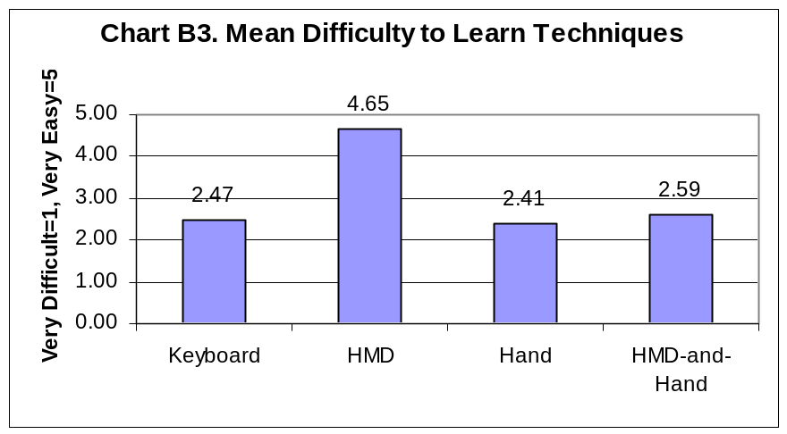

5.2.2.3 Difference in time spent trying to use techniques vs. time spent wayfinding
Three questions were asked concerning the amount of time spent trying to use the travel technique and the amount of time spent wayfinding. It is felt that the more time a participant spends wayfinding the more unobtrusive and ubiquitous the travel technique. It is also felt that if participants find that they are spending very little of their time wayfinding then the technique is difficult to use and will lead to less distance, on average, being traversed. Chart B4 shows the mean ratio between the two variables. From this chart it can be clearly seen that participants feel that they spend most of their time trying to use the keyboard based technique whilst concentrating very little on the actual wayfinding process. The reverse can be said about the HMD based technique. It can be asserted, after viewing this chart, that the HMD-and-Hand based technique is better for wayfinding than the hand based technique. This observation reinforces the earlier findings in which participants find the HMD-and-Hand based technique easier to learn than the hand based technique. This chart also shows a correlation between ease of use and wayfinding. If the technique is easier to use, the potential for wayfinding is increased. In section 5.2.2.1 it was shown that users find the keyboard based technique the most difficult to use even though it is not the most difficult to learn. We can therefore assume that ease of use plays a more important part in wayfinding than does ease of learning.
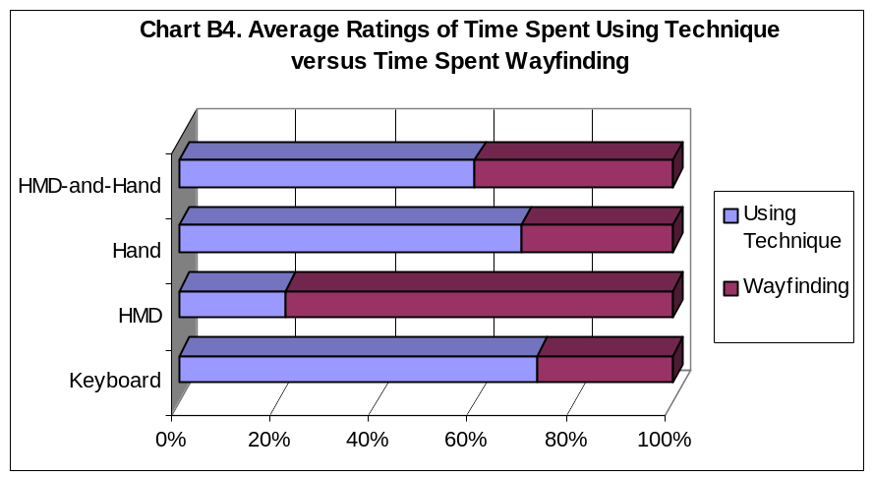
Chart B5 shows another perspective to do with this issue. This chart shows the results of ratings given for question 7 and 8 of the questionnaire sections concerning the separate trials. We can tell from the chart that participants feel that they spend on average twice as much time trying to use the keyboard based technique than they do wayfinding. The point evolved earlier in this section concerning the hand based technique versus the HMD-and-Hand based technique can be reiterated here. The more time spent wayfinding directly correlates to the distance traversed by the various techniques. The HMD based technique has the highest rating for time spent wayfinding and it also had the highest average total distance traversed. The same conclusions can be drawn about the HMD-and-Hand based technique, which has the second highest mean total distance traversed, and the second highest amount of time spent wayfinding. One can draw the same parallels for both the hand and the keyboard based techniques.
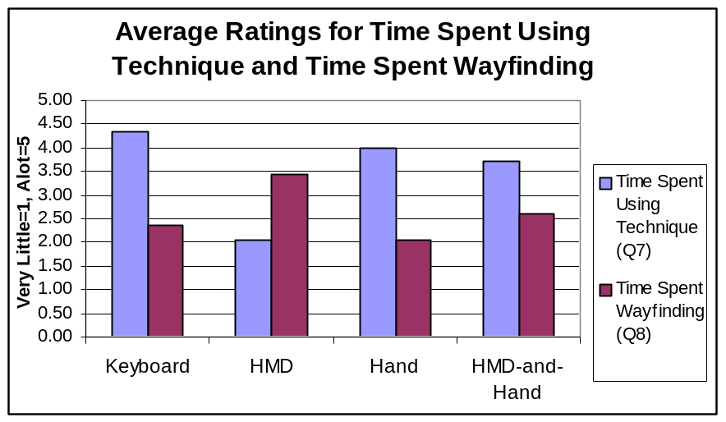

5.2.2.4 Travel Technique Preference Ratings
The following chart (Chart B6) shows the personal ratings subjects gave the travel technique. They were asked to rate the four techniques from their favourite to their least favourite. From the chart it can be seen that no participants rated the keyboard based technique or the hand based technique as their favourite. The HMD based technique was most liked with thirteen of the twenty participants preferring it to any other travel technique. The HMD-and-Hand based technique only took seven first place votes. The hand based technique took six second place votes with the HMD and HMD-and-Hand based technique both getting five second place votes.
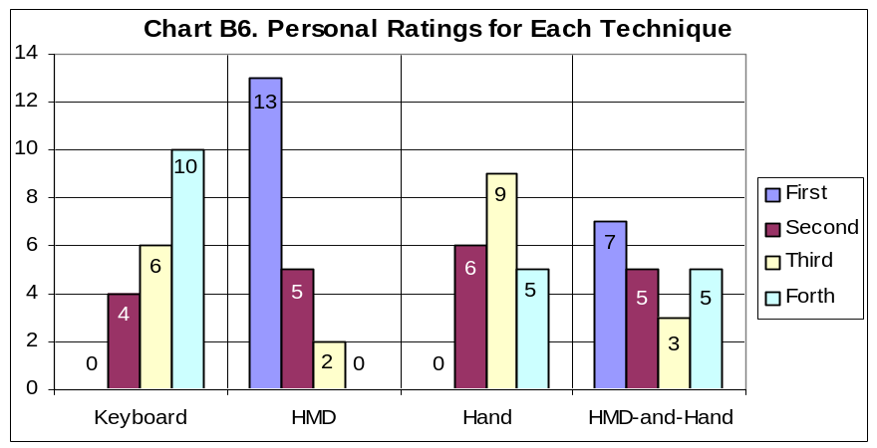
Participants who found the HMD based technique their favourite offered the following reasons: they found it the easiest technique to use, the most intuitive technique to learn and the most natural of the techniques to use. Participants who enjoyed the HMD-and-Hand based technique suggested the following reasons for why they voted for it as their favourite: Some found it the easiest technique to use once they had learnt it. They felt that this technique provided the greatest freedom of movement and that this technique was the most powerful technique even though the HMD based technique was easier. Some found the HMD-and-Hand based more physically interactive and functional. Participants found that this technique provided them with more control over their movements and some suggested that they enjoyed using it the most because it was similar to human motion.

From the findings it is clear that participants preferred a greater level of ease of use when choosing their favourite technique. It is also clear that many individuals prefer techniques that provide them with more control and opportunity to move with greater power over movement. It can be seen that subjects did not enjoy the hand based technique and a likely reason for this is that it is more difficult to use. This is certainly true for the keyboard based technique. Perhaps if the keyboard based technique had provided the users with extra benefits that added more power to their movements (e.g. running or strafing) they would have enjoyed using this technique more.

5.2.2.5 Spatial Awareness
Question ten of the trial questions posed the question asking participants to rate how often they felt they were aware of where they were in the maze. The higher the rating a technique is given, the more aware the participant is of his/her position in the maze. Thus, travel techniques with a higher mean rating afford participants with greater levels of spatial awareness. Chart B7 show the mean ratings given.
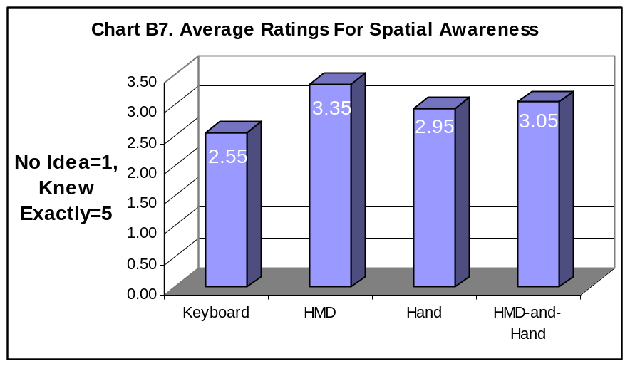
From the chart it is clear that the HMD based technique yields the highest degree of spatial awareness followed by the HMD-and-Hand based technique. The difference in mean ratings is not very big but significant enough to rate the techniques. The keyboard based technique is the clear loser here. This was probably due to the difficulty users found in using this technique. The more time spent trying to use the technique the less time is spent on getting to know the VE and therefore the less spatially aware the user. Thus ease of use plays an important part in spatial awareness.

5.2.2.6 Comfort Ratings
The HMD was rated on average the most comfortable of all the techniques. The keyboard based technique was rated second most comfortable. It is believed that this is due to the stability of these two techniques. The other techniques tend to be harder to control and more disorientating. It is interesting to note that the three cases of extreme illness, causing participants to stop the trial they were doing, involved the hand based technique and the HMD-and-Hand based technique. This indicates that the hand control is a likely stimulator of motion sickness. The very jerky and erratic movements common to the two techniques making use of the hand control is a probable cause of sensory conflict. It is therefore advised to avoid creating travel techniques which lead to jerky and erratic movements such as the two techniques mentioned earlier.
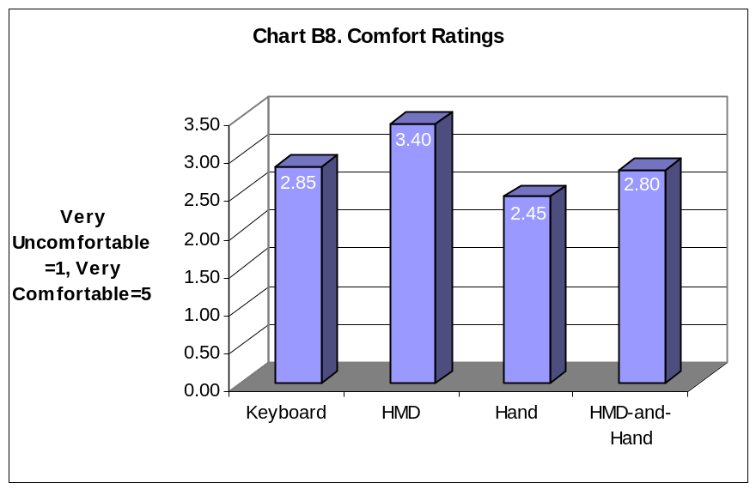

5.2.3 Individual Technique Feedback
This section provides information collected about the individual travel techniques. It includes qualitative information collected from the answers to the questionnaire. This information includes problems participants found with the techniques and suggestions they made for improving the techniques.

5.2.3.1 Keyboard Based Technique
Participants reported a number of specific problems they had with this technique. Many subjects found using the keyboard difficult and some noted that they could sometimes not find the keys. They found that getting the orientation correct was very difficult and not intuitive. They tended to get confused by the orientation for the individual keys affected. Some participants suggested assigning better keys and some suggested allowing the participants to calibrate the keyboard themselves. Most participants requested that the controls be kept constant and that a global angle be used to change orientation rather than the local angle. One participant suggested keeping all the orientation buttons in one area of the keyboard. Several requests for strafing buttons were also made. A number of participants complained of slight feelings of nausea and dizziness.

5.2.3.2 HMD Based Technique
Participants found a few problems with this technique. Some found it hard to orientate their viewpoints along the vertical plane. That is, they found it difficult to look down or up. Certain subjects asked for strafing capabilities to be implemented and said that it would allow them more manoueverability in the maze. One participant said that he felt claustrophobic in the maze using this technique and that more open area might help him feel less claustrophobic. Most of the participants felt nauseous and dizzy after using this technique. Some explained that they felt dizzy as a result of spinning on the chair. A number of subjects also complained about sore necks. Participants seemed content with the Stick II control, which is used to move forward and backward, and there were no complaints about this device.

5.2.3.3 Hand Based Technique
There were quite a few complaints associated with this technique. Most participants complained that it was hard to learn and was "very difficult". They remarked that it was easy to become disorientated using the joystick. Subjects reported that this technique was uncomfortable and that orientating the viewpoint was difficult - "hard to steer". A suggestion was made for the implementation of a "safe button" which could be used to re-orientate the user to a standard orientation and position in space. One subject suggested that the joystick be implemented in the same way a normal analogue computer joystick is calibrated. Most subjects complained of nausea and two subjects had to stop their trial because of an intense feeling of dizziness and motion sickness.

5.2.3.4 HMD-and-Hand Based Technique
Most subjects found it difficult to synchronize the hand control (joystick) and the head tracking. They found it very difficult to keep track of the direction of movement and said that it was very challenging to learn and use. Many participants reported that it was easy to lose track of the orientation of the hand control when looking around. A number of suggestions for improvement were made by the participants. It was suggested that an arrow should be displayed showing which way the joystick was pointing. This suggestion was reiterated by several participants who requested some kind of motion vector or visual calibration of the joystick be displayed. One subject suggested limiting the joystick movement to one hundred and eighty degrees of freedom. Another suggestion was that the joystick be designed in such a way that it was obvious how to hold it. Subjects complained about nausea and dizziness as well as sore necks. One subject had to prematurely stop the trial due to motion sickness.

5.3 Observations
Participants were observed during each trial by the researcher. As a result each technique has a number of observances associated with it. This section will therefore be broken into four sections, one for each travel technique.

5.3.1 Keyboard Based Technique
Most of the participants maintained a motionless posture for this technique. Some did move their heads a little in what seemed a desperate attempt to look around. Those participants who found the technique very difficult to use tended to hang around the same area while trying to learn the technique. It was noted that the standard strategy to navigate somewhere was to stop, look around, orientate oneself in the direction of travel and then move. This stop-orientate-move was more a result of the technique design, which didn't allow for concurrent key presses. It seemed that in some instances not being able to see the keys on the keyboard was a problem. It was noted that most of the participants tried to maintain a horizontal viewpoint orientation, which mimicked the viewpoint one naturally has during walking. This indicates that subjects may be more comfortable travelling using techniques that are more natural and familiar. Two participants did fly around at angles that were not horizontal.

5.3.2 HMD Based Technique
It appeared from the observations that participants caught on to this technique very quickly and that they started exploring the maze very soon after they had started the trial. By the end of the trial participants were generally fully utilizing the techniques capabilities. Participants made use of the swivel chair a lot to flip their orientation. Some subjects appeared more observant and took time out to get different viewpoints of landmark objects. As time passed it seemed that most subjects got more confident and flew around the maze at a faster pace. This explains the steady upward slant of the linear regression line in chart A5.

5.3.3 Hand Based Technique
Some of the participants appeared to become very frustrated while trying to learn how to use this technique. Subjects tended to use their heads a great deal in an attempt to look around, even though this had no effect. Most subjects did not use the swivel chair to start with. They seemed to think that by raising and lowering the joystick they could look up or down. This, however, was not how the joystick worked and some subjects never became aware that they needed to tilt the joystick in a similar way tilting the head in order to look up and down. One participant placed the joystick on his head and moved his head. Of course this strategy worked well because the joystick worked in the same way the head tracking worked. It was noted that often participants would follow their hand movements with their head unconsciously. This occurred very rarely with the keyboard based technique suggesting that perhaps the physical feedback of the joystick provides better proprioceptive feedback than the keyboard. It may also explain why some participants became very nauseous whilst using this technique. It seems as though this technique conflicts with natural feedback mechanisms in the body.

5.3.4 HMD-and-Head Based Technique
It was observed that when participants initially started using this technique they did not synchronize the hand and the head movements, which would result in a far more fluid and consistent travelling movement. Many also remained still in the swivel chair to begin with until they had used the orientation devices for a while. It was found that after subjects had become more accustomed to the disparate nature of the controls they started using the technique more fully, and began making use of the swivel chair. Some participants picked up the technique fairly quickly and after this happened they started having fun in the maze and exploring. Other participants never came to grips with the technique and could not synchronize the movement. The relatively short trial time could be a reason for this and it is thought that if participants are given more time they can become far more proficient with this technique. Some subjects became very frustrated and exclaimed, "it doesn't work!" One participant placed the joystick on the HMD so that he could synchronize the two devices easier. It was noted that when a participant lost the synchronization it was difficult for them to regain it. It may therefore be a good idea to provide the users of this technique with a visual indication where the hand is currently pointed. It appeared as though the participants who managed to come to grips with the technique and who could fully realize its capabilities preferred this technique to the HMD based technique. This may mean that if participants are given more time to become proficient with this technique they will in general begin to enjoy it more than the HMD based technique.

5.4 Combined Results
The primary objective of the project is to develop an efficient and effective way for users to navigate in a VE application. In order to do this it is intended to develop an understanding of the properties of travel techniques, their strengths and weaknesses. The experimental design has focused around gathering and analysing data concerning several aspects deemed important for effective travel. Such aspects include ease of use, ease of learning, degree of spatial awareness, the degree of wayfinding and exploration a travel technique affords the user and navigational aiding. It is believed that these aspects have been analysed effectively by the researcher. This section seeks to assimilate and explain the findings and draws parallels between several discoveries made.

From the findings the HMD seems to be the easiest to use. Not only did the distance data collected point to this but the feedback from participants indicated that the majority found this technique the easiest to use. The HMD-and-Hand based technique comes second in this aspect. This technique is rated as the second easiest technique to use by participants and also has the second highest mean distance covered per time period. The hand based technique is the second most difficult technique to use with the most difficult technique to use being the keyboard based technique. It can be deduced from the data collected that the ease of use of a technique directly correlates to the expected distance per time interval covered, with techniques which are more difficult to use having a smaller mean distance covered.

Data collected indicates that the hand based technique is the most difficult to learn to use with the keyboard based technique coming second. The HMD based technique is the easiest to use. This is due to the intuitive and natural nature of this technique. The HMD-and-Hand based technique is rated second easiest to use and again this is likely due to the natural feeling generated from the head tracking. The participant ratings were backed up by the learning curves generated from the distance data collected.

It has been determined that users spend more time trying to use the keyboard based technique than performing the wayfinding task. This is the likely cause for this technique scoring the lowest number of successes in finding the finish cell. The highest ratings for level of spatial awareness is given to the HMD based technique followed by the HMD-and-Hand based technique. It is asserted that techniques that provide a greater sense of spatial awareness lend themselves more to wayfinding and this assertion is supported by these two techniques, which had the greatest average distances covered.
From the data collected the HMD based technique proves to be the most comfortable followed by the keyboard based technique. The relative stability of the user viewpoint of these techniques contributes to these ratings because participants tend to feel less nauseous during the use of these two techniques than with the other two techniques.

The techniques have been analysed and their strengths and weakness have been revealed. The researcher believes that after considering all the different performance metrics, the technique most suited to the users’ needs is the HMD based technique. This is followed by the HMD-and-Hand based technique. The hand based technique is third best overall with the keyboard-based technique the overall worst technique.

5.5 Specific Problems and Improvements
This section highlights specific problems the researcher has found with the VE and the travel techniques and proposes improvements which can be made to improve the system.

5.5.1 The VEMaze
The maze is not realistic enough and this could have contributed to users feeling less immersed. VE should also attend to as many of the senses as possible and it is believed that the sense of hearing was catered for. The objects themselves are also not unique enough and could benefit from being textured. Specific improvements therefore include:
More Realistic Textures,
Ambient Sound,
Textured Objects,
Variety of textures for different areas of maze (this would provide more survey information).

5.5.2 Keyboard Based Technique
There are a number of specific problems inherent in this technique. The change of orientation relative to the current viewpoint makes using the technique very difficult. The lack of concurrent key presses also slows down movement and forces a stop-orientate-move strategy. The keys should also be easily calibrated for tailoring to individuals preferences. The degree of maneouverability can also be improved, as at present it is very small. Specific improvements therefore include:
Incorporating concurrent key presses,
Make orientation changing global,
Make keys easily calibrateable,
Include a strafing movement to increase manuverability.

5.5.3 HMD Based Technique
This technique does not have very many problems. One problem found is that the degree to which one can look along the vertical plane is limited. The degree of manuverability is also limited. Subjects cannot perform advanced movements such as strafing. Such movements will add to the power of the technique. Specific improvements therefore include:
Add strafing buttons,
Increase the sensitivity of orientation along the vertical plane.

5.2.2.3 Hand Based Technique
The joystick orientation mechanism is difficult for users to use and it is easy for users to become disorientated. This tends to result in nausea. The manuverability inherent in this technique is also limited in the same way as the previous two techniques mentioned. It is also not clear enough as to how the user should hold the device. Specific improvements include:
Incorporating a reset button to restore orientation to a standard direction and position.
Design a device that was more intuitive to use in the hand.
Include a strafing button to add to the manuverability of this technique.
Decrease the sensitivity of the technique to increase stability.

5.2.2.3 HMD-and-Hand Based Technique
A major problem with this technique is the level of difficulty in synchronizing the head and the hand orientation devices. Another problem is that when the synchronization is lost it is difficult to regain control. Improvements to made include:
Incorporating a reset button to restore orientation to a standard orientation and position as well as synchronizing the two input devices.
Include a visual indication of the orientation of the hand control – this could be done in the form of a motion vector or in the form of virtual representation of the hand.

5.5 Summary
This chapter looks at the data collected during the experiment. A number of conclusions are drawn from the data. The performance measurements show that distance is a valuable performance metric and that certain techniques consistently outperform others in terms of average distance covered per time period as well as total distance covered for the entire time period. The other performance metrics monitored also reveal some interesting results. It is found that travel techniques which have higher mean distances traversed than others tend to yield a higher amount of objects seen by participants. From the feedback it is clear that the VE needs some improvements and that generally the HMD based technique is the travel technique of choice. The HMD-and-Hand based technique seems to be the second most favoured technique, followed by the hand based technique and finally the keyboard based technique. From the observations it is clear that users are able to learn the HMD based technique the quickest and that once users become familiar with the HMD-and-Hand based technique they start enjoying using it and explore more. It is revealed that the hand based technique is the hardest technique to learn but that the keyboard based technique is the hardest to use. The researcher proposes that the overall best travel technique is the HMD based technique. A number of problems and suggested improvements have been made for all the travel techniques as well as for the VE.

Chapter 6
conclusion

6. Conclusion
This paper has presented the design and implementation of several immersive travel techniques as well as a specific VE application. The evaluation of these techniques within the context of the virtual maze was explained and results of this evaluation put forward.

The primary goal of this research project was to develop an efficient and effective way for the user to navigate in a VE application. This navigation technique was to involve both travel and wayfinding. To accomplish this primary goal, several secondary goals were set. The first of these goals was to design and implement several immersive travel techniques. The second secondary goal was to develop an understanding of the techniques’ strengths and weaknesses and then determine which of the techniques were most suited to users’ needs.

In chapter two the researcher presented several topics of discussion which were felt to have a bearing on the research. Immersive travel techniques were studied and important characteristics of these kinds of techniques were revealed. The researcher also studied more natural forms of locomotion in VEs in order to get an idea of how these methods of navigation may aid users in wayfinding. Wayfinding itself was looked at and key concepts such as spatial ability, cognitive mapping and spatial knowledge were learnt. Some side effects of VR were also studied to get an idea of how experimentation may effect participants.

Chapter three described the aspects of design covered in this research. The different areas needed to be considered in the design process were explored and explained and reasons were given for the various design decisions made. The design of four travel techniques including the keyboard based technique, the HMD based technique, the hand based technique and the HMD-and-Hand based technique was described. These techniques were all designed to have continuous input and constant velocity but differed in the way users provided input for orientation and steering. The design of the VE application involved designing a perfect maze VE which contained several kinds of objects. The objects included within the maze were landmark objects, end point objects and drop objects. A test was then designed to be used in the analysis of the travel techniques within the context of the VE. Some important aspects examined included ease of use, ease of learning, level of spatial orientation, effectiveness of navigational aids and level of wayfinding.

Chapter four described the implementation of the various aspects of the VE application. The maze structure was implemented using a depth first algorithm and was converted into a visual output using openGL. The various kinds of objects were created using a 3D modeling package and all but the drop objects were made to move along one or more of their own axis. The four travel techniques created included the keyboard based technique, the HMD based technique, the hand based technique and the HMD-and-Hand based technique. The evaluation test implementation was described and the results from the pretesting trials highlighted. A description of the testing itself was then given.

Chapter five described the results of the experimentation. A number of conclusions have been drawn from the data. It is found that distance is a valuable performance metric and that certain techniques consistently outperform others in terms of average distance covered per time period as well as total distance covered for the entire time period. The other performance metrics recorded during testing also reveal some interesting results. It is found that travel techniques which have higher mean distances than others tend to also yield a higher amount of objects seen by participants. Form the feedback it is clear that the VE needs some improvements. In general the HMD based technique is the travel technique preferred by most of the participants. The HMD-and-Hand based technique is the second most favoured technique, followed by the hand based technique and finally the keyboard based technique. From the observations if is clear that users learnt the HMD based technique the quickest and that once users become familiar with the HMD-and-Hand based technique they start enjoying using it and exploring more. It is deduced that the hand based technique is the hardest technique to learn but the keyboard based technique is the hardest to use. The researcher determined that the overall best travel technique of the four techniques is the HMD based technique. A number of problems and suggested improvements have been made for all the different techniques as well as for the VE.

It is felt that a thorough understanding of the travel techniques and their wayfinding affordances has been developed. The strengths and weaknesses of the techniques are identified through the evaluation of performance metrics, feedback and observation. By developing a thorough understanding of the individual techniques the researcher is able to come to a decision as to which techniques offer the greatest potential for further use and which techniques are the most effective.

The primary goal of the research has thus been achieved. An efficient and effective method of navigation has been developed. This was accomplished through the accomplishment of the secondary goals. Techniques found to be effective afford ease of learning and use. The best techniques afford high levels of spatial awareness and enable users to concentrate most of their energies on the task of wayfinding rather than on the use of the technique.

6.1 Contributions
Various contributions to the field of Virtual Reality have been made. It has been shown that immersive travel techniques can be evaluated according to several metrics. Several performance metrics, some previously unused, have been developed in this paper which can be used in future work to analyse travel techniques and wayfinding. It has also been shown that the an important feature of travel techniques is ease of use as it has an overall bearing on the level of spatial awareness in a VE and thus on wayfinding. From this study it is clear that the level of difficulty of learning to use a travel technique is not as important to users as the level of ease of use. It can also be noted that VE users prefer having all their senses stimulated and not just their visual senses stimulated in order to feel more immersed. It is therefore important for designers of VE applications to consider not only the VE look and feel but also the audio input supplied.

6.2 Future Work
There is still a great deal of work to be done concerning this basic element of any VE application, navigation. The suggested improvements could be implemented and more tests run to examine if these improvements make any differences to the performance ratings of the techniques. There are vast variations of travel techniques that can be developed given the current hardware and software limitations. These techniques could also be evaluated for their effect on wayfinding. It is believed that the testing process developed in this research is effective and could be used in further experiments analysing travel techniques.

A more in-depth study into the cause of nausea and dizziness needs to made in order to learn how to combat the side effects of VR. By utilizing travel techniques which are known to cause illness, such as the hand based technique, aspects of the technique can be isolated which cause side effects. More research should be done concerning navigational tools and different techniques which can be used to provide the user with more spatial knowledge. Navigational tools can be very useful in wayfinding and should be seriously considered by designers.

Another interesting aspect which could be worked on is that of the effect of dimensionality on wayfinding. In this paper the maze was three dimensional but it can be very easily changed to display only two dimensions or one dimension. It would be interesting to see what affect these changes may have on the level of spatial orientation and in turn how this affects wayfinding.

References

[Bowman, 97] | Bowman, D.A, Koller, D., Hodges, L.F. (1997), A Methodology for the Evaluation of Travel Techniques for Immersive Virtual Environments, College of Computing, Atlanta.
[Bowman, 99a] | Bowman, D. A. (1999), Interaction Techniques for Common Tasks in Immersive Virtual Environments, Georgia Institute of Technology, Atlanta, U.S.A.
[Bowman, 99b] | Bowman, D.A., Davis, E.T., Hodges, L.F., & Badre, A.N. (1999), Maintaining Spatial Orientation during Travel in an Immersive Virtual Environment, Georgia Institute of Technology, Atlanta, U.S.A.
[Bowman, 99c] | Bowman, D.A. & Hodges, L.F. (1999), Formalizing the design , Evaluation, & Application of Interaction Techniques for Immersive Virtual Environments, Georgia Institute of Technology, Academic Press, Atlanta, U.S.A.
[Bowman, 99d] | Bowman, D.A., Johnson, D.B. & Hodges, L.F. (1999), Testbed Evaluation of Virtual Environment Interaction Techniques, Department of Computer Science, Virginia Polytechnic & State University, Blacksburg, U.S.A.
[Bystrom, 99] | Bystrom, K.E., Barfield, W. & Hendrix, C. (1999), A Conceptual Model of the Sense of Presence in Virtual Environments, Presence: Teleoperators and Virtual Environments, Volume 8, Issue 2.
[Chance, 98] | Chance, S.S. & Gaunet, F. (1998), Locomotion mode affects the updating of objects encountered during Travel: The Contributions of Vestibular and Proprioceptive Inputs to Path Integration, Presence: Teleoperators and Virtual Environments, Volume 7, Issue 2.
[Chen, 99] | Chen, J.L. & Stanney, K.M. (1999), A Theoretical Model of Wayfinding in Virtual Environments: Proposed Strategies for Navigational Aiding, Presence: Teleoperators and Virtual Environments, Volume 8, Issue 6.
[Darken, 93] | Darken, R.P. & Sibert, J.L. (1993), A toolset for navigation in Virtual Environments, Proceedings of ACM User Interface Software and Technologies.
[Darken, 96] | Darken, R.P. (1996), Wayfinding in large-scale virtual worlds, Unpublished doctoral dissertation, George Washington University, Washington D.C.
[Darken, 98] | Darken, R., Allard, T. & Achille, L. (1998), Spatial orientation and wayfinding in large-scale virtual space: An Introduction, Presence: Teleoperators and Virtual Environments, Volume 7, Issue 2.
[Downs, 73] | Downs, R.M. & Stea, D. (1973), Image and Environment, Aldine Press, Chicago.
[Gluck, 90] | Gluck, M. (1990), Making Sense of Human Wayfinding: A review of Cognitive and Linguistic Knowledge for Personal Navigation with a New Research Direction, Myke Gluck School of Information Studies, Sycrase University, Sycrase, N.Y.
[Herndon, 94] | Herndon, K.P., van Dam, A., & Gleicher, M. (1994), Workshop on the Challenges of 3D Interaction, SIGCHI Bulletin, Volume 26, Issue 4.
[Isdale, 98] | Isdale, J. (1998),What is Virtual Reality?  Available: http://vr.isdale.com/WhatIsVR/
[Iwata, 99] | Iwata, H. & Yoshido, Y.(1999), Path Reproduction Tests using a Torus Treadmill, Presence: Teleoperators and Virtual Environments, Volume 8, Issue 6.
[Jul, 97] | Jul., S & Furnas, G.W. (1997), Navigation in Electronic Worlds, CHI 97’ Workshop, ACM SIGCHI Bulletin, Volume 29, Issue 4.
[Kirkland, 00] | Kirkland, B. (2000), Mazeworks, [On-line].  Available: http://www.mazeworks.com/
[Mittelstaedt, 80] | Mittelstaedt, M.L. & Mittelstaedt, H. (1980), Homing by Path Integration in Mammals, Naturwissenschaften.
[Mundell, 99] | Mundell, M. (1999), Towards a Virtual Operating System: Exploring Immersive Virtual Interface Design Using a Simple VR Image Viewer, Department of Computer Science, Rhodes University, South Africa
[Passini, 80] | Passini, R. (1980), Wayfinding: A Conceptual Framework, Man-Environment Systems, Volume 10.
[Peponis, 90] | Peponis, J., Zimring, C. & Choi, Y.K. (1990), Finding the Building in Wayfinding, Environment and Behavior, Volume 22, Issue 5.
[Pullen, 99] | Pullen, W.D. (1999), Maze Classification, [On-line].  Available: http://www.astrolog.org/labyrnth/algrithm.htm
[Rorke, 98] | Rorke, M. (1998), Designing and Implementing a Virtual Reality Interaction Framework, Department of Computer Science, Rhodes University, South Africa.
[Satalich, 95] | Satalich, G.A. (1995), Navigation and Wayfinding in Virtual Reality: Finding Proper Tools and Cues to Enhance Navigation Awareness. Available:  http://www.hitl.washington.edu/publications/satalich/home.html
[Wilson, 97] | Wilson, J.R. (1997), Virtual Environments and Ergonomics: Needs and Opportunities, Department of Manufacturing, Engineering and Operations Management, University of Nottingham, Nottingham, U.K.

Appendix 1 – Screenshots and Objects
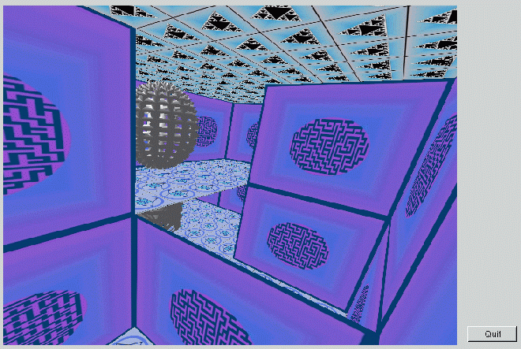
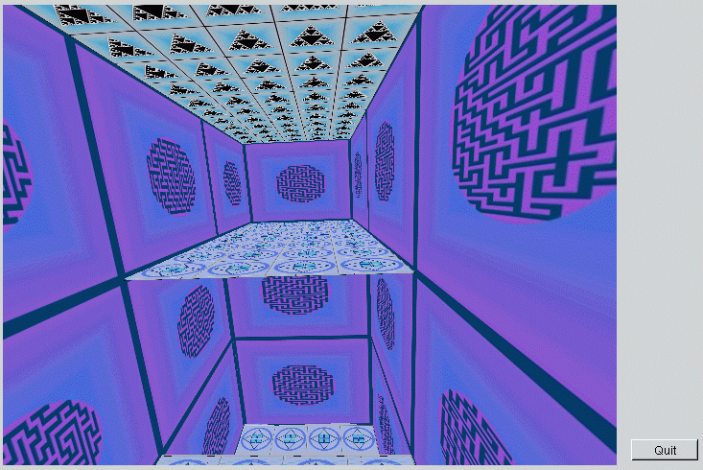
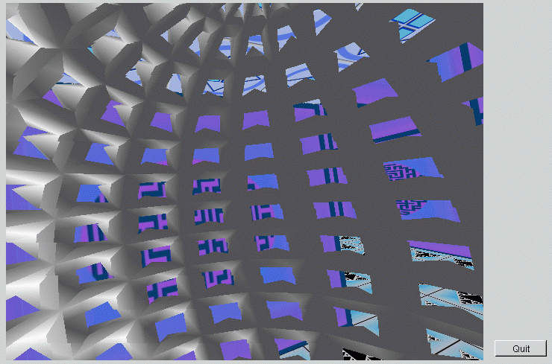
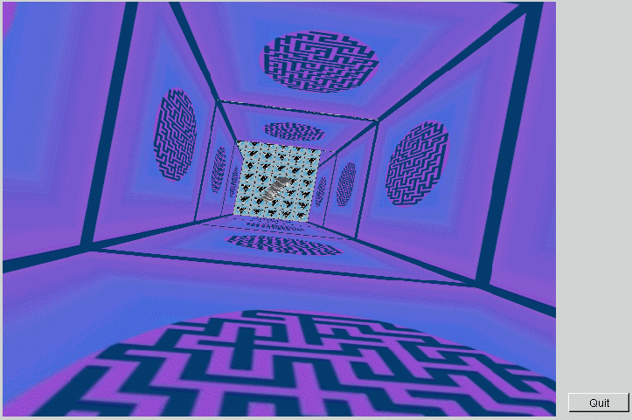
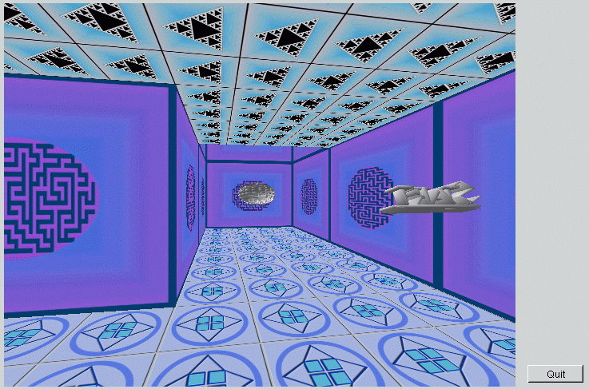
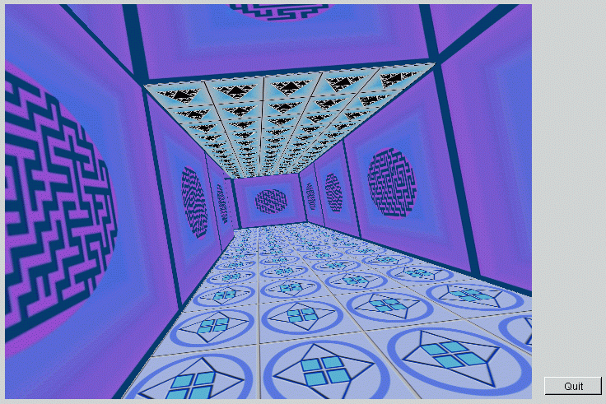
Figure A1: Some objects inside the Maze
Figure A2: Inside an object in the Maze
Figure A3: A view of the multi-dimensional Maze
Figure A4: Looking “down” at the starting cell
Figure A6: A view from the starting cell in the Maze
Figure A7: Users viewpoint from the end of a corridor

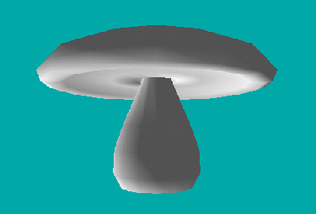
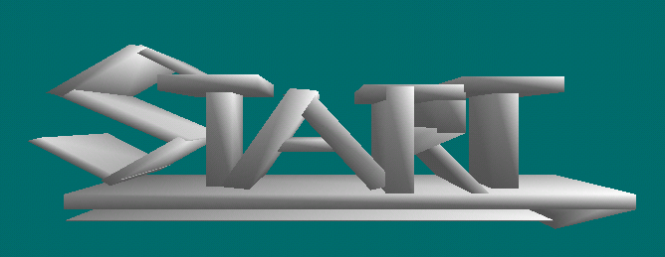
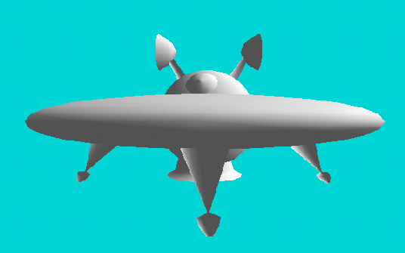
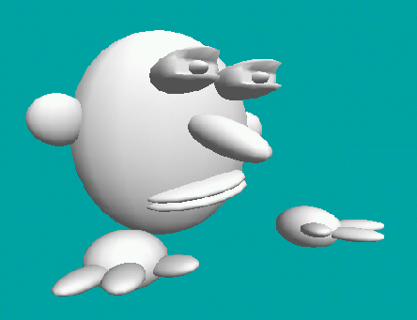
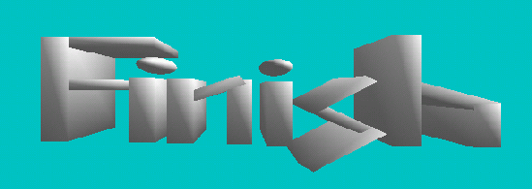
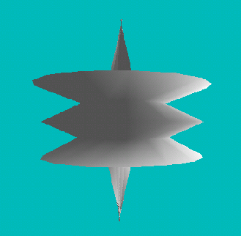
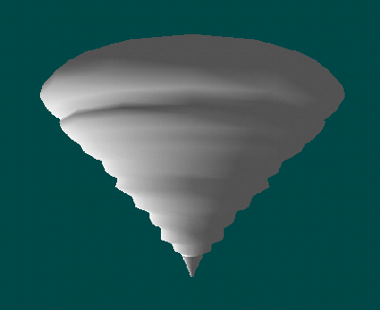
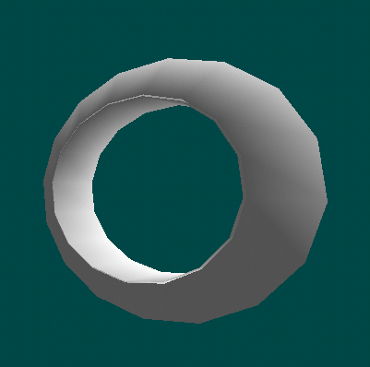
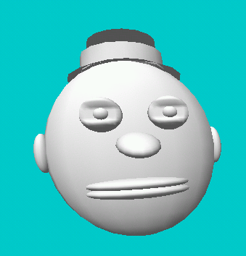
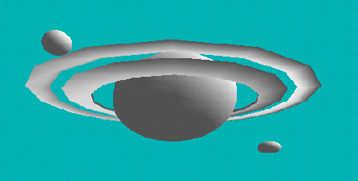
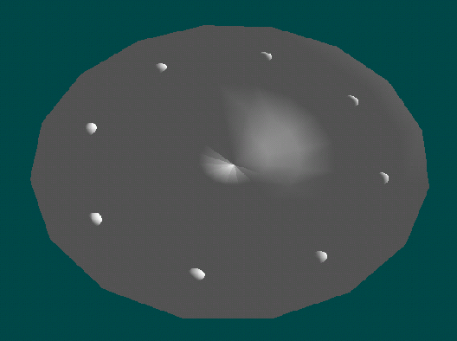
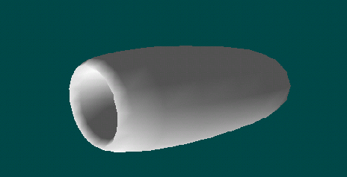
1
2
3
4
5
6
7
8
9
10
11
12

Object Group A
These objects where displayed in the Maze using the Keyboard Based Travel Technique.
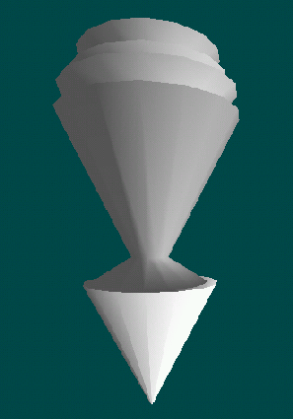
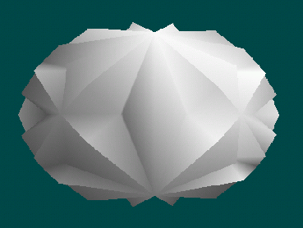
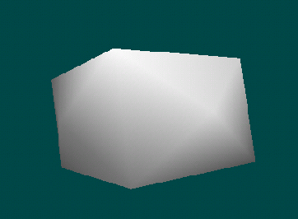
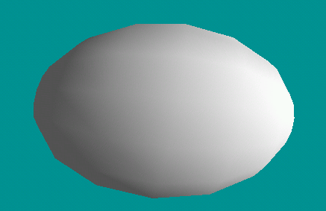
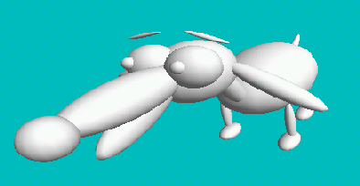
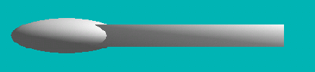
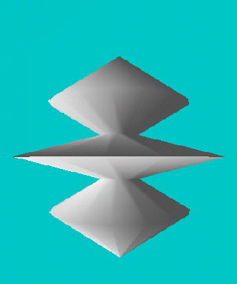
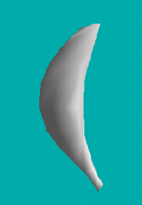
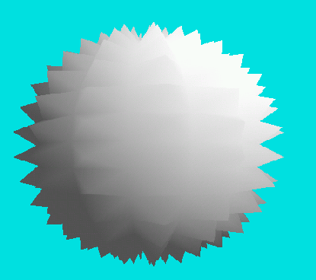
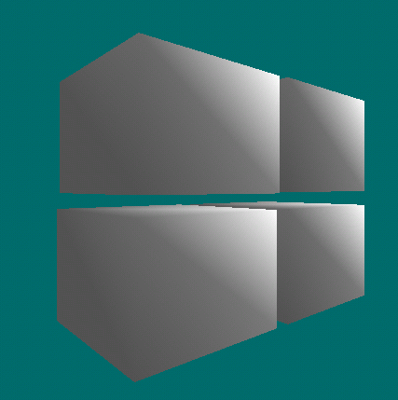
1
2
3
4
5
6
7
8
9
10
11
12

Object Group B
These objects where displayed in the Maze using the HMD Based Travel Technique.

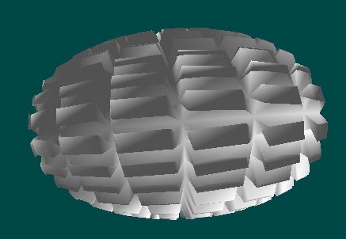
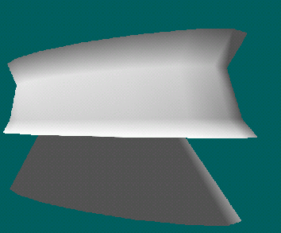
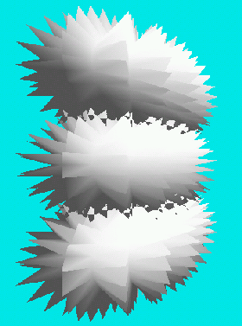
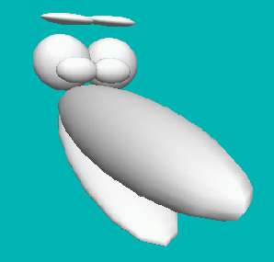
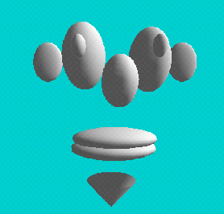
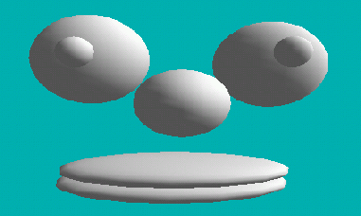
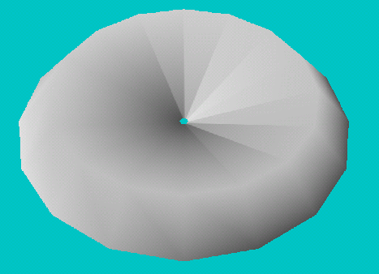
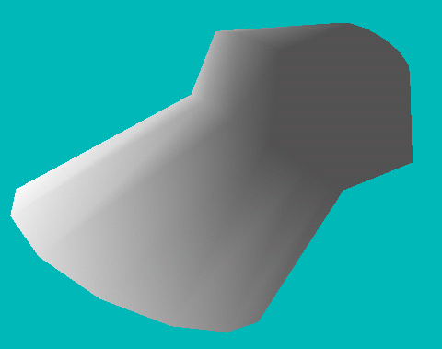
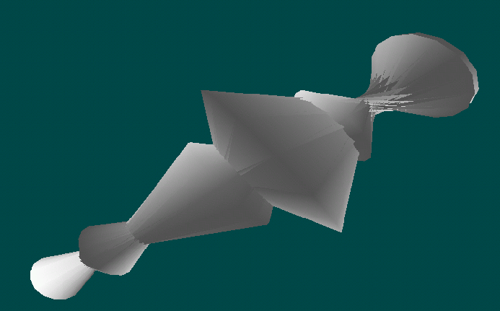
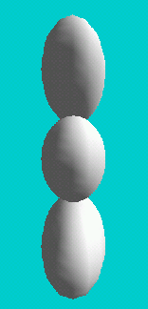
3
2
1
4
5
6
7
8
9
10
11
12

Object Group C
These objects where displayed in the Maze using the Hand Based Travel Technique.

Object Group D
These objects where displayed in the Maze using the Hand-Head Based Travel Technique.

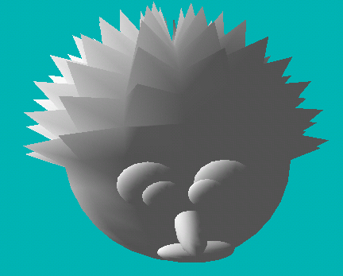
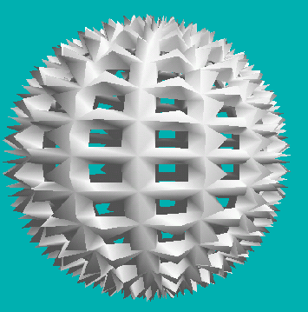
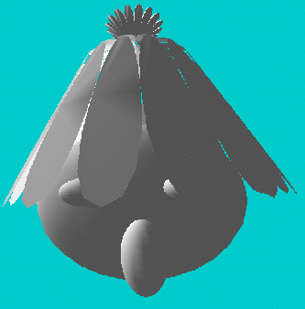
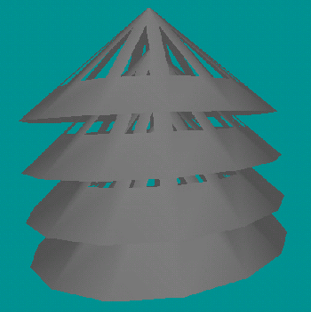
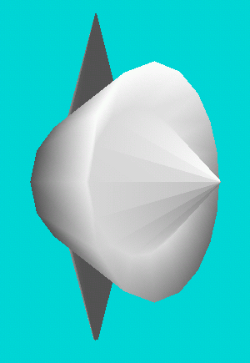
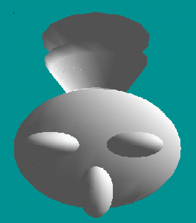
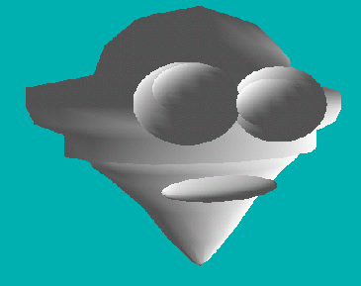
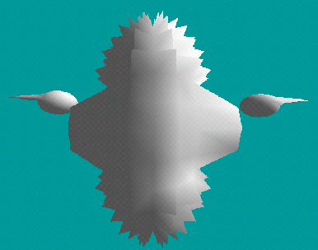
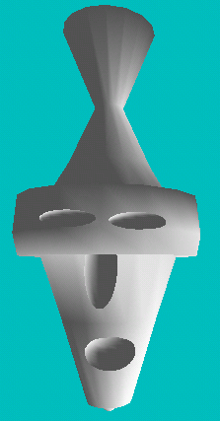
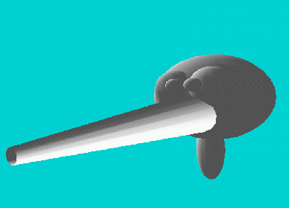
1
2
3
4
5
6
7
8
9
10
11
12

Appendix 2 – Questionnaire

Travel Techniques in the Maze Virtual Environment

The purpose of this questionnaire is to help the researcher analyse various aspects of the Virtual Reality Travel Techniques.
You should not feel obliged to answer any questions.
All information will be treated with complete confidentiality.
Please tick or cross the relevant blocks and if you need to write please write legibly if it’s possible!!
These blocks are for the researcher to fill out.
Warning! This test could lead to dizziness or nausea.

Some General Information About You
(To be completed before testing starts)
1.1
- Age
1.2
M
F
- Gender

- Please give an indication of your computer experience
1.3

None at all A hell of a lot
1 | 2 | 3 | 4 | 5

1.4
Y
N
- Have you had any exposure to Virtual Reality (VR) systems before?
If so, please give a brief description:

1.5
- Do you suffer from any sort of motion sickness?
Y
N
If so please describe them briefly:

- Do your or have you ever played any first person shoot ‘em up games (e.g. Quake)?
1.6
Y
N

Subject No.:
Date:

Feedback Section – Travel Technique 1

Keyboard Based Technique
(To be filled out after Travel Technique Exercise has been completed)

1. Was travelling through the maze using this technique enjoyable?
2.1

Not At All Very Enjoyable
1 | 2 | 3 | 4 | 5

2.2
2. How difficult was it to learn this method of travel?

Very Difficult Very Easy
1 | 2 | 3 | 4 | 5

3. How many minutes do you think it took you to find the finish cell and if you did not find it
can you estimate how long you were in the maze for (in minutes and/or seconds)?
2.3

4. Did you at any time forget you were in a Virtual Environment?
2.4 (a)
Y
N

If so, how easy was it for you to forget that you were in the Virtual Environment?
2.4 (b)
Very Difficult Very Easy
1 | 2 | 3 | 4 | 5

5. Could you suggest any way that would make you feel more immersed in this environment?

2.6 (a)
6. How many times do you think you collided with the corridor walls?

2.6 (b)
Did the audio alert help you realize you where colliding with the walls?
Y
N

7. How often did you find yourself concentrating on using the travel technique?
2.7

Never Continually
1 | 2 | 3 | 4 | 5

8. How often did you find yourself concentrating on finding the finishing cell?
2.8

Never Continually
1 | 2 | 3 | 4 | 5

9. Approximately how much of the time do you think you spent trying use the travel technique
and how much of the time do you think you spent deciding which path to take?
(E.g. If I spent about 20 percent of the time trying to use the technique and around 80
percent of the time trying to find the finishing cell I would write 20/80)
2.9
/
Using Technique Path Finding

10. Did you often feel you had no idea were you where or did you know exactly were you
where at all times?
2.10
No idea at all times I knew exactly where I was at all times
1 | 2 | 3 | 4 | 5

2.11
11. How many objects do you remember seeing?

Please briefly describe what they looked like to you and if you saw any replica objects:

12. Can you recall any sort of strategy you might have used to enable yourself to get a better
idea of the area you where travelling in?

13. Was travelling though the maze using this travel technique comfortable?
2.13
Very Uncomfortable Very Comfortable
1 | 2 | 3 | 4 | 5

Did you feel any physical discomfort such as dizziness or nausea, and if you did please describe them?

14. What specific problems, if any, do you feel you have with this travel technique?

15. Can you suggest any improvements?

Feedback Section – Travel Technique 2

HMD Based Technique
(To be filled out after Travel Technique Exercise has been completed)

1. Was travelling through the maze using this travel technique enjoyable?
3.1

Not At All Very Enjoyable
1 | 2 | 3 | 4 | 5

3.2
2. How difficult was it to learn this method of travel?

Very Difficult Very Easy
1 | 2 | 3 | 4 | 5

3. How many minutes do you think it took you to find the finish cell and if you did not find it
can you estimate how long you were in the maze for (in minutes and/or seconds)?
3.3

4. Did you at any time forget you were in a Virtual Environment?
3.4 (a)
Y
N

If so, how easy was it for you to forget that you were in the Virtual Environment?
3.4 (b)
Very Difficult Very Easy
1 | 2 | 3 | 4 | 5

5. Could you suggest any way that would make you feel more immersed in this environment?

3.6
6. How many times do you think you collided with the corridor walls?

7. How often did you find yourself concentrating on using the travel technique?
3.7

Never Continually
1 | 2 | 3 | 4 | 5

8. How often did you find yourself concentrating on finding the finishing cell?
3.8

Never Continually
1 | 2 | 3 | 4 | 5

9. Approximately how much of the time do you think you spent trying use the travel technique
and how much of the time do you think you spent deciding which path to take?
(E.g. If I spent about 20 percent of the time trying to use the technique and around 80
percent of the time trying to find the finishing cell I would write 20/80)
3.9
/
Using Technique Path Finding

10. Did you often feel you had no idea were you where or did you know exactly were you
where at all times?
3.10
No idea at all times I knew exactly where I was at all times
1 | 2 | 3 | 4 | 5

3.11
11. How many objects do you remember seeing?

Please briefly describe what they looked like to you and if you saw any replica objects:

12. Can you recall any sort of strategy you might have used to enable yourself to get a better idea
of the area you where travelling in?

13. Was travelling though the maze using this travel technique comfortable?
3.13
Very Uncomfortable Very Comfortable
1 | 2 | 3 | 4 | 5

Did you feel any physical discomfort such as dizziness or nausea, and if you did please describe them?

14. What specific problems, if any, do you feel you have with this travel technique?

15. Can you suggest any improvements?

Feedback Section – Travel Technique 3

Hand Based Technique
(To be filled out after Travel Technique Exercise has been completed)

1. Was travelling through the maze using this technique enjoyable?
4.1

Not At All Very Enjoyable
1 | 2 | 3 | 4 | 5
4.2
2. How difficult was it to learn this method of travel?

Very Difficult Very Easy
1 | 2 | 3 | 4 | 5

3. How many minutes do you think it took you to find the finish cell and if you did not find it
can you estimate how long you were in the maze for (in minutes and/or seconds)?
4.3

4. Did you at any time forget you where in a Virtual Environment?
4.4 (a)
Y
N

If so, how easy was it for you to forget that you where in the Virtual Environment?
4.4 (b)
Very Difficult Very Easy
1 | 2 | 3 | 4 | 5

5. Could you suggest any way that would make you feel more immersed in this environment?

4.6 (a)
6. How many times do you think you collided with the corridor walls?

4.6 (b)
Did the audio alert help you realize you where colliding with the walls?
Y
N

7. How often did you find yourself concentrating on using the travel technique?
4.7

Never Continually
1 | 2 | 3 | 4 | 5

8. How often did you find yourself concentrating on finding the finishing cell?
4.8

Never Continually
1 | 2 | 3 | 4 | 5

9. Approximately how much of the time do you think you spent trying use the travel technique
and how much of the time do you think you spent deciding which path to take?
(E.g. If I spent about 20 percent of the time trying to use the technique and around 80
percent of the time trying to find the finishing cell I would write 20/80)
4.9
/
Using Technique Path Finding

10. Did you often feel you had no idea were you where or did you know exactly were you
where at all times?
4.10
No idea at all times I knew exactly where I was at all times
1 | 2 | 3 | 4 | 5

4.11
11. How many objects do you remember seeing?

Please briefly describe what they looked like to you and if you saw any replica objects:

12. Can you recall any sort of strategy you might have used to enable yourself to get a better idea
of the area you were travelling in?

13. Was travelling though the maze using this technique comfortable?
4.13
Very Uncomfortable Very Comfortable
1 | 2 | 3 | 4 | 5

Did you feel any physical discomfort such as dizziness or nausea, and if you did please describe them?

14. What specific problems, if any, do you feel you have with this travel technique?

15. Can you suggest any improvements?

Feedback Section – Travel Technique 4

Hand & HMD Based Technique
(To be filled out after Travel Technique Exercise has been completed)

1. Was travelling through the maze using this technique enjoyable?
5.1

Not At All Very Enjoyable
1 | 2 | 3 | 4 | 5

5.2
2. How difficult was it to learn this method of travel?

Very Difficult Very Easy
1 | 2 | 3 | 4 | 5

3. How many minutes do you think it took you to find the finish cell and if you did not find it
can you estimate how long you were in the maze for (in minutes and/or seconds)?
5.3

4. Did you at any time forget you where in a Virtual Environment?
5.4 (a)
Y
N

If so, how easy was it for you to forget that you were in the Virtual Environment?
5.4 (b)
Very Difficult Very Easy
1 | 2 | 3 | 4 | 5

5. Could you suggest any way that would make you feel more immersed in this environment?

5.6 (a)
6. How many times do you think you collided with the corridor walls?

7. How often did you find yourself concentrating on using the travel technique?
5.7

Never Continually
1 | 2 | 3 | 4 | 5

8. How often did you find yourself concentrating on finding the finishing cell?
5.8

Never Continually
1 | 2 | 3 | 4 | 5

9. Approximately how much of the time do you think you spent trying use the travel technique
and how much of the time do you think you spent deciding which path to take?
(E.g. If I spent about 20 percent of the time trying to use the technique and around 80
percent of the time trying to find the finishing cell I would write 20/80)
5.9
/
Using Technique Path Finding

10. Did you often feel you had no idea were you where or did you know exactly were you
where at all times?
5.10
No idea at all times I knew exactly where I was at all times
1 | 2 | 3 | 4 | 5

5.11
11. How many objects do you remember seeing?

Please briefly describe what they looked like to you and if you saw any replica objects:

12. Can you recall any sort of strategy you might have used to enable yourself to get a better idea
of the area you where travelling in?

13. Was travelling though the maze using this travel technique comfortable?
5.13
Very Uncomfortable Very Comfortable
1 | 2 | 3 | 4 | 5

Did you feel any physical discomfort such as dizziness or nausea, and if you did please describe them?

14. What specific problems, if any, do you feel you have with this travel technique?

15. Can you suggest any improvements?

General
(To be done after all techniques have been tested)
6.1
1. Which technique would you choose to use in the future to navigate through the VE Maze?
6.2

     
6.3
6.4
Please Rate (e.g. 1st, 2nd, 3rd, 4th)
Keyboard Based | HMD | Hand  Based | Hand & HMD  Based

Why?

6.5
2. Did you drop any objects at all to help you remember your position?
Y
N

If so, briefly describe how you used them:

3. Do you have any other comments about the system?

4. Do you have any comments about the testing or questionnaire?

Evaluation Organiser:
Joshuah Vincent
G97v3095@campus.ru.ac.za

Researchers Notes:
Subject No.:
Order of Techniques Tested:

Observances for Technique 1:

Observances for Technique 2:

Observances for Technique 3:

Observances for Technique 4:

Other Notes:

Appendix 3 – Data Collected

A. Distance and Time Data

Table A1. Average Distance Travelled per Technique

HMD-and-Hand | Backward | 2056.40
Based Technique | Forward | 6136.60
 | Total | 8193.00
Keyboard Based | Backward | 147.19
Based Technique | Forward | 3097.75
 | Total | 3244.94
Hand Based | Backward | 506.36
Technique | Forward | 6084.21
 | Total | 6590.57
HMD Based | Backward | 436.50
Technique | Forward | 9110.63
 | Total | 9547.13

Table A2. No. of Subjects Successfully Finding Finish

Keyboard | 3
HMD | 13
Hand | 9
HMD-and-Hand | 7

Table A3. Objects Dropped in Maze
 | Total | Average
Keyboard | 63.00 | 3.71
HMD | 85.00 | 5.00
Hand | 33.00 | 1.94
HMD-and-Hand | 54.00 | 3.18

Table A4. Average Technique Time vs. Distance Travelled
Time | Keyboard | HMD | Hand | HMD-and-Hand
5 | 5.625 | 8.8125 | 9.214285714 | 14.2
10 | 16.3125 | 48.375 | 45.21428571 | 47
15 | 22.875 | 110.25 | 53.35714286 | 43
20 | 25.125 | 101.0625 | 68.35714286 | 36.4
25 | 41.0625 | 104.8125 | 95.57142857 | 69.6
30 | 38.625 | 113.4375 | 75.85714286 | 91.4
35 | 28.8125 | 89.0625 | 47.57142857 | 97.2
40 | 36.75 | 107.4375 | 48.21428571 | 68.2
45 | 38.25 | 98.8125 | 28.5 | 116.6
50 | 37.875 | 74.25 | 59.35714286 | 114.6
55 | 28.3125 | 85.3125 | 76.5 | 73.4
60 | 51.75 | 111.5625 | 90.64285714 | 69.2
65 | 30.75 | 93 | 96.42857143 | 85.6
70 | 45.9375 | 117.75 | 51.85714286 | 100.4
75 | 56.9375 | 83.8125 | 66.21428571 | 88.6
80 | 33.5625 | 114 | 41.14285714 | 77.8
85 | 38.0625 | 126.5625 | 86.78571429 | 91.6
90 | 54.375 | 96.5625 | 58.71428571 | 109.6
95 | 55.125 | 120.5625 | 73.5 | 75
100 | 46.6875 | 87.5625 | 68.57142857 | 83.6
105 | 42.75 | 105.75 | 88.07142857 | 77.2
110 | 22.3125 | 72 | 63.85714286 | 86
115 | 48.9375 | 79.125 | 36.85714286 | 83.4
120 | 35.25 | 95.0625 | 69.85714286 | 84.4
125 | 40.5 | 121.125 | 94.5 | 79
130 | 25.3125 | 116.625 | 111.6428571 | 91.2
135 | 31.5 | 123.375 | 62.78571429 | 83.6
140 | 53.4375 | 109.875 | 45 | 110.2
145 | 28.5 | 101.0625 | 80.35714286 | 85
150 | 41.4375 | 92.0625 | 69.42857143 | 77
155 | 46.875 | 82.3125 | 97.71428571 | 105.2
160 | 30.5625 | 95.625 | 93.85714286 | 102.4
165 | 30.375 | 89.625 | 69.42857143 | 68.4
170 | 45.375 | 94.6875 | 77.35714286 | 53
175 | 36.1875 | 108.5625 | 92.14285714 | 75.4
180 | 20.25 | 99.1875 | 88.28571429 | 94.6
185 | 39.1875 | 113.25 | 70.28571429 | 69.8
190 | 30.375 | 101.625 | 78.21428571 | 89.2
195 | 37.6875 | 90 | 47.14285714 | 78
200 | 33.9375 | 112.875 | 60.21428571 | 102
205 | 28.6875 | 104.625 | 47.57142857 | 89
210 | 44.625 | 129 | 43.5 | 82.4
215 | 28.5 | 104.625 | 38.14285714 | 116
220 | 45.75 | 98.625 | 70.71428571 | 72.6
225 | 33.375 | 101.625 | 103.7142857 | 84.2
230 | 48 | 92.25 | 66.21428571 | 134
235 | 40.3125 | 119.0625 | 71.14285714 | 88
240 | 32.25 | 151.125 | 88.5 | 89.6
Time | Keyboard | HMD | Hand | HMD-and-Hand
250 | 36.75 | 117.5625 | 41.35714286 | 86.8
255 | 27 | 93.9375 | 85.07142857 | 100
260 | 43.875 | 128.25 | 60.64285714 | 104.8
265 | 31.5 | 98.0625 | 79.71428571 | 99
270 | 39 | 110.25 | 55.71428571 | 125.6
275 | 39.75 | 114.75 | 81.85714286 | 91.8
280 | 41.8125 | 139.5 | 50.78571429 | 90.2
285 | 33 | 125.0625 | 73.92857143 | 102.2
290 | 42.375 | 118.3125 | 68.57142857 | 92.4
295 | 22.3125 | 115.3125 | 66.64285714 | 64
300 | 33 | 113.25 | 55.07142857 | 62.4
305 | 43.3125 | 90.9375 | 60 | 93.8
310 | 36.9375 | 145.875 | 125.1428571 | 90
315 | 44.8125 | 125.0625 | 92.78571429 | 112.2
320 | 43.5 | 110.625 | 62.57142857 | 119
325 | 45.1875 | 88.3125 | 78.21428571 | 99.2
330 | 28.6875 | 93 | 72 | 109.4
335 | 41.0625 | 89.625 | 60 | 87.8
340 | 33 | 128.0625 | 48 | 97
345 | 21.375 | 108.375 | 83.57142857 | 96.8
350 | 32.25 | 123.75 | 110.1428571 | 91.8
355 | 51.75 | 123.75 | 79.92857143 | 92.8
360 | 40.875 | 104.25 | 72.42857143 | 84.6
365 | 35.0625 | 141.5625 | 81.21428571 | 125.4
370 | 41.4375 | 130.6875 | 87.42857143 | 105.6
375 | 40.875 | 126.375 | 75.21428571 | 97.4
380 | 27.5625 | 94.125 | 99 | 102.2
385 | 42.9375 | 125.4375 | 79.5 | 102.8
390 | 42.5625 | 110.0625 | 110.7857143 | 100.6
395 | 35.25 | 114.75 | 85.5 | 111.8
400 | 39.375 | 117.5625 | 73.5 | 78.8
405 | 53.8125 | 127.875 | 93.42857143 | 113.8
410 | 49.125 | 130.6875 | 120.2142857 | 102.8
415 | 27.375 | 102 | 98.14285714 | 69.2
420 | 35.25 | 99 | 90.42857143 | 98
425 | 45.75 | 99 | 73.5 | 84.8
430 | 38.0625 | 112.875 | 98.35714286 | 110.2
435 | 43.6875 | 98.0625 | 59.57142857 | 127.8
440 | 45.375 | 106.3125 | 62.78571429 | 100.4
445 | 31.875 | 88.875 | 67.28571429 | 108
450 | 41.25 | 107.0625 | 106.5 | 136.8

B. Feedback (Questionnaire) Data

Table B1. General Details as Answered from Section 1 of Questionnaire
Mean Age: | Min Age: | Max Age:
22.65 | 20 | 31
 |  | No. of Subjects with VR Exposure:
 |  | 14
 |  | No. of subjects who suffer form motion sickness:
 |  | 3
 |  | No. played First person shooter games:
 |  | 19

Table B2. Average Guessed Time vs. Actual Time
 | Average Guessed Time: | Average Actual Time:
Technique 1 (Key) | 05:34 | 07:00
Technique 2 (HMD) | 04:51 | 07:00
Technique 3 (Hand) | 05:15 | 07:00
Technique 4 (HMD-and-Hand | 04:48 | 07:00

Table B3. Number of Objects Seen vs. No. of Objects Reported Seen
 | Average No. Objects Guessed: | No. Objects Seen (Avg):
Technique 1 (Key) | 4.8 | 5.1
Technique 2 (HMD) | 8.3 | 8.75
Technique 3 (Hand) | 5.6 | 6.3
Technique 4 (HMD-and-Hand | 5.65 | 6.35

Table B4. Result of Ratings for the Favorite Travel Technique
 | Technique 1 | Technique 2 | Technique 3 | Technique 4
First (Best) | 0 | 13 | 0 | 7
Second | 4 | 5 | 6 | 5
Third | 6 | 2 | 9 | 3
Forth (Worst) | 10 | 0 | 5 | 5

Table B5. Average of Ratios between Time Spent Trying to Use Technique vs. Wayfinding
 | Technique 1 | Technique 2 | Technique 3 | Technique 4
Using Technique | 72.5 | 21.5 | 69.25 | 60
Wayfinding | 26.5 | 79.5 | 30.75 | 40

Table B5. Average ratings given for question posed in the questionnaire
(Rating where from 1 to 5, where 5 implies positive result and 1 negative results)
 | Difficulty to learn technique  (Q 1) | Enjoyable Rating (Q2) | Time concentrating on travel technique  (Q7) | Time spent wayfinding  (Q8) | where you where at all times  (Q10) | Level of Comfort  (Q13)
Keyboard | 2.470588 | 2.15 | 4.35 | 2.35 | 2.55 | 2.85
HMD | 4.647059 | 4.4 | 2.05 | 3.45 | 3.35 | 3.4
Hand | 2.411765 | 2.9 | 4 | 2.05 | 2.95 | 2.45
HMD-and-Hand | 2.588235 | 3.2 | 3.7 | 2.6 | 3.05 | 2.8

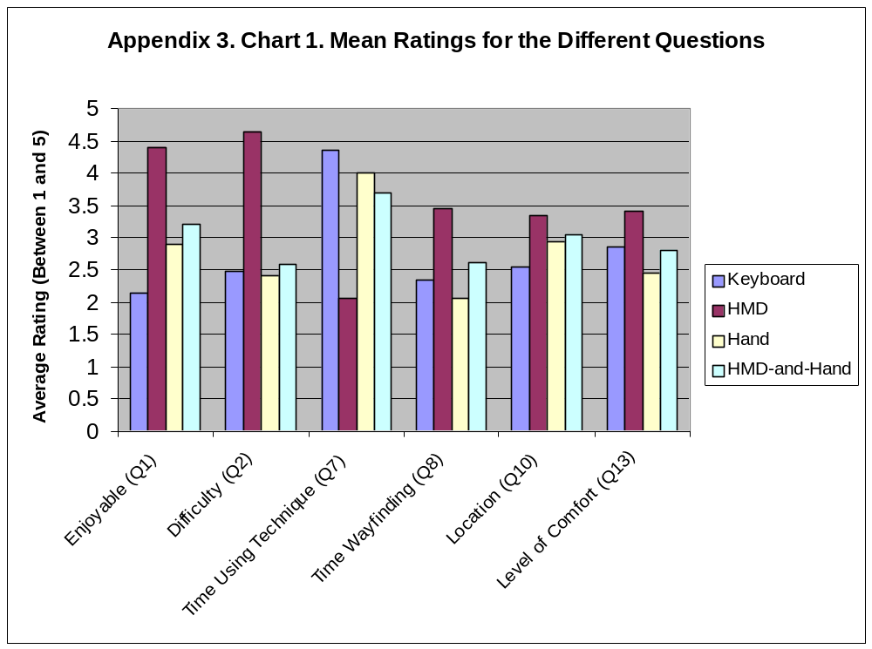

Appendix 4 – Code Samples

Collision Detection Algorithm

static boolean checkForCollisions () //f_or_b tells function if viewer is going forward or backward
{
/* - we take the start and end positions and determine if they go through a wall
* - if they do return false else return true
*/

//get viewers current position
double xStartPos = startpos.xValue();
double yStartPos = startpos.yValue();
double zStartPos = startpos.zValue();

//get the cell the viewer is currently in
int cellStartPos [] = new int [3];
theMaze.getCurrentCellPosition (xStartPos, yStartPos, zStartPos, cellStartPos);

//get viewers end position
double xEndPos = endpos.xValue();
double yEndPos = endpos.yValue();
double zEndPos = endpos.zValue();

//get the cell the viewer will end up in
int cellEndPos [] = new int [3];
theMaze.getCurrentCellPosition (xEndPos, yEndPos, zEndPos, cellEndPos);

/*
* we now have the cell that the start and end positions are in
* and the coord relative to the world
* we now need the coordsinates relative to the cell
*/

int xdiff = cellEndPos[0] - cellStartPos[0];
int ydiff = cellEndPos[1] - cellStartPos[1];
int zdiff = cellEndPos[2] - cellStartPos[2];

//make sure we haven't moved outside the actual maze - we need special cases
//for the times where x, y, or z are negative

if (xEndPos <= 10) xdiff = -1;
if (yEndPos <= 10) ydiff = -1;
if (zEndPos <= 10) zdiff = -1;

//if the difference between start and end positions is not 0 then
//we have moved into a new cell & we therefore need to check whether
//a wall is there

if (!(xdiff == 0))
{
if (xdiff > 0)//we are moving into forward into a new cell
{
if (theMaze.getCellInformation (5, cellStartPos[0], cellStartPos[1], cellStartPos[2]))
return false;
}
if (xdiff < 0)//we are moving backward into a new cell
{
if (theMaze.getCellInformation (6, cellStartPos[0], cellStartPos[1], cellStartPos[2]))
return false;
}
}

if (!(ydiff == 0))
{
if (ydiff < 0)//we are moving backward into a new cell
{
if (theMaze.getCellInformation (1, cellStartPos[0], cellStartPos[1], cellStartPos[2]))
return false;

if (ydiff > 0)//we are moving into forward into a new cell
{
if (theMaze.getCellInformation (2, cellStartPos[0], cellStartPos[1],cellStartPos[2]))
return false;
}
}

if (!(zdiff == 0))
{
if (zdiff > 0)//we are moving into forward into a new cell
{
if (theMaze.getCellInformation (3, cellStartPos[0], cellStartPos[1], cellStartPos[2]))
return false;
}

if (zdiff < 0)//we are moving backward into a new cell
{
if (theMaze.getCellInformation (4, cellStartPos[0], cellStartPos[1], cellStartPos[2]))
return false;
}
}

return true;
}

VE Maze Class

/** Java File: VEMaze.java
Joshuah Vincent, 2000
*/
import java.net.*;

class VEMaze
{
//maze cordinates
static final int mazeXCoords = 3;
static final int mazeYCoords = 4;
static final int mazeZCoords = 6;
static final int mazeType = 0; // perfect maze
static final int mazeScale = 100;//gives the length of the cell walls of the maze
//and changes all object sizes and starting positions accordingly
static final int NUM_RANDOM_OBJECTS = 10;
static objectID viewer;
static Point3D viewerpos;
static Quaternion viewerori;
static VRQtOutputDevice OutputWindow;
static VRMazeActor theMaze;
static int NUMPORTS = 6;

public static void main (String args [])
{
int i;
OutputWindow = new VRQtOutputDevice ("Virtual Maze", 0, 0, 640, 480);
VRSink testsink = new VRSink(OutputWindow);
VREnvironment vrenv = new VREnvironment ();
VREnvironment.setCurrentEnvironment (vrenv);

/**************************DRAW OBJECTS ***************************/
objectID objMaze, start_obj, finish_obj;
objMaze = VREnvironment.createThing ();

theMaze = new VRMazeActor (mazeXCoords, mazeYCoords ,mazeZCoords, mazeType, mazeScale);
VREnvironment.setPhysicalRepresentation (theMaze, objMaze);

//place random objects in maze
int coords [] = new int[3];
objectID randObj [] = new objectID [NUM_RANDOM_OBJECTS];
VRTec1RandomObject theRandObj [] = new VRTec1RandomObject [NUM_RANDOM_OBJECTS];
for(i = 0; i < NUM_RANDOM_OBJECTS; i++)
{
randObj[i] = VREnvironment.createThing();
theRandObj[i] = new VRTec1RandomObject(mazeXCoords, mazeYCoords ,mazeZCoords, mazeScale, i);
VREnvironment.setPhysicalRepresentation (theRandObj[i], randObj[i]);
}

//place start object in world
start_obj = VREnvironment.createThing();
VRStartObject theStart = new VRStartObject(mazeScale);
VREnvironment.setPhysicalRepresentation (theStart, start_obj);

//place finish object in world
finish_obj = VREnvironment.createThing();
VRFinishObject theFinish = new VRFinishObject(mazeXCoords, mazeYCoords ,mazeZCoords, mazeScale);
VREnvironment.setPhysicalRepresentation (theFinish, finish_obj);

boolean keybased =true; //set this to false when we want to use devices over network eg. HMD
//Polhemus

System.out.println ("\nSubject No: 1");
System.out.println ("Date: 3 November 2000");

/*************** //the travel actor\\ *******************/
boolean s_e = true;
System.out.println ("**************************************************************************");
System.out.println (" Travel Technique 1 - Keyboard Based Travel Technique");
System.out.println ("**************************************************************************");
VRMazeKeyBasedTravelActor theViewer = new VRMazeKeyBasedTravelActor (theMaze, vrenv, testsink, mazeScale, OutputWindow, s_e);
/******************connection to Pentium 133*****************/
//set up connection
if (keybased == false) //if we want to use external devices then set keybased to false
{
UDPChannel outconn [] = new UDPChannel [NUMPORTS];
NetworkComponent outlink [] = new NetworkComponent [NUMPORTS];
Connection polcon [] = new Connection [NUMPORTS];
Connection ctrlpolcon [] = new Connection [NUMPORTS];
InetAddress deviceserver = null;
try
{
deviceserver = InetAddress.getByName ("snert");
}
catch (Exception e)
{
System.err.println ("Address for device server could not be found in VEMaze.java");
System.exit (1);
}
for (i = 0; i < NUMPORTS; i++)
{
outconn[i] = new UDPChannel ();
outlink[i] = new NetworkComponent (outconn[i]);
polcon[i] = new Connection (outlink[i], 0, theViewer, i); // Connect to port
ctrlpolcon[i] = new Connection (theViewer, i, outlink[i], 0);
outlink[i].OpenConnection (deviceserver, 8000 + (250 * i) + 2);
}
}
while (true)
{
Component.RunComponents ();
}
}//main

